Adolf Hitler

The Life Of The Leader

Introduction -- By Hermann Göring

Preface -- By Dr. Joseph Göbbels

The Leader's Travels -- By SS-Brigade Leader Julius Schreck

Farewell From The National Socialist German Workers' Party To Julius Schreck -- By Rudolf Heß

The Leader And The German Folk -- By Dr. Otto Dietrich

The Leader As An Orator -- By Dr. Joseph Göbbels

The Leader In His Private Life -- By SS Higher Group Leader Wilhelm Bruckner

The Leader As A Statesman -- By Dr. Joseph Göbbels

The Leader And The German Worker -- By Dr. Robert Ley

The Leader And The Arts -- By Dr. Joseph Göbbels

The Buildings Of The Leader -- By Architect Albert Speer

Adolf Hitler And His Roads -- By Inspector General Doctor Of Engineering Fritz Todt

Our Hitler: A Radio Broadcast -- The German Folk On The Leader's Birthday -- By Dr. Joseph Göbbels

The Leader And The Defence Force -- By Lieutenant Colonel Förtsch

The Leader And German Youth -- By Baldur von Schirach, Lead Of The Hitler Youth

Introduction -- By Hermann Göring

We are unable, My Leader, to express our thanks in words. We are also unable to reveal our loyalty and our affection to you through words. All our gratitude, our love and our fervent trust in you, My Leader, can be seen glowing in the hundreds of thousands of faces turned towards you today.
All our Folk, our whole nation, today feel strong and happy because in you there has arisen not on The Leader of the nation, but also the saviour of the nation.

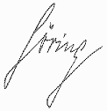

The Reich Parliament President before the German Reich Parliament at Nürnberg on the 15th of September, 1935.

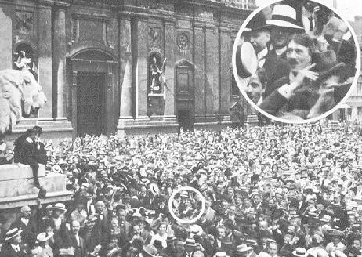
1st August, 1914, at the Odeonsplatz, München -- Adolf Hitler in the middle of the enthusiastic throng greeting the English declaration of war -- photographed by Heinrich Hoffmann, later to become Adolf Hitler's official photographer.

Preface -- By Dr. Joseph Göbbels

The idea of propaganda is associated the world over, and even still in Germany today, with a host of misconceptions. These misconceptions are so deeply rooted, and often linked with prejudices, that they can only be clarified with difficulty. Of all people, it is the Germans who, since the Great War, have learned a lesson from experience in this respect. In this relatively short period of time, propaganda in Germany has proved itself to be a politically powerful force of the first order. Today no further proof is needed that the Germany under the Kaisers was being undermined by Marxist propaganda, and that the Marxist democratic regime was able to be removed because it was opposed by a superior new order and power, expounded not only by the National Socialist doctrine, but also by National Socialist propaganda.
Propaganda must also be masterful. It is pointless to direct a few resourceful men into this area now and then. As with every great art form, there are men who are particularly skilled at propaganda, who usually establish a school and then become its teachers. That there is something dishonourable or despicable about propaganda is a widespread misconception which should be put aside. As in every field of human endeavour, the important thing is what is being supported, and what propaganda brings to the practical world. In this sense it has nothing to do with publicity. At its best, it lets issues and people speak for themselves, and ensures that, if they are of value, then they will also be portrayed and elucidated in their full value.
Good things and great people have their own effect. They must therefore be allowed to speak freely for themselves. The most important characteristic of particularly successful propaganda is that it neither omits nor adds anything which does not belong to the essential nature of the subject. The characteristic feature of events and personalities should be brought out clearly, distinctively, and simply, stripped bare of confusing details, so that they may be readily understood and recognised by the masses whom the propaganda is attempting to reach.
National Socialism and its principal representatives have brought along to this art form a natural talent. They have also learnt their trade and applied it through hard work, untiring close contact with the Folk, and a continual refining of the techniques involved. The Leader himself was the greatest master in this process. It is not widely known that, in the early days of the Party, he held no other office than that of Head Of Propaganda, and that in his brilliant mastery of this office he gave the Party its present intellectual, organisational, and political stamp.
He has also instinctively understood how to speak and deal with his Folk, whose child he has always been and will always be. From an early time, all the love and immense trust of his followers, and later of the whole of the German Nation, has been focused on him. Yet, initially, the masses saw him from a distance only as a politician and statesman. His purely humane side

remained largely in the background.
Today the whole world recognises him as the initiator of the National Socialist doctrine and the creator of the National Socialist State, the pioneer of a new European order, and the guide to peace and the welfare of nations. But behind this recognition countless millions of people the world over suspect that there is a fascinating and compelling personality behind the facade of the man Adolf Hitler. Germans and non Germans alike have been captured by the great simplicity and simple greatness which this man radiates. He can probably be designated as the man who in all the world is most deeply and clearly rooted in the feelings and thoughts of our modern time, and is therefore capable as no other man to give this time a new shape and direction.
In order to understand him completely, one must know him not only as a politician and a statesman, but also as a human being. It is to this end that this book has been written. It is a testimony to his personality, and has been compiled with affection and admiration by his closest colleagues and his oldest fellow combatants. They have put pen to paper to show the public an intimate picture of this great man. They have all know The Leader closely for many years, and have learned to admire him anew on a daily basis. This is what constitutes the actual worth of this book.
In this book The Leader is presented in his immediate relationship to all the issues of our time. The German Folk will seize this opportunity of seeing The Leader at close range, and personally getting to know him more closely.
It is pleasing to note that the book may be acquired simply and without great cost, a fact which will make it accessible to the masses of the German readership. May it find a happy and successful path into the German Nation!

Dr. Joseph Göbbels.

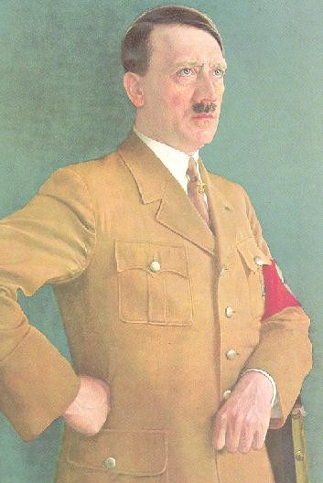

The Leader's Travels -- By SS-Brigade Leader Julius Schreck

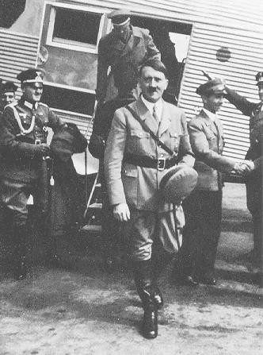
The Leader promotes aviation by his example.

Never before has a leading statesman got to know his country and his Folk as thoroughly as has Adolf Hitler. Whether by motor vehicle, aeroplane or train, his travels always served his purpose, which was to acquaint himself thoroughly with his Folk.

Already at the beginning of his Movement he was far sighted in recognising the importance of rapid means of transport, particularly the motor vehicle which he used at that time despite its still rudimentary state of development. Even today The Leader still prefers the motor vehicle because he considers it important to remain in constant contact with his national comrades and his old soldiers.

At the time of the great political struggles for power, it was evident that The Leader was far ahead of all his opponents due to the motorisation of his forces. There were not always crowds of enthusiastic people around The Leader cheering him on then. In those years we experienced many a journey where the going was very tough, and we could only secure our way through our presence of mind and through force.

No alarm signals could stop The Leader from driving into the strongholds of his red and black opponents, often right through desolate scattered villages of Bolshevist organisations, past protesting marchers. Sometimes our car was totally surrounded by thousands of fellow countrymen who had been incited to violence. However, it was our experience that, again and again, at the sight of The Leader, these people would suddenly drop their raised fists. They would look up and realise that this Hitler looked completely different from the one who had always been described to them. How many misled workers at that time looked for the first time into the eyes of the man who was supposed to be their opponent, only to become immediate and fanatical followers of his Movement? No amount of propaganda in the newspapers, and no books alone, could have brought about this miracle. And so, three years after his seizure of power, he could say: Where is the statesman who, after three years of rule, need not fear to go out among his Folk as I do?

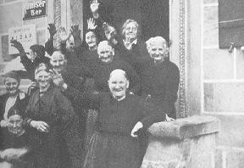
Trip through a small Franconian town.

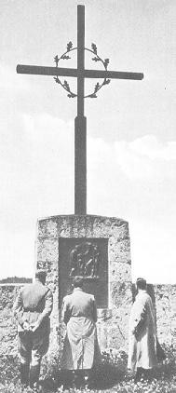
The Leader in Franconia, at the War Memorial in Hiltpolstein (Franconian Switzerland)

When his work and his official duties permit it, then you will find The Leader not only sitting in his office, but driving out into the country amidst his Folk. Sitting in his Mercedes again, he will appear sometimes here, sometimes there; one day in the Ruhr, the next in Baden, Württemberg, Saxony, East Prussia, at the coast. In brief, there is no district where his travels do not take him at least once. At the wheel of the car behind the windscreen, I then suddenly hear the amazed and enthusiastic cries: It's Hitler, or: The Leader is here. Often the people do not even notice who has just driven through the town. Not until the convoy has moved on do they become aware of the three black cars, and then all at once they realise who has just driven past. The children are, in the main, the first to recognise The Leader. The moment this happens, there is a race with the car, and then in a little while people gather around the car, several streets are alerted, and finally we will have to stop a number of times so that The Leader can shake hands with enthusiasts, accept flowers offered to him, and at times autograph a few cards.

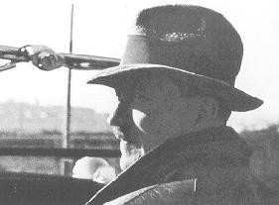
During a trip through Germany in his first car, his seat was already next to the driver.

Whoever has been fortunate enough, as I have been, to be constantly by The Leader's side and participate in his many journeys, will have thousands of unforgettable pictures imprinted in his mind in the course of the years. Such journeys leave you with an enormous belief in the German Folk and an immense feeling of warmth.

Major journeys are undertaken by The Leader only in an open vehicle, which he refuses to close even if it rains in the course of an official visit. To the advice of his entourage his only response is always: As long as the SA and the other groups have to stand in the rain, we can get wet as well. Thousands were witnesses as he inspected, bare headed and dressed only in his brown shirt, the marchpast of the SA at the reintegration of the Saar, as he spoke to the waiting crowds in pouring rain after a night flight at three o'clock in the morning at the election campaigns in Stralsund, or drove in the rain through Holstein to the Adolf Hitler Reclamation, with no consideration for himself, because the SA was also standing in the rain.

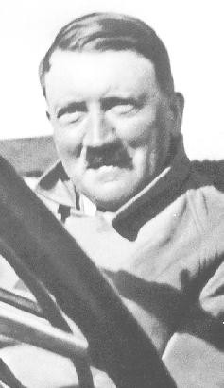
On his journeys through Germany, The Leader prefers an open vehicle.

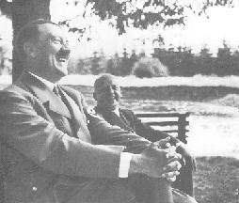
Trip through the Harz. Even The Leader can be cheerful.

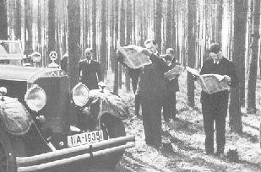
Rest in the forest.

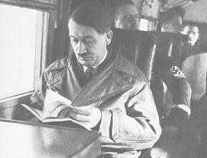
The Leader on a flight.

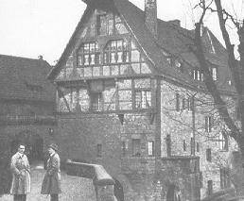
On top of the Wartburg.

Today, after fifteen years, as Chancellor Of The Reich, he has not given up this habit.
He also determines the route himself, because The Leader loves to use the side streets and experience Germany's countryside away from the major highways.

Before, when The Leader was not as well known as today, it was often easier. Then there were times when we could spend the night or have a meal in a small inn. Today it is quite different. The news of the arrival of The Leader spreads like wildfire in the villages and towns through which we pass. Many people are overjoyed and telephone the next village to pass on the news, and then the villagers, who have not yet seen their Leader, will be waiting at the entrance of the town to greet Hitler as he arrives. There are then such impressive moments that many a time I have wished I were a poet so that I could find the words to describe the myriad of minor occurrences with the impact with which I experienced them.

We arrive in a town. Everyone is there, the old and the young, mothers with young children in their arms, clubs and schools. The main street is quickly transformed into a sea of flags. The girls in the BDM try to stop the car, but time is pressing and The Leader must be at his destination at a certain time because hundreds of thousands in the gathering will be waiting for him. Then a large strapping fellow, the blacksmith of the village, suddenly jumps onto the bonnet of the car; now The Leader is forced to slow down his trip, and already the car is surrounded by the villagers. Everyone wants to shake The Leader's hand. Women with children in their arms cannot get close. They hold their children, Germany's future, above the heads of the enthusiastic crowds, as if they wanted to say: You belong to him!

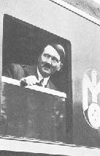
Travelling.

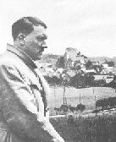
In the German countryside. Hiltpoltstein (Franconian Switzerland)

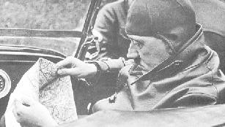
The Leader determines the route.

If one wants to describe great men, one also has to see their smaller traits. One of a hundred such episodes comes to mind. It is around ten o'clock at night as The Leader is driving towards Würzburg after a marchpast in Meiningen. Then, in the glow of the headlights, we see two SA men marching along. The Leader stops the car. They are asked where they are going. To the nearest railway station. My comrade can't walk much further. We still have three hours ahead of us.

Then jump in! They have no idea whose guests they are. We ask them a number of trivial questions. Then we ask them if they have already seen The Leader. Yes, today, during the marchpast. The car stops, we have reached our destination. The Leader, who is sitting in the front, calls to them and presses a sum of money into their hands. Then, in the darkness of the night, a small ray of light illuminates The Leader's face. The two SA men are paralysed.
Wasn't it The Leader who had just spoken to them? Yes, it's him! No words can pass their lips. They are overcome by joy. I put my foot on the accelerator and we drive off into the dark night. As we turn a curve we see the two of them still standing motionless on the side of the road, dumbfounded by what they have just experienced.

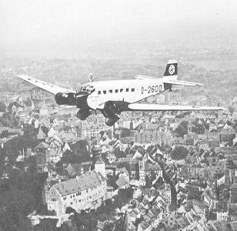
The D-2600 above Nürnberg. Arrival at the Party Conference Of The Reich.

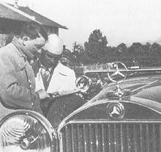
Election trip through Germany.

The major election campaigns at that time required The Leader to utilise his time to the maximum, and so The Leader would often make use of aircraft. This was at a time when air traffic was still a cause for apprehension. For weeks on end an aircraft would take him from town to town, with no consideration for wind or bad weather.

Looking back at this time, I experience a slight shudder when I remember the numerous flights through storms, fog and dark nights. It says a lot that, at the time when the aircraft figured prominently in The Leader's election campaign, the schedule for the take off was never changed. Every meeting which had been planned -- and at times there were 4 or 5 in various towns in Germany on the one day -- was carried through on time.

Often The Leader was advised not to go through with a certain flight. However, his answer was always: If need be, then I will also fly through a storm. How the opposition would have rejoiced at that time if the scheduled flight plan had not been carried out or a planned meeting had been cancelled. But Hitler did not do them that favour.

Of these flights, one in particular has stayed in my memory. This was the flight from Furth to Frankfurt. The old Rohrbach, the first machine which The Leader used at that time, was anchored with fuel drums. Over the whole of Germany there was a storm the intensity of which we rarely experienced. All general air traffic was banned. Only with difficulty could we walk upright. Everyone shook their head when The Leader boarded the aircraft. Yet, after a few minutes, it was already struggling to take off. Laboriously the aircraft made its way through thunderstorms, heavy gusts of rain and snow. Often the aircraft would suddenly plunge and the heads of many of the passengers hit the roof, but each time the flight continued successfully. Once the plane was forced to make an unscheduled emergency landing long before we reached our destination. The meeting in Kiel was to begin at 8 o'clock. At 5 o'clock I was informed that The Leader had had to land at Travemunde due to the low clouds, fog and severe storms. Immediately the convoy sped off towards Lübeck and near Eutin we were to pick up The Leader who was driving towards us in a hire car and bring him to Kiel on time.

Even if nowadays, due to the pressures of time, The Leader avails himself of train travel now and again on his night journeys, his great love is still for the motor vehicle, of which he himself once said that it opened up Germany for him. Likewise his love is for his Ju

52 under the command of Captain SS-Oberführer Baur, who must number among the first geniuses of Flight Captains. The most pleasurable thing for The Leader is when, after many strenuous weeks, he can once again drive through the German countryside in his car. The most pleasurable days for me are then when I can sit behind the wheel and, as once through war and deprivation, now drive The Leader through a happy and peaceful country.

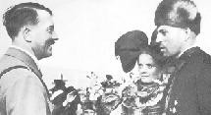
On the Bückeburg for the Harvest Festival of 1934.

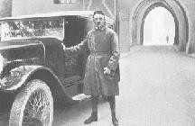
The Leader leaves the Landsburg Fortress, 1924.

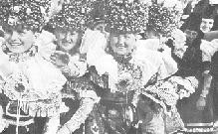
Women from Bückeburg in their festival costumes during the Harvest Festival in 1934.

Farewell From The National Socialist German Workers' Party To Julius Schreck -- By Rudolf Heß

The National Socialist Movement today takes leave of Julius Schreck. It takes leaves of one of its oldest and most faithful members. It takes leave of one of its best and most irreplaceable members. It takes leave of one of its most modest members, who wanted nothing for himself, who gave everything for Germany and for The Leader.
When it was a question of fighting for Germany, he stood at the front, whether it was in the World War or at home.
Boundless was his admiration and his love for The Leader, untiring his concern for The Leader, prudent his care for the protection of The Leader.
His nature radiated dependability to the last. His presence spread a feeling of security among his Party members in times of difficult struggle.
Unerring was his judgement of people, unequivocal his affection as was his aversion. A tough old warhorse with a warm heart. Feared by his opponents, loved by all who considered him one of themselves, honoured as a fatherly friend by his subordinates.
He had the good fortune of enjoying the highest trust of his Leader. The Movement lowers its flags in a last greeting to Julius Schreck. In doing so, it swears to him that his behaviour and his spirit will be an example to the young and to generations to come, and that he will thus serve the Movement in the many years that lie ahead to the glory of our great National Socialist Germany.

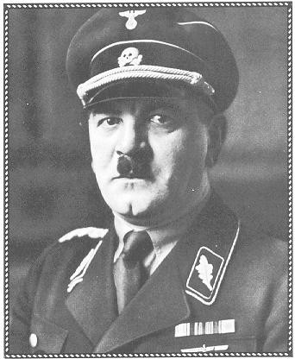
Julius Schreck -- died 15.5.1936.

The Leader And The German Folk -- By Dr. Otto Dietrich

The relationship of the German Folk to The Leader is a constant source of joyous pride to the Germans themselves, and a cause of amazement and surprise for the rest of the world. Nowhere else in the world will you find such a fanatical love of millions of people for one man, a love which is not excessive, nor ecstatic, but rather the result of an immense and deep trust, a supreme confidence, such as children sometimes have for a very good father.

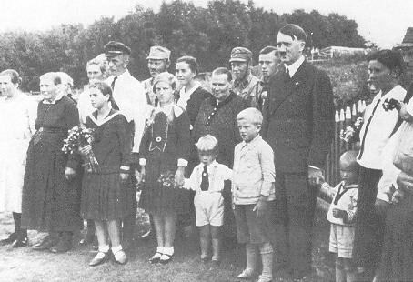
During a trip through East Prussia, The Leader visited a peasant family.

Enthusiasm lasts for only a few years; this love from the depths of the soul, however, once manifested, is indestructible, and will last for centuries. It is like a large, powerful flame, remarkable for its constancy. It is a love which has not suddenly flared up or been lit by unexpected and stirring events, but one which has grown slowly and insistently. It does not break out with wild impetuousness on any one single occasion, but is always there, at any time and in the heart of every German, whether it is triggered off by something in particular that fills his heart with pride, or whether he gathers together with hundreds of thousands of other fellow countrymen to listen to The Leader -- or whether there is no external reason at all, and it manifests itself in a moment of quiet reflection during the course of his daily work.
Whenever anyone thinks of The Leader, there is always a deep love which rises within him and of itself justifies the statement: Hitler is Germany -- Germany is

Hitler. Never before has any man been closer to the heart of every German as this man, who himself came from their midst. He did not come from outside, but was born in the cradle of the nation, having felt its sorrow and lived its life, and if anyone today were to ask the name of the unknown German soldier at the Front, then the whole of the German nation would answer: Adolf Hitler.

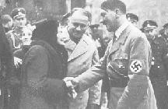
On the day of the reintegration of the Saar.

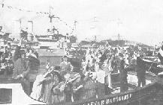
Enthusiastic crowds in the presence of The Leader in the Port Of Hamburg

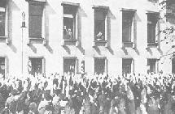
Delegation from the Saar in front of the Imperial Chancellery.

He was the conscience of the nation; from him came the cry of

suffering and also of defiance of an oppressed Folk; in him the will to live of the whole of Germany at the hour of its greatest humiliation became word and deed. Adolf Hitler never once uttered a single word than those which the Folk thought in the depths of their souls, never once committed an act than those which the entire country would have wanted. He was never, is and will never be a dictator who imposes his personal opinions and his desire for power on the Folk. He is really only a leader, which is the greatest thing that can be said of a man. This is why he is so beloved by the Folk, this is why he is so trusted, this is why his Folk are so unspeakably happy. For the first time in its history the German Folk have become themselves.

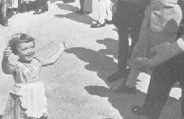
She wants the hand of The Leader.

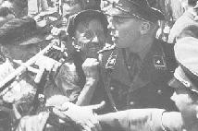
Everyone wants to shake The Leader's hand just once.

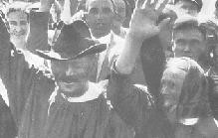
Even the peasants believe in The Leader.

Herein lies the secret of the indestructibility of Adolf Hitler and of his work, the assurance of the irrevocability of the path he has adopted, because he is no longer the man Adolf Hitler, it is no longer his work, no longer his path, but it is the German Folk themselves who express themself through him. In him the Germans love themselves, in him they follow their most secret wishes, in him their boldest thoughts become reality. Every single person feels this, and for that reason Adolf Hitler is a stranger to no one and no one is a stranger to The Leader. Workers and peasants, Nobel Prize winners and artists, soldiers and dreamers, the happy and the desperate, speak to him, and everyone hears his own language, understands and is understood. Everything is done without design and in a completely natural way, and no one stands in awe of the great man. No one is ordered about, no one is courted, but everyone is called on as he was called on by his own conscience, and he can do nothing but follow if he does not want to feel guilty and unhappy in his own mind. So what must happen happens of its own will, and no Folk on Earth are freer than the German Folk.

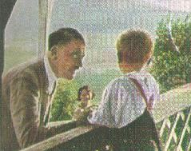
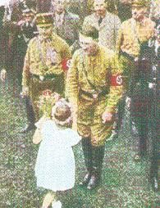
The Leader's eyes -- Father's eyes.

Thus the German Folk do not tire of listening to the words of The Leader, and if the party conference of the Reich in Nürnberg were to last twice as long, the Folk would still stand there on the last day as they did on the first and listen. He could drive through Germany continually, the Folk would wait day after day beside the road as they did on the first day and cheer him on, bringing him their children so that he could gaze at Germany's future. If they had to, they would also give him their lives as hundreds of his Party members did in the years of fighting.
There have been emperors and kings, sovereigns and folk heroes, upsurgers and men of terror, clever and great rulers at the head of nations, but never before has there been a man like The Leader. This is unique and is the great fortune which has been given to the German Folk. As long as one does not appreciate this, one cannot appreciate anything about the German Folk, one cannot understand why their eyes light up, their voices cheer, their arms fly up, their hearts beat faster when Adolf Hitler appears before the German Folk. And from these external signs which show the constant and mysterious attachment between the people and The Leader, Hitler again draws strength for new works, just as the Folk draw strength from his sight.
This is seen particularly when the youth of Germany and The Leader come face to face, and whoever has spent some time with The Leader and been able to accompany him in these days, weeks and months, will have a store of unforgettable pictures.
Between Stettin and Pasewalk, a distance of at least ten kilometres, young Germans had taken up their positions in the middle of the country road in the rain and storm, because they had heard from someone somewhere that The Leader would pass this way today. Evening was falling, and when The Leader's car with its two escort cars roared along the road, far ahead in the distance between the trees lining the road, a crowd could be seen. As the cars drew nearer a throng of flagwaving children came into view. They were burning red, blue and green Bengal matches, and a number of children were standing guard before the bulk of the group to indicate by their waving hands that the convoy was to stop. Even though time was incredibly short, The Leader still gave the order to stop, and at that moment the cars were surrounded by about a hundred children who jumped not only onto the running boards but even crept onto the radiators and bonnets in an attempt to catch a glimpse of The Leader inside the car through the windscreens.

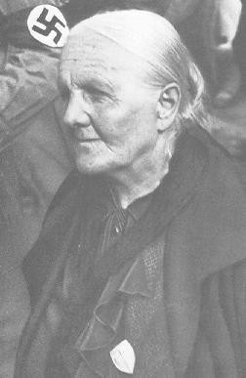
Old people trust The Leader.

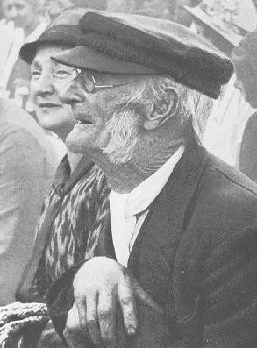
A photograph of the election campaign in Hessen in 1932.

After the three cars in the convoy had been thoroughly inspected in this way, a particularly resourceful lad finally caught sight of The Leader. He screamed at the top of his voice: He's here, everyone over here! -- and then everything happened. The escort command had to step in because a number of boys were even trying to climb onto the swaying canvas hood of the car. The Leader of the young Troop, the same young boy who had discovered The Leader, held a short speech, young, fresh and carefree, and then everyone made way for a young girl dressed in white. The girl curtsied deeply and then recited a poem she had composed herself about the joy young people had in seeing The Leader. When she finished the child handed Adolf Hitler a small basket of rosy red apples.
Deeply moved, The Leader stroked her blond hair, upon which the child suddenly burst into tears of overflowing joy and happiness. Slowly the convoy then moved away from the host of children, and for a long time the flag waving little figures could be seen through the rear windows of the cars bidding their farewells.
At every rally it is always the children who stand in the front rows.

The well behaved and unassuming ones stand there just as their teacher or Troop Leader has placed them, in straight rows and not moving from their spots. The more bold ones among them, however, hang in the trees, sit on memorials and the ledges of buildings, or stand like an avenue of living statues on top of tall factory walls, perch on flag poles and lantern poles, and, wherever The Leader passes, fill the air with their endless cries of joy. The favourite places where children await The Leader have always been sharp bends in the road. By their clever positioning they render these bends even sharper and force the cars to drive as slowly as possible. Better still if one comes upon a construction site somewhere on a country road. Here it is quite certain that The Leader will only be able to proceed at a very slow pace, and the opportunity to capture him will definitely present itself. It then inevitably becomes a real effort to extricate oneself from the crowd. When finally a path opens up in front of the cars, the children will run from behind the car only to block the way again with their joyous cheers.
Once in a town in the south of Germany, on the evening of a rally for The Leader, tens of thousands of Hitler Youth formed a guard of honour in the streets. The further the line extended, the tighter the two walls of the guard of honour were pushed together, so that, finally, there remained just enough room for the car to squeeze through. At first everything went well. Suddenly, however, there was much running, pushing and shoving, and while initially the torchlight bearers standing in the front row managed to contain the crowd, they were suddenly carried along and pushed towards the cars. Their torches shone into the insides of the cars, and in their enthusiasm and love, they gave The Leader and his entourage a heavy portion of smoke to inhale. It was fortunate that they did not set fire to the cars themselves. Only after a quarter of an hour did The Leader succeed in extricating himself again from this enthusiastic crowd of young people.
It is amusing to see the seriousness and eagerness with which the young people endeavour to photograph The Leader. They stand there with their tiny cameras, shaking with nervousness and excitement, their finger on the button. From the sight of these cameras you would think that it would only be sheer luck if a photo were to succeed. And yet it is just among these snapshots that you find a surprisingly large number of good photos. Here also luck seems to be on the side of the young people, because, on the other hand, experienced amateur photographers often complain that it is impossible for them to seize a favourable opportunity in the general excitement and massive crowds of people.

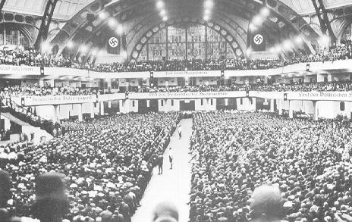
Elections in Frankfurt, 1932.

On a trip through Upper Silesia, The Leader is greeted and a young girl has the honour of presenting him with a bouquet of flowers. She is also supposed to say a little poem as she hands him the flowers. She recites the first line without faltering, but then loses the thread due to her excitement. After looking around helplessly several times, she suddenly takes the flowers and, standing on the tips of her toes, she reaches towards The Leader, presses the flowers into his hands, and says: Herr Hitler, here you are, I've forgotten everything!, whereupon she runs away.
There is a street. It is closed off, and people are standing closely packed together. They are waiting and waiting. Many have been waiting for hours. They are waiting for The Leader. They want to see him. Everyone wants to see him -- men, women, boys and girls. It is like a holiday today, says an old woman, and she is right, because The Leader is coming to this little town for the first time.
From the roofs and gables of the houses flags are waving and garlands have been stretched above the streets. The whole town has put on its festive dress. And then The Leader arrives ..... A whirlwind seems to rush through the crowd. Here and there the orderly rows begin to bulge, the people push and jostle each other, arms are raised towards The Leader, laughter and sobs are heard, all expressions of the joy and enthusiasm these people have for their Leader. The women lift their children onto their arms, and their little arms jut out above the heads of the crowds. Their eyes beaming and their lips smiling, they add their voices to the enthusiastic Heil Hitlers! of the crowd.
The women and mothers gaze at The Leader, trust and belief in their

eyes. They know that it is only him whom they have to thank for the fact that their unemployed men have found work again, and can feed their families. Life once again has a purpose, and without fear and worrying they can once again look towards the future.
There is a letter which a young girl doing her year's service in the country wrote to her parents: ..... I must start to write another page. I am sure that what I am about to write to you now will make you very happy. Can you believe it, my dear parents, I have seen The Leader! Just imagine, The Leader!!
.....

What emotion was conveyed by these four words: Just imagine, The Leader! The pride in her experience and the immensity of the love of this child of the German Folk for her Leader are astonishing! It is the fulfilment of a wish which this child probably never had the courage to harbour. It is a genuine present of fate which in the middle of her year of country service afforded her the most beautiful thing there is -- a meeting with The Leader. Just imagine what that means !

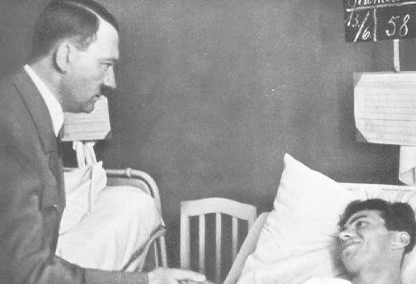
A visit to the victims of Reinsdorf.

And it is like this everywhere, in Bavaria and in East Prussia, in Silesia and in the Rhineland.
On a country road in the Palatinate two men from the Labour Service are marching towards the next town. The Labour Service camp lies a long way

off in the country, and it is a long way to the railway station. But the two men are in high spirits and are whistling, because they are going home on holidays after months of healthy and strenuous work. They whistle: In the Homeland, in the Homeland ..... Just then a line of cars sweeps past the two men. They're lucky, one of them says. They'll be there sooner than we will, the other says.
They're waving! both call out together. And then, in fact, the line of cars comes to a halt and waits until the two men, who have begun to run, have caught up. Where from? Where to? Climb in! The two men open their eyes wide in amazement, because the man stopping in the middle of the country road and inviting them to climb in is none other than The Leader. He makes them describe for him their lives, and asks to know in great detail what it is like in their labour camp. In no time they arrive at the little town. The cars stop. As they leave The Leader asks one of the two men: It is about to rain. Don't you have a coat with you?
I have no civilian coat, my Leader. I was unemployed for a long time.
On hearing this, The Leader takes off his grey travelling coat and hangs it on the shoulders of his fellow countryman. And before the latter can utter a work of thanks, the line of cars is already speeding away.
Somewhere a group of young workers in a large factory have lined up for roll call. The Leader inspects the rows, and looks deeply into the eyes of each of the young men. He turns to one of the young workers: Are you a member of the Party? -- No! -- Are you one of the SA? -- No, I belong to the workers. -- Where were you before? the Leader asks after a short interval. The blond young man lowers his head, and then raises it and says, haltingly: I was a young Communist, my Leader! He is obviously finding it difficult to speak. All eyes are turned towards him. An embarrassing moment. Then The Leader takes the young man's hand, presses it, and says, smiling: But today you are all with me, my young man. And, blushing deeply, the young man replies: In the name of God, you can be sure of that, my Leader!
In this way, picture is heaped upon picture of the solidarity of every individual of the German Folk with Adolf Hitler.
In Hamburg on the occasion of The Leader's rally on the eve of a decisive public opinion poll, a seriously disabled exserviceman pushes his way with his son through the safety chains which sealed off the access to The Leader's quarters with the words: I want to serenade The Leader. The SS men let the man pass, and he took up his position on the street under The Leader's window. With trembling fingers he removed his instrument from his grey cloak and played a song. The crowd of many thousands maintained a reverent silence. Plaintively the tunes of the street musician sought out the ear of The Leader. And The Leader heard the music. The Leader had the man come to him, spoke with him, and listened to the story of his life. I have been unemployed for four years now, the disabled man's concluding words were. My Leader, can't you help me find a livelihood again? The Leader waved to one of his Adjutants. Two rapid telephone calls ensued, and then The Leader said: Report tomorrow to this place. You can start work there immediately. In a flash the news spread amongst the waiting crowd. A seemingly unending, stormy ovation roared up to

The Leader by way of thanks.
Unforgettable also is the day when The Leader appeared at the funeral of the victims of the explosion catastrophe in Reinsdorf. The coffins of the fallen work heroes stood in long rows. The flags were flying at half mast, decked in dark crepe. The mourners stood by in silence. In one particular area the next of kin of the dead men had gathered together. It was a picture of boundless sorrow to see the weeping mothers, sisters, brothers and fathers.
Then The Leader appeared, and the funeral oration began. The suffering of the relatives was heartbreaking. The orators and ministers spoke, the Song Of The Good Comrade was heard, and the final salutes boomed over the field. Then The Leader left his entourage and walked unaccompanied over to the relatives. Hundreds of arms reached out towards him seeking comfort, and all those who were present will always remember the anguished face of The Leader as he now stood in the midst of this deeply sorrowful gathering. Then he began to speak to or silently take the hands of the men and women in turn. The circle around him grew tighter and tighter. Tears died up and people who had broken down in their sorrow straightened up again. Now The Leader took the head of an inconsolable old woman who had lost her son in his comforting hands, now he helped up with a few kindly words a deathly pale Hitler Youth whose father was one of the fallen. So strong was the comfort which The Leader gave to the mourners, because they were not alone in their sorrow. When the relatives then raised their arms in farewell and thanked Adolf Hitler once again silently, The Leader and his Folk were so infinitely close, even in this hour of deepest distress.

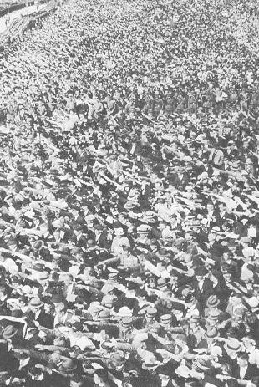
Saar Rally on the Ehrenbreitstein in August, 1934.

The Leader and the German Folk ..... Once there was a rally in the Festival Hall in Frankfurt, and while The Leader was addressing the thousands inside, a woman stole her way to his car and placed a tiny bunch of lily of the valley -- it was mid winter -- on the seat in which, in her estimation, The Leader would sit after the rally. When the line of cars sped off after the conclusion of the gathering, a clear, penetrating voice was heard above the roaring cheers: The lily of the valley is from me!
Hundreds and thousands of such moving and humorous, stirring and amusing stories could still be told. All of them, however, say only the one thing, namely, that a miracle has occurred, such as happens to a Folk only once in its history, that here The Leader and his Folk are one and the same, and that the love which binds the Folk with their Leader is so great, so spontaneous, so self evident and joyous, that it breaks forth at every minute in renewed form, but always with the same intensity.

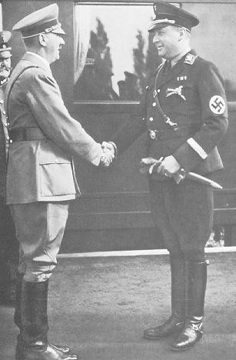
Minister Darré greets The Leader on the occasion of the Harvest Festival.

The Leader As An Orator -- By Dr. Joseph Göbbels

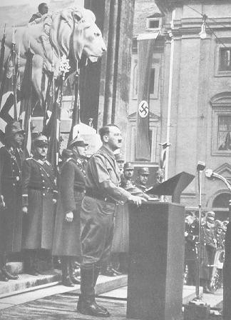
9th November, 1934, in München. In front of the Feldherrnhalle Hitler speaks
to members of the Hitler Youth and the League Of German Girls who have just been admitted into the Party.

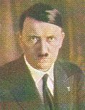
Adolf Hitler

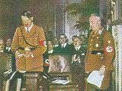
Congress of the German Labour Front.

There are two types of orators which differ fundamentally and essentially: those who speak from the head or the intellect, and those who speak from the heart. Accordingly they also turn to two types of people: those who listen with their intellect, and those who listen with their heart. Orators of the intellect are generally produced by the parliament; orators of the heart are born of the Folk.
For the orator of the intellect, it is imperative that he have at his disposal a wealth of statistics and knowledge. If he is to speak effectively, he must master dialectics as the pianist masters the keyboard. With the icy coldness of a relentlessly developed logic, he orders his chain of thoughts, and draws from them his inevitable conclusions. He is effective mainly with people who are accustomed to working principally or exclusively with their intellect.
Great, rousing successes are denied him. He is unable to stir the masses to the depths of their souls, nor can he rouse them to achieve great and monumental goals. He remains limited to the purely didactic.

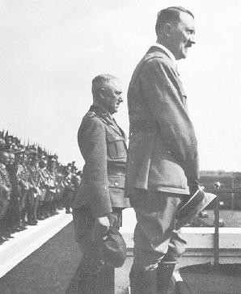
The Leader with Reich Labour Leader Hierl addressing 47000 workers at the Reich Party Day in 1935.

As he himself is cold, so he leaves those around him cold. At best he is able to sway people, but he can never rouse the masses and mobilise them, regardless of their own advantage or even to the acceptance of death and danger.

It is different with the orator who speaks from the heart. That is not to say that he has no control over the skills of which the orator of the intellect is the master. Frequently they serve him only as tools which he, as a true virtuoso of rhetoric, uses at his discretion. In addition to this, however, he has other capabilities which the intellectual orator can never hope to attain: the clarity of his diction combines with the seemingly natural simplicity of his train of thoughts; he divines instinctively what must be said and how it must be said. He unites the greatness of the poetic spectacle with the monumental nature of the ideas he expounds. He knows the most secret hopes and aspirations of the soul of the masses, and knows how to reveal and stir them as if by a masterstroke. His speeches are masterpieces of declamation. In a far reaching epic form, he portrays people and circumstances; with a sharp stylus, he engraves his theories on the slates of time; with elevated and noble emotion, the looming pillars of his philosophy tower over his chain of thoughts. Just as his voice speaks from the depths of his being, so does it penetrate deep into

the listener's being. It causes the most secret strings of the human soul to resound. It stirs the indolent and the lazy, it rouses the halfhearted and the doubtful; cowards it turns into men, and weaklings into heroes.
Such words are only rarely heard by history. However, once they penetrate a lethargic period with their omnipotence, then people and circumstances are orientated anew by them.
These rhetoric geniuses are the drum beaters of destiny. They begin as loners in degenerate and crumbling periods of history, and suddenly and unexpectedly stand in the middle of the brightest spotlights of a new evolution. These are orators who shape the history of a Folk.
Like every great man, the orator of renown also has his own style. He can only speak as he is. His words are an integral part of him. Whether on an appeal, on a poster, in a letter, or in an essay, during an address or during a speech, he speaks the language which corresponds to his nature and his manner.

There are numerous examples in history which demonstrate perfectly that eminent orators resemble each other only in greatness of their desired effect. The manner of their call to the Folk and their appeal to the hearts, on the other hand, is always essentially different and varies according to the time, the nation, and the character of the era. Caesar spoke differently to his legions than Frederick The Great to his infantrymen, and Napoleon spoke differently to his guards than Bismarck to the representatives of the Prussian State Parliament. And yet each of them used the language which the people they were dealing with understood, and used words and thoughts which kindled enthusiasm in their minds and met with a response in their hearts. They gave a concrete expression to the deepest and most puzzling demon of their time, and, in so doing, have been handed down in history as the harbingers of the great ideas of the time who made history and formed the lives of Folk.
It also seems as if different races vary in their disposition to the powers of oratory, as if there are people whose talents are not suited to this rousing art, and then again others who seem almost destined for it. It is not in vain that one speaks of a Latin eloquence. The plentitude of indifferent and important talents, as far as rhetoric is concerned, in the Romans gives this a certain justification. And it is also probably true to add that these talents for rhetoric were directed at a public which understood it, fostered it, and gave orators the greatest possible opportunities to exercise their talents.

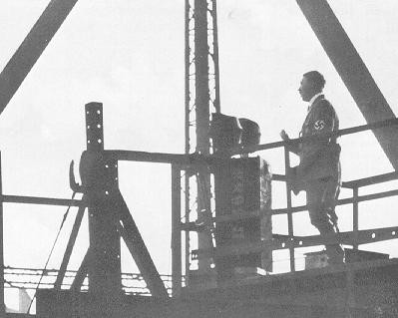
Speech to the staff of Blohm & Voss.

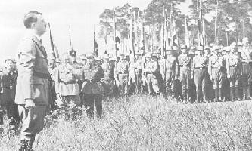
Taking over the Reich Leaders School in Bernau in 1933.

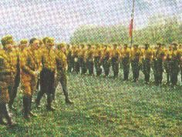
The Leader reviews the Motorised Troops.

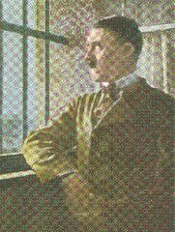
Adolf Hitler in the Landsberg Fortress.

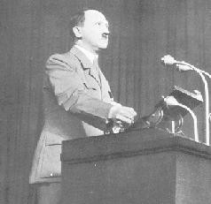
The Leader in the election campaign for Germany's freedom. March, 1936.

As far as oratory is concerned, the German Folk have not been served well in the past. They have brought forth in abundance statesmen and soldiers, musicians and poets, architects and engineers, expert planners and organisers. But there has always been a shortage of great rhetoric talents. Since Fichte addressed the German Nation with his classical speeches, there has been no one who stirred the hearts of the Folk, until Bismarck's call to his time. When Bismarck left the rostrum, it remained empty of real talent, until a new harbinger of the Folk's suffering arouse out of the collapse after the Great War. What existed between these times was at best mediocre, sufficing the daily business of Parliament and sittings of the board, but meeting only with an icy reserve as far as the Folk, who should have been deeply roused, were concerned.
This may have been a product of the times themselves. There were no great ideas and no idealistic projects; times were barren and sated. The only illusory revolt at the time, Marxism, was secretly aligned to the time, and its supporters were representatives of materialism, which has never ignited the spark of true geniuses.
Revolutions, however, give birth to true orators, and true orators give rise to revolutions. In the course of a revolution, one must not overestimate the written or printed word; it is the spoken word which arouses the hearts and minds of people with the secret magic of its immediate effect. People perceive with their eyes and ears, and the infectious force of the masses who are gripped by the sound of the human voice carries along irresistibly in its spell those who are still wavering and doubting.
Where would the statesman of genius, who has sown the seeds of a higher and unfathomable destiny, be if he did not have at his disposal the strength of speech and the explosive power of words! It gives him the possibility to make ideas from ideals, and reality from ideas. With its help he

gathers around his flag people who are prepared to fight for it; driven by it, men risk their lives and livelihood to lead a new world to victory. From the propaganda of the word, organisations are formed, from the organisation the movement develops, and the movement conquers the State. It is not a question of whether the ideas are correct; what is crucial is that they are correctly presented to the masses, and that the masses themselves become their propagators. Theories will always remain theories if men do not carry them out. In times of turmoil, however, men obey only one appeal which ignites in their hearts, because it comes from the heart.

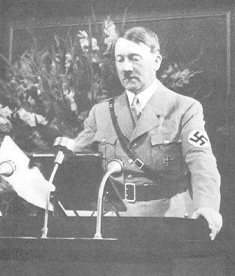
The Leader opens the Reich Party Day Of Freedom (1935) in the historic Town
Hall auditorium in Nürnberg.

It is difficult to classify The Leader in this series. His skill in moulding the masses is so amazing and unique that no pattern or dogma can be superimposed upon it. It would be absurd to think that he had ever attended a school for oratory or speech; he is a genius of rhetoric. His rhetoric is unique to him, and has never been influenced by anyone else. One could never imagine that The Leader had ever spoken differently than he now speaks, or that he will ever speak differently. He says what comes from his heart, and his words therefore go straight to the heart of his listeners. He possesses the remarkable gift of instinctively sensing what is in the air. He has the ability of expressing it

so clearly, logically, and unreservedly, that the listener comes to believe that what is being expounded has always been his own opinion. This is the actual secret of the magical effect of a Hitler speech. For The Leader is neither exclusively a speaker from the intellect nor from the heart. He speaks from both according to the demands of the hour at hand. The essential characteristics of his speeches to the Folk are: clarity of structure, a relentlessly logical development of his chain of thoughts, simplicity and general intelligibility of expression, razor sharp dialectics, a marked and never deceptive instinct for the masses and their feelings, a fascinating emotionalism which is used with the utmost economy, and the power of being able to appeal to the soul and generating an immediate response.

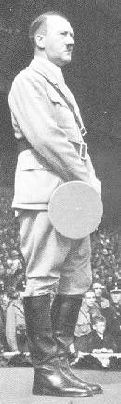
The orator .....

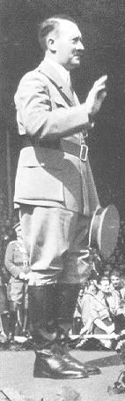
..... Adolf Hitler .....

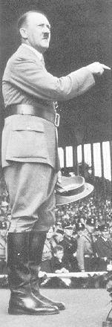
..... in front of the Youth .....

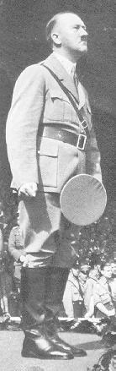
..... Reich Party Day 1935

Once, many years ago, when The Leader was still a long way from power, he spoke to a gathering which consisted largely of political opponents. In the beginning he was therefore met with only icy rejection. In a two hour match with the unruliness of his audience, he lay aside all their objections and arguments. In the end he was speaking to a sea of people shouting to the furthermost row: Hitler is our Columbus!
This summarises the essence of Hitler's speech. Hitler had managed to inspire the Folk. The times and the longings of the Folk were confused and secretive, but he had clarified them and wrested from them their secrets. He showed them again to his listeners clearly and simply, in such a way as the man on the street had long perceived them, but had never before had the courage to express them. Hitler said what everyone thought and felt! More than that: he had the courage of his convictions against the opposition of almost everyone present to draw a moral and to make demands with an iron logic which arose from the needs of the time.

The Leader is the first person in the evolution of Germany who used language as a tool to fashion history. When he started, he had nothing else. He began with only the strength of his mighty heart and the power of his mere words. With both he reached deeply into the souls of the Folk. He did not recognise the needs and worries which oppressed the little man and speak about them; but for him they were only a mere depiction; he was not a tendentious describer of the existing conditions like the others. He situated the difficulties of the day in their general national sense, and gave them a meaning which reached further than the actual day. He appealed not to the bad, but to the good instincts of the masses. His speech was a magnet which drew the blood and iron that still existed in the Folk to it.
Stupid and arrogant bourgeois blockheads delighted for some time in saying that he was only beating his own drum. They were making fun of themselves, and did not know why. Because they themselves were so completely lacking in the power of oratory, they saw in it a lesser form of statesmanship. They were only after power, without fully understanding that Marxism had taken the power from them by force, and would only ever return it to them by force. They formed conventions in which a Folk's movement was forced to march up. They tried their hand at coups where a revolution was in the air. They displayed contempt for the masses because they were unable to control the masses. For the masses surrender only to a man who can take them under his inexorable command. They obey only when someone understands how to give them orders. Their instincts are too acute not to be able to distinguish whether something is really meant, or merely said.
This is perhaps the classic proof of the inner purity of the German Folk. They lent their ear to the appeal of a man who had only himself and his words to challenge the State and the society, the press and public opinion, and all that seemed sensible and useful. And this is also, on the other hand, the classic proof of the rhetoric genius of The Leader which towers above all times. His word alone caused a whole era to totter, a seemingly established State to collapse, and a new era to dawn.

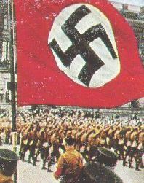
Courtyard of Braunschweig Castle, 1931.

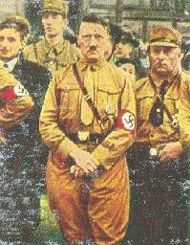
Braunschweig, 1931.

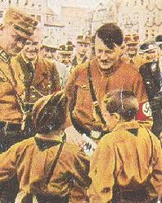
Germany's youth.

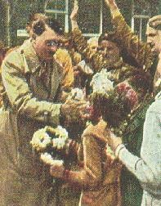
Flowers for The Leader.

A historical orator who triggers off such an effect must have at his disposal all the possibilities of the spoken word. And such is the case with The Leader. He speaks to workers just as naturally and supremely well as he does to scientists. His words penetrate just as deeply into the hearts of the farmers as the city dwellers. When he speaks with children, they feel deeply touched by his words. When he speaks with men, the magic of his voice stirs their most secret feelings. His speeches are the philosophy of history translated into the

language of the Folk. He has the gift of calling forth long forgotten great historical epochs from the past and presenting them in such a way that they seem well known even to those who had never known them or heard about them. His speeches are totally devoid of the provocative tone of oneupmanship which usually characterises the so called speeches of scholarly men.
Again and again his words revolve around the central thought of the Folk and developing nation of our race. His wording to express this is without measure. The listener never has the feeling that he has heard it all before. The people are continually impressed anew and in ever changing ways with the great and fundamental thought of our national rebirth. At the same time this type of rhetoric is devoid of anything doctrinaire. If a fact sounds initially like an assertion, it is inevitably verified in the course of his explanation by an inexhaustible abundance of examples. These examples are not taken from one particular section of the population and society, with the result that other sections remain unconvinced of their power of proof. They all come from the knowledge that this speaker, contrary to all the parliamentary charlatans, believes what he says.
In his speeches the mundane side of life comes alive and holds the listener captive. Here the sufferings of the day are tackled not only with the heavy handed tools of philosophy, but with wit and the sting of irony. Here humour manifests both tears and laughter and celebrates its triumphs. Here a note is struck which also resounds through the sorrows and worries of everyday life.
An unmistakable sign that a speech meets the highest standards is the fact that it not only sounds good, but also reads well. The speeches of The Leader are stylistic masterpieces, whether they be totally impromptu, or developed along the lines of a few brief keywords, or read from carefully formulated notes on the occasion of an important international gathering.
Those not in his immediate vicinity can scarcely distinguish whether the written speech is being made freely, or whether the speech being made freely is the result of a carefully worded written speech, because both are polished speeches in the best sense of the word. This picture would not be complete it if were not mentioned that The Leader is an outstanding creator and master of public debate. The last time a large section of the general public had the opportunity of seeing him as such was during his clash with the Social Democrats at the Reich Parliament of 1933, when he responded to a clumsy and insolent complaint made by Wels, a member of the Reich Parliament at the time. People had the feeling that a game of cat and mouse was taking place.
Marxism was driven from one corner to another, and where it hoped for mercy, it was met only with annihilation. With an almost breathtaking precision, his rhetorical lashes pelted Wels. Without the aid of a script or any hastily sketched keywords, The Leader held his great, long awaited reckoning with those Social Democrats who were old hands in Parliament and who now received the coup de grace. How often before had he pushed them into a corner in his meeting whenever they dared to approach him.
At that time they still had the opportunity of falsely reporting

humiliating defeat as triumphant victories in their newspapers. Now, before the eyes of all the Folk, they succumbed to his power and were threatened with complete defeat.
All those judges and public prosecutors who had wanted to take Hitler for a ride, when he appeared as a witness or a defendant, with their seemingly naive and harmless questions or stupid and dull comments, have a tale or two to tell about this relentless, rhetoric mind on the offensive. A triumphant victory for the defendants arose from the People's Court Trial of 1924 which was supposed to resolve judicially the uprising of the 8th and 9th of November 1923, because The Leader countered the mountains of lies, malice and lack of understanding with the radiant strength of his open truthfulness and the compelling effect of his forceful eloquence. And it is not without regret that the Republic took note of the Army Trial in Leipzig in 1930, which was supposed to destroy The Leader and his Movement, but which in reality served as a springboard for his rhetorical effectiveness which spread into the rest of the world. One can only recall with horror the fact that a Jewish Communist lawyer could once call him as a witness before a Berlin court and bombard him with questions for nine hours without a break, and note with proud satisfaction that here Jewish Bolshevism was opposed by a man who relentlessly cut him short with the power of his oratory and did not desist until he lay overwhelmed on the floor.
We saw and experienced The Leader as an orator in the Party Day Of Freedom in 1935. He spoke to the masses fifteen times in the space of seven days. In doing so, not once did he repeat the same thought or use the same turns of phrase. Each time what he said sounded fresh, young, vital and insistent. He spoke differently to the office workers than to the SA and the SS, and he spoke differently to the youth than he did to the women. He, who in his great talk on culture, bared the most secret secrets of artistic creation, addressed himself in his speech to the Army to the last soldier in the last Batallion, and was understood by him. He has cast an arc under which the life of the whole German Folk takes place. He has become a messenger of the word, who approaches his manifold existence with the divine grace of language.
The Leader is at his very best as an orator when he speaks in a very small circle. Here he continually addresses himself to every single one of his listeners. This gives his talk the impression of a moving stream which continues without a moment's rest, and arouses in the listener the sort of interest which never wanes, because the listener continually feels he is being personally spoken to. It may be that he is speaking on a topic that has been raised purely by chance and to which he lends an expertise which strikes everyone and causes the specialist to marvel at his knowledge, or it may be that an everyday matter is mentioned incidentally by someone and is suddenly bestowed with fundamental universality.

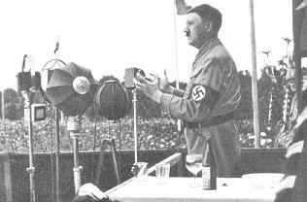
The Leader speaks to the German Folk.

Here The Leader touches on the heart of matters more intimately and in greater detail than his public speeches permit, in order to lay it bare with a relentless logic. Only someone who has heard him speaking face to face like this can grasp the immensity of his rhetoric genius.
Of his speeches to his Folk and to the world, one can in fact say that they are words which strike an audience such as history has never before seen. They are also words which ignite in the heart and which continue to have a lasting effect on the formation of a new international epoch. There is probably scarcely one man today in the whole of the civilised world who has not once heard the sound of his voice, whether he understood his words or not, and in whose heart of hearts the magic of his voice has not met with a response. Our Folk can consider themselves lucky to know that there is a voice above them to which the world listens, a voice which is blessed with the ability of turning words into thoughts, and setting an era into motion with these thoughts. This man belongs to those people who have the courage of saying yes and no without subsequently modifying what they have said by an if or a but. In a situation where, in every country of the world, millions and millions of people have been hit by bitter suffering, grave afflictions, and terrible sorrow, in which there is hardly one star in the dark clouds that hang over the skies of Europe, in which people are filled and driven by dulled longings which they lack the gift and grace of expressing, he stands over Germany as one amongst the uncounted millions silent in their torture to whom God has given the ability to say what we suffer!

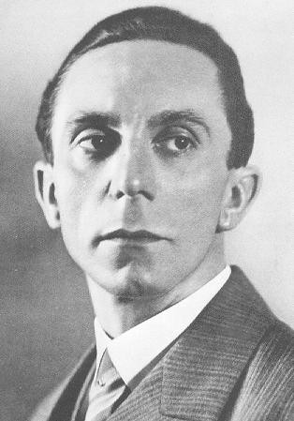
Dr Göbbels.

The Leader In His Private Life -- By SS Higher Group Leader Wilhelm Bruckner

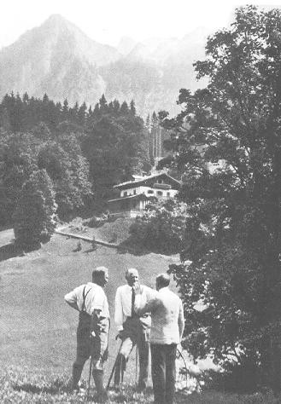
A walk on the Obersalzberg.

It goes without saying that a man who is as entrenched in his political work as The Leader must sacrifice his private life to his work. And if ever he wants to free himself from the pressures of his official duties, the problems associated with politics nevertheless follow him to the furthest corners of the German Homeland, whether it be a small, quiet village in the dunes near the Baltic Sea, or Wachenfeld House on the Obersalzberg. They pursue him not only in the form of telephone calls and telegrams, letters and files. He can never banish from his heart the constant political work, his

concern for Germany. It is with this concern uppermost in his mind that The Leader goes to bed late at night and awakes early in the morning. He is pursued by the difficulties concerning foreign affairs, the necessities of the new employment onslaught, difficulties in the domain of financial policy, necessities of assuring the wellbeing of the German Folk, problems of youth education, questions about German culture, decisions within the framework of the restoration of German military security, and so it goes unendingly. There is scarcely a conversation which does not lead immediately to the central political issues, scarcely an experience which does not at once recall important decisions. After all, everything in Germany begins with this man and ends with him. And if he seems to be relaxing for a few days in total seclusion, then he is probably only preparing himself for new and weighty decisions to be met, or for a new intensive work output. Indeed, even in his aeroplane he is met by radio telegrams from his Reich Leaders and Ministers.
Thus the private life of The Leader is merged with his public life and his work for Germany. If one wants to talk about his private life, all that can actually be said is that it consists of transferring his political work from the offices of the Chancellery to less official rooms.

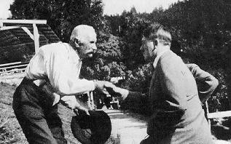
On the Obersalzberg. A neighbour greets The Leader.

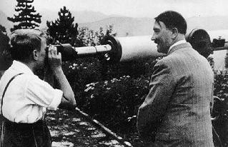
He is allowed to look through the telescope.

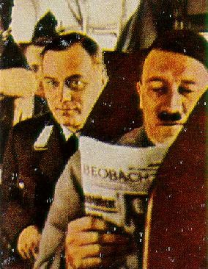
In an aeroplane.

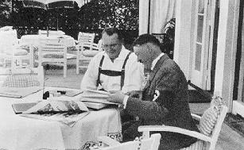
Prime Minister Göring at The Leader's house on the Obersalzberg.

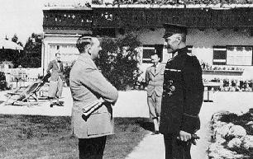
A comrade from the Front visits The Leader.

Despite all this he finds time to concern himself with all aspects of art and science. His favourite relaxation after a stressful day's work is to listen to an opera or a symphony concert. Only then is he completely removed from the pressing issues of the day, and many a great creative thought has arisen from his absorption in the powerful realm of music.
Even in the rooms of his official residence in the Chancellery, The Leader welcomes from time to time leading German artists who bring him the best creations of our time. On many occasions, after the artistic performances, the conversations about music and drama, poetry and novels, architecture and philosophy, continue on until late at night. There are few people who have not left his house stimulated and inspired after such an evening.

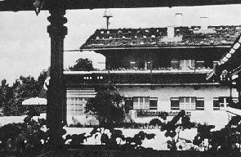
Wachenfeld House on the Obersalzberg near Berchtesgaden.

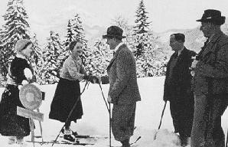
An encounter on the Obersalzberg.

Besides music, the theatre and architecture, The Leader is particularly interested in film, as it is the most recent branch of creative art. Film equipment in the Great Hall of the Chancellery enables The Leader to see what is being produced by Germany and the rest of the world, between the pressing issues of the day. From his own knowledge of matters, The Leader has also stimulated many film producers in their work.
Often The Leader invites to lunch visitors who have come to him for official talks, so that he can find the time to discuss with them in greater detail any issue which has come to his notice in the course of the talk. Thus there will frequently be at his luncheon table people from the most diverse work and interest groups, Officers and scientists, men from the world of business and the world of art, senior Party officials and old fighting companions from the War and the early days of the Movement. These people receive new information and inspiration not only from The Leader, but also from each other, in the course of their conversation.

The Leader likes to use his weekends to see for himself the morale of the Folk, and to inform himself about the progress in the reconstruction work, without taking part in an official tour. Then he drives throughout the Districts of Germany in the car he had come to love in the Time Of The Struggle, and at almost every spot some memory from the time of his rise to power comes alive. For his entourage it is always a renewing and deeply moving experience to witness the incredible love of the Folk with which The Leader is met on such journeys.

There are a number of places in Germany to which The Leader particularly likes to return for a short break. Above all, there is the house on the Obersalzberg which is known to all Germans, and which is so closely linked with the history of the Movement. On the Baltic Sea and the North Sea there are also a few places hidden among the dunes to which The Leader likes to go for a short rest, or to engage in important discussions.

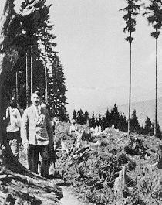
A walk in the mountains.

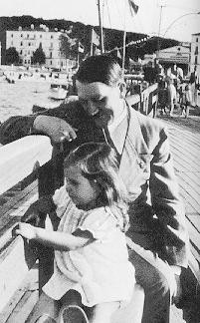
The Leader and little Helga Göbbels.

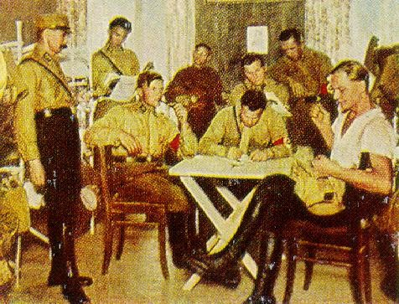
Off duty.

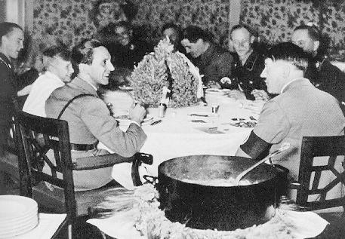
Stew, also served for the Chancellor Of The Reich.

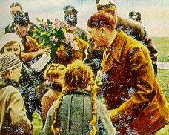
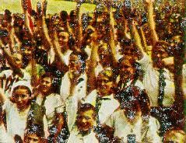
The Leader -- beloved of the children.

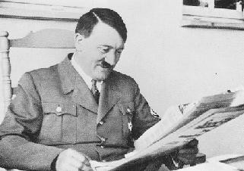
Good news.

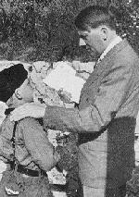
A Cub from the German Young Folk hands The Leader a letter from his sick
mother.

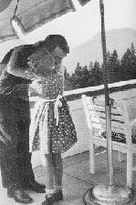
A little visitor to The Leader on the Obersalzberg.

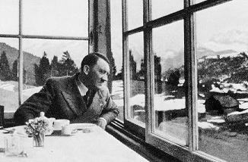
On the G'schwandner Alm, near Garnisch.

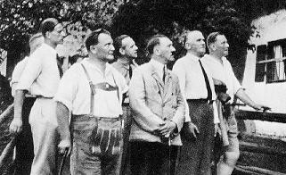
The Leader, during a summer vacation, in front of the Fruckerlehen near Berchtesgaden, where Dietrich Eckart lived for some time in 1923.

Walks through the beech forests at sunset on the shores of a lake have often offered him a measure of relaxation, and at the same time resulted in important political decisions. In the course of such walks, children approach The Leader freely, reach out to take his hand, chat with him, and relate to him all their minor experiences which are nevertheless so important to them.
Then it may happen that The Leader takes time off from his most important discourses to devote himself entirely to the joys and sufferings of such a child.
In the larger seaports, Navy personnel gather around The Leader, and their accounts from the War, reports of submarine forays, and the battles at Skagerrak enliven a short, relaxing evening. It is exactly like this in the small garrisons in the country where The Leader often speaks in an exciting and impressive manner about his wartime experiences on the Western Front.
Often when he is travelling, The Leader will stop at a particularly charming spot in the country for a picnic, whether it be on a bright sunny day in summer or a beautiful, warm moonlit night. It then often happens that fruit pickers and wood gatherers suddenly pass by and stop in amazement when they realise that it is The Leader they see here in a glade peeling an apple or eating a few sandwiches. He then waves to the hesitant onlookers, and invites them to share in his meal.
Many people wonder why The Leader has chosen the Obersalzberg of all places for his home. However, anyone who has ever stood up there realises that there is probably no other place in Germany which, despite the mountains all around, offers such a far reaching and unimpeded view of the beauty of the world. In a gap in the mountains to the north, at the foot of the Gaisberg, there nestles the old diocesan town of Salzburg. On days when the Alpine Wind is blowing, the castle and the little town can be seen with the naked eye. With the aid of a telescope, all the details of the buildings can be seen even without the Alpine Wind which brings everything closer. To the left of the Obersalzberg

there looms the massif of the Untersberg, whose changing colours evoke a different atmosphere every day. Still further to the left the eye then wanders over to the Watzmann and the giant mountains which surround it, and which finally appear to move closer in a wide arc and culminate in the Hoher Goll behind the Obersalzberg.

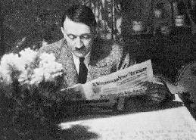
Evening on the Obersalzberg.

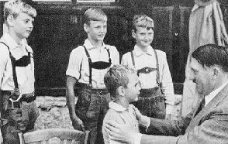
Four sturdy brothers.

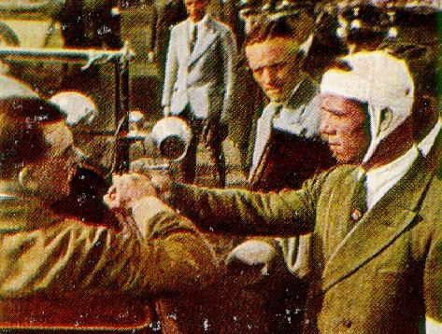
One of the faithful.

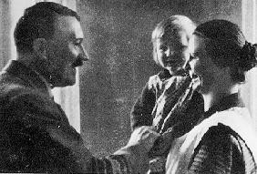
The joy of motherhood.

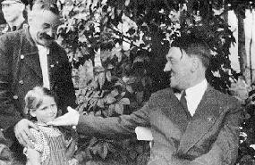
My Leader, may I present my grandchild.

No day is like another here. At times the mists build up in the morning and stage a desperate battle with the sun high above them until they are defeated and forced to rise from the valleys, only to float as light white clouds against the azure sky around noon. At other times the day commences bright and sunny, and every last detail of the landscape stands out sharply and clearly to the onlookers. The Alpine Wind descends warmly from the heights and fills the surrounding valleys with its mild, yearning atmosphere. At yet other times, rain and snowstorms lash the mountains, and the wind roars around the small, modest country house.

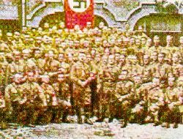
Hitler visits the Leadership School in München.

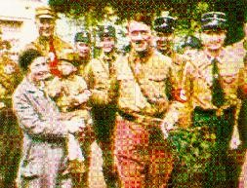
Hitler visits the townspeople.

Here, amidst the magnificence of nature, which is a symbol of the human condition, The Leader resides when he is preparing his great speeches, which have given a new impetus or a new direction not only to events in Germany, but also to the political happenings in the world. Here the crucial discussions take place before the laws and statutes which will decisively affect centuries to come take shape.
A German American of the Steuben Society grasped the meaning of this little country house during a visit to his old Homeland, and later expressed the following words: We Germans from America didn't recognise the new Germany. We knew only the old Germany and saw it again in the new country, when we visited the palaces and castles from times gone by. But now we have come to know this house, and in it we experience an obvious example of the contrast of the Germany created by Adolf Hitler to the old Germany. We also know now from what inexhaustible well he draws the material for his speeches.

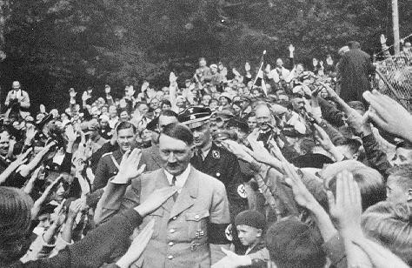
The Leader in front of his country house on the Obersalzberg.

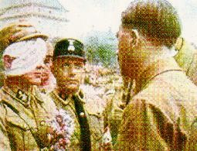
The Leader speaks to a wounded soldier.

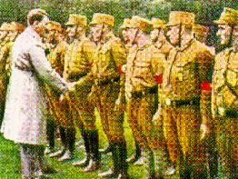
Old comrades.

And it is true that here, far from the confusing bustle of everyday life, and guided by the indestructible splendour of the landscape, his searching mind finds the right paths for his Folk and the Fatherland. But The Leader cannot enjoy the magnificent beauty of nature like a holiday maker who has left behind all his business cares. The moment he arrives on the Obersalzberg, he is met with an imposing number of letters and files, telegrams and telephone calls, and with each mail delivery, new piles of work arrive. Almost daily his Ministers and Reich Leaders telephone to ascertain The Leader's opinion on some important and pressing matter. Often they arrive in person at Berchtesgaden to talk with The Leader during his short period of relaxation.
Issues concerning Party matters, which had had to be postponed due to important political decisions in Berlin, are settled here, and many books of aesthetic and political literature, of domestic or foreign origin, which were waiting in vain to be read in the Chancellery, are studied by The Leader here in peace. His entourage has long since gone to sleep. There is a magnificent and deep stillness, and The Leader reads -- these are his most enjoyable hours. On the following morning, however, the telephone exchange reports dozens of appointments which have come in, files lie open expectant before him, and the mail mounts up. Indeed, this is the way it is: When The Leader is on the Obersalzberg for the purpose of relaxation, the post office and the exchange in Berchtesgaden have their busiest time. And even The Leader's entourage have more than their fair share of work, because thoughts arrive thick and fast, and decisions are made in rapid succession.
Before the communal breakfast, The Leader has already read the newspapers. He works through the papers himself rather than being presented with prepared excerpts. Then his Adjutants, Press Secretary and the remaining men from his entourage report briefly on what lies ahead for the day. Then everyone sits down for breakfast, and immediately afterwards he takes care of his appointments -- visitors, Reich Leaders, Ministers, close coworkers, and Party members. In the meantime the mail is prepared and then presented to The Leader, who sketches out brief answers or dictates them at once himself.
And so the morning passes rapidly.

Welcome guests on the Obersalzberg are always his old comrades in arms: Party Comrade Göring, Party Comrade Dr. Göbbels, the Reich Treasurer Schwarz, the Minister Adolf Wagner, and also the Reich War Minister and many others.

The busy morning is usually followed by a brief, or not so brief, midday walk, or a trip to the surrounding area. The Leader takes particular delight in hiking, summer and winter, to the Goll-Hausl, where once Dietrich Eckart lived, until death tore him from The Leader's side.

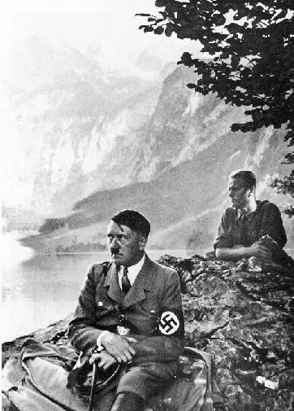
By the Obersee near Berchtesgaden.

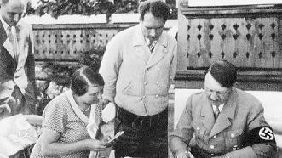
In the summer holidays on the Obersalzberg.

If the time is insufficient for an extended walk, and work must be continued straight after lunch, then at least one brief hour will often be found during the afternoon coffee break to walk over to the little mountain inn on the Hochlenzer, or to visit the house of Prime Minister Göring, if its host is present. Then Party Comrade Göring likes to extend an invitation to an archery contest, of which he is a master.
Often, however, The Leader has only a few brief moments in the day which he then spends in the garden of his house with his devoted Alsatian dogs, or lost in thought in winter watching the birds sitting at the many feeding troughs and enjoying the seeds The Leader has spread out for them in the morning. There is only one unshakeable daily occurrence. Every day hundreds and thousands of Party Comrades gather below on the drive to see The Leader at the midday hour. The Leader, who knows full well that they have all come to Berchtesgaden not only to see him, but to express to him the love of all the Folk, will allow nothing to deter him from granting their most ardent wish. Each time it is once again a most startling picture to see the joy which breaks forth when The Leader walks down amongst them. Manual workers and professional workers alike have gathered here from all over Germany, and every day it is like another pilgrimage. Every one of them, the old and the young, walk past The Leader. Their eyes light up, their hands rise in greeting, and many of them are so seized by emotion that they have tears in their eyes. From the rows of people walking past can be heard cries which announce from which part of Germany they have come: from East Prussia, from Schleswig, from Oldenburg, from Saxony, from Hamburg, and so forth. Young Cubs and League Of German Girls cannot be held back by the cordons. Quick as a flash, they rush up to The Leader, hand him their carefully prepared flowers, and are overjoyed when The Leader exchanges a few words with them. They are even more overjoyed when he invites a few of them to lunch or to afternoon coffee.
At mealtimes all his guests and coworkers sit harmoniously together, and often joyous laughter resounds through the room. These few moments are

spent in a relaxed and peaceful manner. Frequently architects and artists visit and present their new plans to The Leader. The Leader takes pleasure in all aspects of the reconstruction of culture, and discusses at length the plans brought to him. Dr. Todt, the Inspector General For The Reich Autobahns, will also always receive The Leader's full attention for his plans and photographs. The Leader's old comrades in arms from the time of the World War are also always welcome guests on the Obersalzberg.
If at times it seems that the work on the Obersalzberg will never come to an end, The Leader will then take a short, bracing walk to give him new vigour, and it is immaterial to him whether the hot summer sun is beating down, or crisp snow is covering the mountains, or rain is pelting down, or mists are obscuring the visibility. These walks are not always sheer pleasure for his entourage, who, in the cities, have grown out of the habit of mountain climbing. The Leader walks very quickly, and even fit people often find it difficult to keep pace with him. Consequently many Adjutants often have problems keeping up the tempo. While they are already exhausted and out of breath, The Leader continues briskly and effortlessly.
These days of relaxation are short, and most of the time they are shortened even further by unexpected events. But what is certain is that nowhere does The Leader find a lifestyle so suited to him as in the few days which he spends here on the mountain.
Just as in the course of thousands of years the mountains remain eternal, so will the work The Leader has begun here live on eternally in his Folk for thousands of years to come.

The Leader As A Statesman -- By Dr. Joseph Göbbels

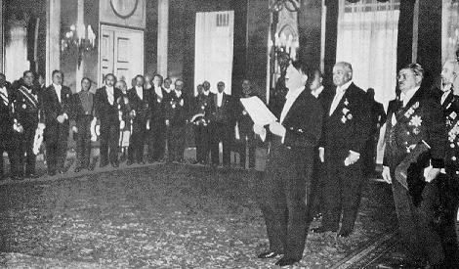
New Year's Reception for the Diplomatic Corps, 1934.

All human greatness has its origin in the blood. Instinct is its guide, and intuition its great saving grace. Intellect only ever contributes partially to the works of true genius; it is more concerned with checking the direction and meaning of these works, and revealing them later to the eye of the beholder. These laws apply above all to art, the highest and most noble activity of men, which brings men closer to their divine origin. They apply in the same way to the domain of great politics, which not in vain we call statesmanship, because such politics is in fact an art, as it has all the essential characteristics of artistic creation. The sculptor puts his hammer and chisel to the cumbersome stone to imbue it with divine breath: the raw marble becomes an artistic form. The painter uses the raw material of colour to recreate the noble picture of nature and reproduce it, as it were, a second time. The poet arranges the words of a basically formless language into a poem, a play, or an epic portrayal, in which he depicts the human passions of good and evil.
The statesman has the raw material of the masses at his disposal. With the strength of his word and his work, he moulds them into a living and breathing body of Folk; his brilliant plans show the Folk the goal of the nation. They are all created from the brilliant display which finally is an inspiration whose instrument the true artist considers himself to be. In addition, there exists in all these domains the craftsmen, who also must have their place, and whose duties and responsibilities are sharply delineated. They learn their work diligently and industriously, and, if they belong to the better men in their

occupation, acquire a wide and worthwhile knowledge of their craft, which they know how to use when required; but what they do remains an occupation and not a vocation. They are the talented in any artistic activity. The real artist, however, is a genius.
Herein lies the difference between talent and genius; talent creates from experience, from knowledge, and perhaps also from the imagination and the intellect; genius, on the other hand, from divine grace. Geniuses turn worlds upside down and erect new worlds. They are the great guides of Folks; the times align themselves to geniuses. They set the course history takes.
The saying that there is a child hidden inside every man applies particularly to the genius, because the genius acts from a childlike inhibitedness, and approaches things with the confident lack of self awareness with which children usually act.
The brilliant statesman dares the impossible to make what is possible possible. His actual strength lies in the simplification of seemingly irreconcilable differences. Before the average intellect has even seen or recognised the tasks waiting to be solved, the great leader has already come to grips with their solution.

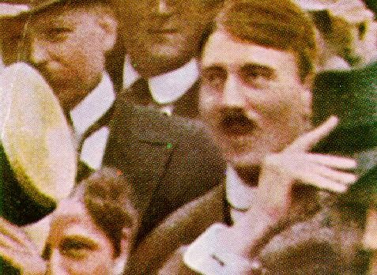
Adolf Hitler, 2nd August, 1914, in München.

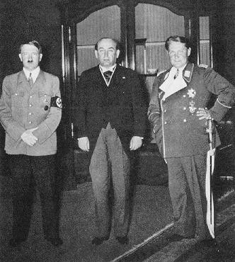
Visit to the Chancellery of the Reich (Prime Minister Gombos).

The problem urgently facing us Germans after the Great War consisted of shaping a uniformly thinking, feeling and acting Nation from the conglomeration of States, Parties, Organisations and individuals. This problem did not initially come to light in the War; but the fact that it had not been solved finally cost us the War. For many centuries Germany had been excluded from world politics because of its internal disunity. We Germans have indulged our inner differences of opinion, whether they were of a religious, economic or social nature, and suffered terribly accordingly, while other nations, who recognised sooner than we did their destiny in world politics, began to take over the world.
But it was not until the Great War that the continued impossibility of this situation was made clear. And yet, without learning from this terrible lesson, Germans did exactly the opposite of what history required of them.
Never had particularism of every kind raged in Germany as in the time when we needed to rely most strongly on our internal unity.
In the years after the War it seemed at times as if Germany were finally about to leave the great interplay of world powers and withdraw into provincial isolation. All the prerequisites for standardising the overall national

mode of thinking were lacking; indeed, the so called Weimar Constitution at the time, whose slurping beneficiaries were the parliamentary parties, represented to a certain extent the perpetuation of this internal disunity. The Government withdrew itself from this task, turning its vigilance more within Germany rather than outside Germany. Its goal consisted of preserving and conserving the small remainder of internal freedom of movement and external sovereignty which had been left to us.
For a brilliant statesman who appeared at this time, the first and most difficult test therefore consisted of recognising the fact that, within the Government itself, the restitution of the international standing of Germany was hopeless from the start, and as a result should not even be attempted. Because the Government itself has surrendered this international standing by signing the Versailles Treaty, and had even gone a step further by jealously watching over the preservation of this document, and considering any national movement against it as an attack on its own existence and punishing it accordingly.
The true statesman could therefore at that time not be found in the parties or the Government, but outside the Government. This Government had to fall to make possible the process of the moral, social and economic restitution of the German Folk and, associated with this, the consolidation of a true Government which would reflect his ideals. In the fight against the Government, it therefore became a question of forming a Government within the Government in which all the laws could then be put to the test as far as the practical and organisational side of things were concerned. These laws would then later become the fundamental laws of the new Government. The issue was not simply replacing the Weimar theory with a new theory, however well thought out and well meant it was. An association of men had to be gathered around the new theory to give this theory life, colour, and real substance. The idea against the Weimar non Government had at its centre the necessity of a Government, even in opposition, in the non Government, and of a Folk within the Folk who would embrace it. Only according to these principles could the process of the regeneration of the German Nation be put in motion.
Here began the statesmanlike work of The Leader.
To begin with, we must clarify a number of principal decisions which, in a certain measure, became the actual origins of his overall political actions. Already as an unknown corporal in the World War speaking in the turmoil of the Revolution to Bavarian garrisons, The Leader made a series of resolutions which point to the absolutely certain and sovereign instinct of the brilliant statesman, and which, through the very fact that at the time they were understood by scarcely anyone, later became the actual origin of his phenomenal and fantastic rise. They also provided the confirmation for the correctness of the world view which was taking shape in his head. It would have been easy for him to join one of the existing parties. The attraction there was a quiet and assured livelihood, and opportunities for promotion of all kinds. He could have soothed his tortured conscience with the notion that one had to save what could still be saved, and that therefore it seemed necessary

to choose the lesser evil. He did none of this. He refused to do it because none of the existing parties offered the guarantee, let alone the possibility, of overcoming the spirit within Germany, and yet, without the reunification of the Germans, a solution to the national German problem in the statesmanlike sense was out of the question altogether. Here already we see the instinctive sense of a gifted man who would rather take upon himself the seeming hopelessness of a desperate struggle starting with nothing against the Government, the power of money, the press, and the parties, than to burden the beginning of his work with a compromise.

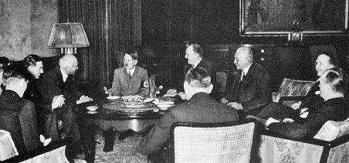
An historic meeting. Eden and Simon with The Leader.

It was the fashion of the time to go along with the Government.
There were two reasons for this: one was to identify with the Government, the other was to attempt to reform the Government from within. The Leader adhered to neither of the two, because he knew that this Government was wrong in its conception, and that it could not therefore be reformed, but rather had to be sidestepped, to enable the formation of a true Government. Later on, there were men and parties who, when they recognised, or professed to recognise, the impossibility of the reform of the Weimar system from within, began to take the lead in opposing the system from outside; but they had been burdened from the outset with the compromise of an albeit temporary peace treaty with the Weimar democracy. Only The Leader could refer his opposition from the first to the last days to the fact that he had never made a pact with the parliamentary regime, and therefore appeared to be the only one destined to give it its coup de grace in its final hour.
Parties and politicians at that time never spoke to the Folk as a nation; they only ever addressed individual parts of the nation. The worker parties spoke to the workers, the bourgeois parties to the middle classes, the denominational parties to their denominations, and the farmer parties to the farmers. To the casual observer in the first meetings of the National Socialist German Workers' Party in München, where The Leader addressed scarcely one

hundred people, it may at times have appeared grotesque that the call nevertheless was always to the nation. He spoke neither to the educated nor to the proletariat, and rejected buying the approval of the masses through cheap flattery. Today one must go back to these origins of the National Socialist Movement and the actual leadership of Adolf Hitler to understand the wonder of his statesmanlike show, which is already based in these origins. Because it is not time which has changed The Leader, but The Leader who has changed the times. What still seemed like a paradox at the time has today long since become self evident. And it became self evident not of itself, but due to the clear and uncompromising decision of a man and the tough and relentless struggle, until it had become established.

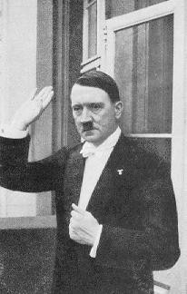
After the New Year's Diplomatic Reception in 1936.

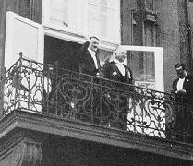
The Leader and the Reich Foreign Minister, von Neurath.

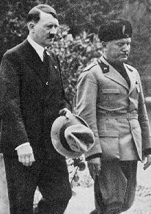
Adolf Hitler meets Mussolini in Venice in 1934.

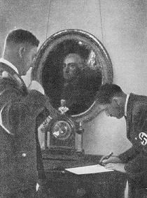
In the Chancellery: The Leader and his Chief Of Staff, Lutze.

It would have been a cheap trick at the time to make social claims which could be all the wilder the further The Leader and his Movement became removed from the realisation of the promises. It can also be admitted that for the first few years it would perhaps have been easier to recruit followers in this way. The Leader refused to do this. He created for his Movement a philosophical platform which, to a certain extent, became the major basis of his Party and his Government. The essential characteristic of this philosophy was the combination of the national principal and the socialist principal which, in an extremely simple and easily intelligible way, joined together on a higher plane the actual driving forces of the time which were locked in a bitter feud. The fact that nothing needed to be changed as far as the programme and the philosophy, the flag and the name of the National Socialist Movement were concerned when it came to power shows clearly how far seeing and statesmanlike the foundations of the National Socialist rise were laid from the very beginnings of the Party. The Leader had seen to it that no compromises were made. It combined the greatest irreconcilability, as far as principles were concerned, with the greatest flexibility as far as methods and actions were concerned. From the first day of its existence, it led a life and death struggle against parliamentarianism, until it destroyed it. It did not evade the terror of the Marxist parties with cautious and cowardly speeches, but pitched brute force against brute force. If its first bold attempt at an attempted uprising to conquer power from the 8th to the 9th of November in 1923 failed, later historians will have to investigate not only what was achieved by this, but also what was hindered by this. And we can already say today that their judgement will completely justify the action The Leader took. How do bourgeois politicians usually behave in times after unsuccessful coups? They either flee abroad, or claim that they have not taken part. Not so with The Leader! He stood before

his men, was the first among the accused, refused to step onto any golden bridge built by the court or the Government, offered no excuses, confessed openly that he had wanted to overthrow the Government, and that he would do it again whenever the opportunity presented itself. Thus he did what was obviously the most dangerous and devastating thing to do at the moment, and in doing so actually saved the Movement and his work. His conduct of the great trial before the People's Court in München is a statesmanlike act on the greatest scale. It shows all the elements of political action at its best. Here boldness was matched with logic, frankness with courage, contempt for danger with bold action. It was a last gamble where everything was won because everything had been risked. The self defence against the non Government of Versailles and Weimar was elevated here to a high, moral principle, and carried along in a wave of enthusiastic admiration hundreds of thousands and millions of men who had, up till then, only dreamed about it, or had longed for it. The Leader cannot be held responsible for the path the Party took during his imprisonment. The extent to which he recognised the tasks of a statesman which awaited him and his followers after his release is shown by the fact that he did not become involved in any of the attempts at unification initiated by parliament and which, on the surface, seemed to be similar to his own. Instead, he set about founding anew the old Movement along the principles that had been laid down at its inception. A tough struggle, full of sacrifices and privations, to renew the prestige of the Party thus began. For years it seemed as if the undertaking was hopeless. At this time the National Socialist German Workers' Party was not even considered to be worthy of the hate of its opponents. While to all external appearances little seemed to change, the internal, organic development of the Party gradually resulted in a reconstruction of the Movement and of its individual organisations. If one were to judge a statesman according to his ability to assemble together men of intelligence, character and vitality, The Leader need not fear this judgement.
Rarely has any period of history seen such an abundance of real experts as
ours. It is easy to determine today that these exist. It was more difficult, however, to choose them from the vast mass of his followers, to recognise their talents instinctively, and to allocate to them the position which corresponded to their abilities in the struggle of the Movement and later in the Government itself.

While there were still only 12 representatives of the National Socialist Movement in the Parliament in 1928, this figure increased almost tenfold in the next two years. The Party once again stood before the public at large, and was thus faced with a decisive test. It could, as every other Party up to now, let itself be fobbed off with a few minor ministerial posts and take part in the regime; but it could also somehow continue the struggle it had begun and carry it through to the end under the motto: Everything or nothing!

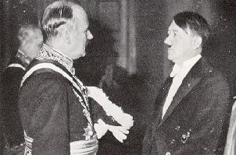
The Chancellor Of The Reich at the New Year's Reception with the French Diplomat, Francois-Poncet.

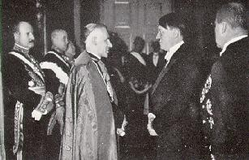
New Year's Reception, 1935. The Leader speaks with the Doyen of the
Diplomatic Corps.

Again the statesmanlike instinct of The Leader led to the right decision. The struggle went on and found its particular trump during the German Army Trial in the Leipzig Central Court in the proclamation of the legality standpoint by The Leader himself. Probably no one in the regime had suspected at the beginning of this trial what a democratic newspaper in Berlin reluctantly stated at its end, namely, that the actual winner was Adolf Hitler, and that the highest German Court had moreover given him the opportunity to confirm his legality principle by an oath before the court and the face of the whole world. This had never before been granted him because of his previous record, but now he could always refer to it in the continuation of his struggle against the Republic. This was the deciding factor, and the very thing which distinguished The Leader from his adversaries. With this statesmanlike insight he had recognised the possibilities of the trial at its outset, and not, like his

opponents, at its conclusion. He was obviously aware that he would have to carry through the principle of legality with the extremists of his own Party, but he also knew that this was absolutely necessary if the Party were to win unanimously.

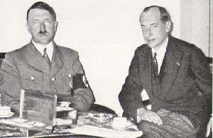
The Leader and the Polish Foreign Minister, Colonel Beck.

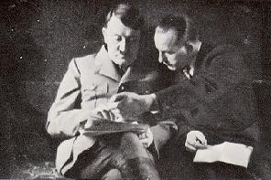
The Reich Press Secretary, Dr. Dietrich, shows The Leader press reports.

The gradual breaking up and systematic dissolution of the bourgeois parties were the next goal. Two years later, after untiring efforts, he succeeded in toppling the Brüning Cabinet. The apparent tolerance to the Government of Papen went until the 13th August, 1932, and here again the supreme moment for the real statesman had come. For the final time it became a question of settling for half measures or wanting everything. Any ordinary politician would have chosen the first option. Dozens of examples from Germany's past have shown this. As a true statesman, The Leader chose the latter. He was rewarded for this great and daring decision in the November elections in 1932 with two

million votes. Then, in a never before seen concentration of all his strength, he made one last onslaught against the regime in the Lippe elections in the beginning of January in 1933, and two weeks later he assumed power.

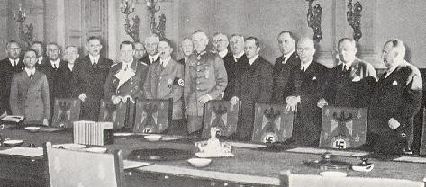
The Reich Cabinet during the proclamation of the Defence Bill.

The alliance between Hindenburg and Hitler was the first symbol of the reconstruction. Here tradition and revolution shook hands. The brilliant statesmanship of The Leader brought about a miracle in achieving a revolution of the greatest dimensions without major bloodshed by a reconciliation with the genuine traditional powers. Here is proof of a man of vision and instinct acting supremely to bring an innate law to its natural conclusion. Here, under the contempt of seemingly radical empty phrases, a grandiose change was effected, a world was turned upside down, and a new world was created.
The miracle of German unification was the result. Having brought the traditional forces over to the Government on the 21st of March, 1933, Hitler then brought the German workers into the Government on the 1st of May, 1933. The occupation of the trade union headquarters at the strategic and only possible moment was an almost inevitable consequence of this process of remoulding the nation, and the setting up of a four year plan to solve the urgent matters in German life was a far sighted and extensive project which allowed time to attend to matters calmly and without tension. If, in the time which followed, The Leader selected a very small but pressing number of matters facing the Government, and, by deploying any means at his disposal, set about finding a solution for them, his actions in doing this were those of a statesman without par. Never was a revolutionary on a grand scale as far removed from any trace of hysteria and haste as he was. Never has a history making politician worked as clearly and purposefully, and without great ado, as he did. And where in history has such a miracle been achieved under foreign pressure as here!
Boldness and daring went hand in hand in The Leader's decision to

withdraw Germany from the League Of Nations. What filled the doubting with a sense of hopelessness was done here with a supreme assurance because it was necessary and had to be risked. It was the act of a statesman to put this monumental decision in his first year to the vote of the Folk themselves. It was the act of a statesman to proclaim Germany's military freedom at the decisive hour, and to announce it to the world as an established fact, in the conviction that the time was ripe and that action was therefore necessary. Here we see his real mission. Here we see a man acting under a higher law. Here we see a man with an inspiration which does not come from the intellect, but from the blood.

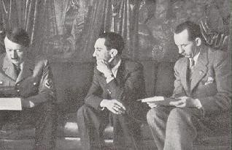
In the Reich Chancellery.

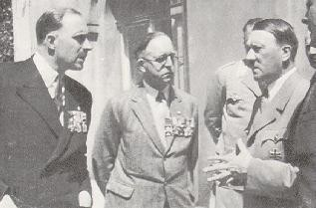
English Frontline soldiers with The Leader.

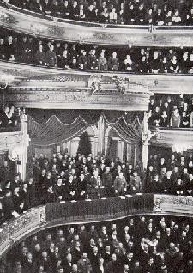
National Day Of Mourning, 1934. The function in the Berlin State Opera.

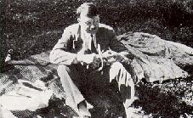
A restful pause between assemblies.

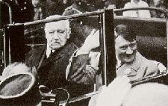
Reich President and Reich Chancellor on the 1st May, 1933.

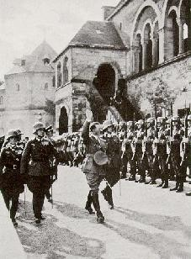
The Leader in front of the Imperial Palace in Goslar on the occasion of the
Harvest Festival in 1934.

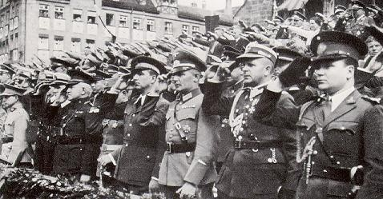
The Foreign Military Attaches at the Party Day in Nürnberg.

A German Nation which is once again in a position of protecting itself by its own means, which has established the continued existence of its Navy in an honest agreement with England, which today once again takes its place as a great power amongst other nations, which in increasing measure has aroused the admiration, or at least the envy, of the whole world, which is emerging more and more clearly as the most important element in world peace -- these are the results of a statesmanlike development which led from the seven man Party in München to the great power that is the German Reich today. A host of decisions is involved in this development. Altogether they give a picture of a fantastic and meteoric rise which will undoubtedly be praised as the greatest political miracle of the twentieth century by later historians. Here we see the results of an infallible feeling for what is possible and what is impossible at the time. Here clarity of direction was combined with purposeful action. Here we see the workings of an incredibly pure political instinct which achieved miracles because it believed in miracles.
Today Germany houses a different nation from the one it housed ten years ago. It owes its strength and its belief to the sure and unwavering leadership of a true statesman who not only knows what he wants, but also wants what he knows. He belongs to the few chosen men of history, because he is great enough to be an ordinary man, and ordinary enough to be great.

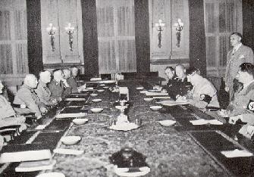
A sitting of the Reich Governors in the Chancellory under the chairmanship of The Leader.

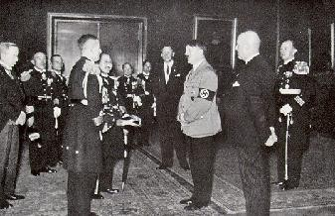
The Leader welcomes a Japanese Navy delegation in 1934.

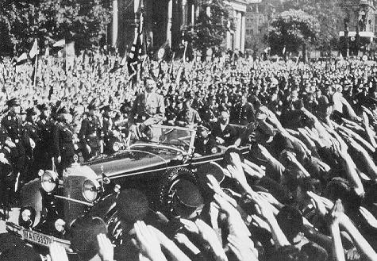
Labour Day, 1934. Youth rally in the Berlin Lustgaten on the 1st of May. The Leader departs after his great speech to the youth.

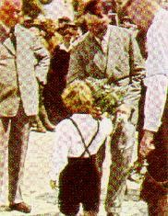
A child presents The Leader with a gift.

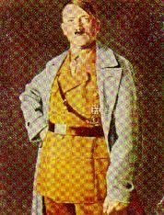
The Leader.

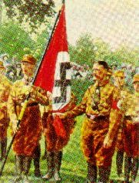
The Blood Flag of 9th November, 1923.

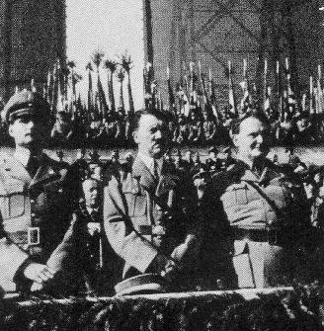
On the Tempelhof Field on the 1st of May.

The Leader And The German Worker -- By Dr. Robert Ley

The change which has taken place in the German Nation since it has been conquered by National Socialism can be seen most clearly in the attitude which the worker has assumed towards the new German Government, and in the esteem which the worker and his work have found in the Government.

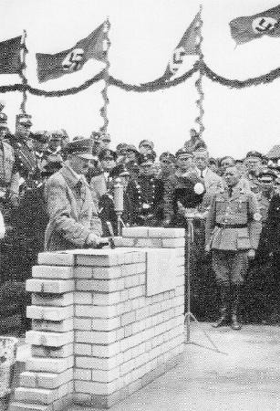
The Leader lays the foundation wall of the Community Hall in the Adolf Hitler Reclamation.

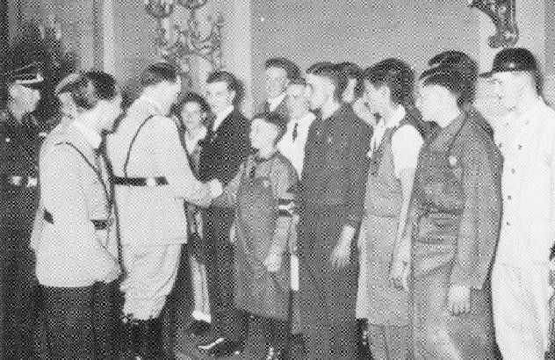
Young workers with The Leader in the Chancellery on the 1st of May, 1934.

Workers as a social class came into being at a time when liberalistic thoughts became the prevalent ideology in Europe. Liberalism has always viewed work as something unpleasant, almost dishonourable. Its highest ideal was to live off the work of others. Man's most desirable goal no longer lay in helping to build the future of the Nation, contributing his labours and deriving joy in doing so, but in discarding as quickly as possible the unpleasant situation of having to work, and then living as a pensioner or from his interest, ideally also drawing more money from the management of his wealth and properties, or as a middleman in trade. It is obvious that such an attitude to life necessarily led to a downgrading of the work ethic, and we can reproduce the scale of worth of any work and its standing in the following way: At the top of the ladder there is the unemployment of the well to do, then work involving monetary or goods trade, then intellectual work, and, finally, manual work.
This was really the dirtiest and most debasing thing which could happen to an individual, and whoever was unfortunate enough to have to work with his own hands to earn his living, was already fully degraded and excluded from the better circles of society. He was impossible. Just how deeply this liberalistic attitude poisoned popular sentiment is shown by the mere fact that even the worker himself, who day after day had to slave away at his job, saw himself almost as an outcast, and scraped together all his pennies to enable his son to become something better, perhaps a craftsman. The son in turn used every penny of his meagre earnings to send his son to a grammar school, or at least to some better school, however hard the son found Latin and mathematics. The father himself did not specifically say that he did this so that his son may one day have an easier life, or be better equipped for life, in short, that he may have things better than the father, but so that one day in the future he may be something better than the father.
Can the insanity of this way of thinking be understood? This was the sort of insanity which was systematically supported by Marxism, which took great pains to reinforce

further the inferiority complex of the German working man imposed on him from above by liberalistic arrogance. Marxism continually dinned into the worker the feeling that he was a disinherited person, a mere proletarian, and that his hatred should therefore be directed at the better class.
What an execrable crime committed in the name of Liberalism and Marxism, caste spirit and class spirit, and class hatred!
Under Marxist enticement, the worker thought he was improving his working conditions by refusing to work; under Liberal stultification, large numbers of educated people preferred to go hungry rather than dirty their hands with solid work. The German saying Work does not degrade! was corrupted to Work degrades! The propertied and well to do saw in the worker a lowly slave. The worker took his revenge by viewing employers as leeches and parasites, and treating them as such in his dealings with them. However, neither group noticed that their attitude and consequent dealings would soon destroy the Nation to which they both belonged for better or for worse.
This is where the incredible work of Adolf Hitler begins. He recognised that it was not a question of either the haves or the have nots, the employer or the employed; and that Marxism was not to be wiped out without the eradication of an arrogant and reactionary Liberalism, and he instilled a completely new and at the same time age old set of values into the Nation. His short, lucid sentences made the Nation sit up and listen. At first, only a few, then, more and more, and finally everyone came to see that for a whole century they had been wandering about in the deepest, most terrible darkness. It was as if a blindfold had been taken from their eyes, and suddenly they were bestowed with a new insight. In the light of this new insight everything which up to now had been hostile, and had seemed to be an irreconcilable difference, became deadly enemies to this insubstantial void. However, The Leader taught one thing: You are nothing, your Nation is everything. When you work, you work for the nation. Work is therefore an honour. There is no distinction in work. The work of a General Director has no more intrinsic worth and is no better than the work of a street cleaner. It does not depend on what sort of work you do, but how you do your work. Anyone who does not work loses his honour in the National Community. Work is not degrading, but enobling, irrespective of whether it is achieved with the mind or the sweat of your brow.
Disgrace is brought about only by leading a parasitic existence and showing contempt for a working National Comrade.

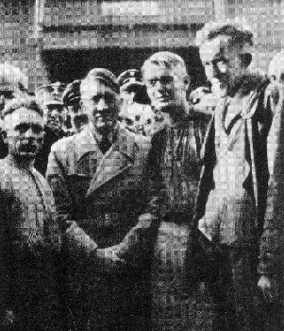
With the workers in Siemensstadt.

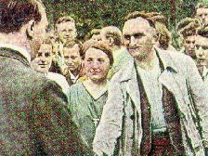
German workers love their Leader.

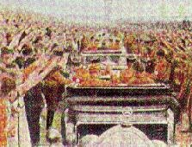
Driving through a throng of well wishers.

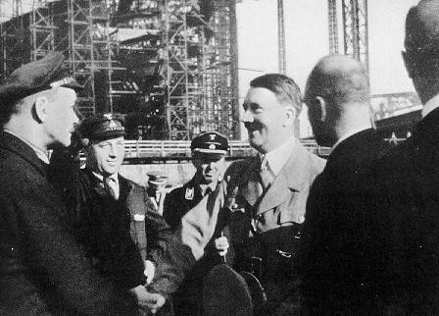
At the Blohm And Voss Shipyards in 1934.

And these sentences did not remain mere theory. If perhaps in 1933 the German worker, mislead by Marxism, and the reactionary stultified Liberals were sceptical and believed that National Socialism may not have been totally serious with this philosophy of life, this attitude changed in no time. Today the German worker is the proudest follower of The Leader who rescued him from his proletarian existence, restored to him and his work the honour of which Liberalism and Marxism together had robbed him, who finally gave back to him what he had always been struggling for deep in his soul, namely, to be a respected man amongst his fellow men, to be worth just as much in his work as the next man, distinguished only by his achievement and his efficiency.
When this came about, the German workers followed The Leader with great enthusiasm, each one of them unanimously stood behind the leading worker of the Reich, and even the liberals among the propertied class changed their ideas to the National Socialist way of thinking. In the third year of the National Socialist Reich, this new work ethic found its outward expression in the final stabilisation of the German Labour Front as an organisation which includes all creative German men, from the General Director to the apprentice. From this day on there are in Germany only German working men and German businesses. The nobility of Work reigns supreme in Germany.
However, this could only be achieved because every single person in the German Nation learned a new way of thinking, and began to look at the world from the point of view of National Socialism. The Leader once said: Whoever wants to be a true Socialist must personally have suffered need. The German working masses know that The Leader himself was for many years a manual worker and personally experienced the pains which are associated with labouring from morning until evening, in sun, rain and wind, in frost and heat. Only such a man could think the thought behind National Socialism. He knew what he was talking about when he spoke of the honour of work, and the masses understood it exactly. Here is the mysterious bond which links the German worker with his Leader. He freed the worker from his slavelike existence, and gave him back the honour of the free man. Thus National Socialism today rests safely and soundly on the workforce. Thus it is therefore

only a matter of course that on the national holiday of the German Nation on the 1st of May, The Leader should welcome in the Chancellery delegations of German workers, and in these delegations is represented the whole of the German workforce, white collar workers and blue collar workers. They come as guests of the Nation from all the Districts of the Reich, by aeroplane and by train, and they stay in the great hotels of the metropolis. They bring The Leader the gifts of German industry, the greetings of their comrades, and the assurance of their loyalty, their love and their faith. They all come face to face with him before they drive with him to the massive rallies on the Day Of German Labour.
If, individually, there are still many things to be improved, if mistakes still occur here and there, and difficulties arise due to need and lack of judgement, if disappointments are still with us, if the material situation of the workforce has not yet improved, if in some areas there is still evidence of self interest and meanness, if there are still some people unwilling to accept the new gospel of the honour of work -- these are all only minor, peripheral things. The worker is not concerned by this, because the word stands and the word must be left standing, the word of the nobility of Work. Only from such a way of thinking can the activity of the German Labour Front be understood. Previously, who would have concerned himself with the state of working conditions in which the German worker laboured for his nation? Today the Department Of Beauty Of Work has the responsibility of ensuring that the German working man carries on his work in dignified places, and not in ramshackle sheds. Through Strength Through Joy, the German worker has time for holidays and relaxation; today he wanders happily, and often for the first time, through his beautiful Fatherland; today he travels in his own ships to the magic of the southern seas and lands, to the exalted beauty of the north.

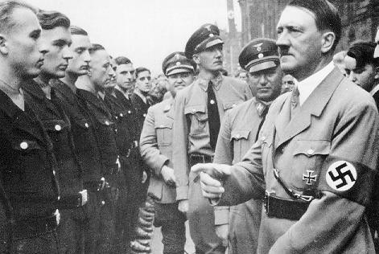
Reich Party Day, 1935. The Leader with Dr. Ley inspecting a troop of workers.

Today, like every German National Comrade, the worker enjoys the magnificent achievements of German drama and German music, the best German orchestras, the best German opera and theatre performances, and the best German films. He is entertained by programmes on the radio. He can take up every sort of sport. However, the content of his new existence is not characterised by hedonism, diversion and physical impulses, but by the noble and genuine pleasure he derives from his physical labours, from nature and culture.
Whoever works hard should also be able to enjoy himself thoroughly, so that his value to the

Nation increases. No longer does the scourge of unemployment cripple the nation. Millions have already returned to their place of work, and those still waiting are under the care of the whole Nation. Trustees ensure that the worker's rights and his honour are not affected, and the manager is just as responsible for the well being of his employees as his employers, working with him, are responsible for the prospering of the business in which they work together. Here the fundamental difference between National Socialism and the past is most clearly marked: everywhere in the past there were only presidents and chairmen, and then the common herd. There were chairmen of the boards, of the administration, of the parties, of the unions, of the employers groups, of social benefits committees and strike committees. Today we have The Leader of the whole Nation, and behind him a leader (or leaders), of whom each one has his particular field or a group of people. Previously, everyone chaired a meeting of others, everyone took to their chairs, and there was no goal or defined path.
Today there is direction, a defined path and a goal; everyone has been broken up, and everyone marches behind The Leader.

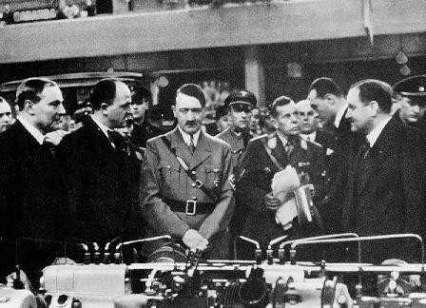
The Leader at the Automobile Exhibition of 1935 in Berlin.

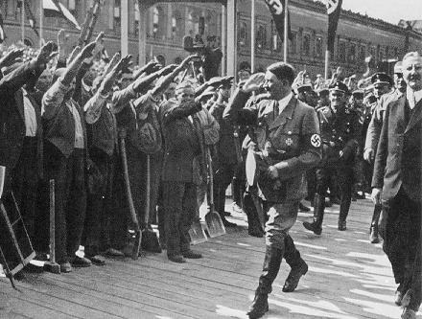
Laying of the foundation stone for the new Reich Bank, May, 1934.

In language and in speech, the whole difference between the two times is also expressed.
Everyone, however, knows that he has only one man to thank for all this, and that man is Adolf Hitler, who created National Socialism, put the common good before self interest, put an end to class struggle from above and below, from the left and the right, by proclaiming the honour of work and of service to the Nation. So that this doctrine, which has made the German worker the upholder of the Government, may never again go astray, the National Socialist Labour Service has been created. Here every German National Comrade, before he is allowed to work for personal gain, must contribute with his own hands to the benefit of the Nation.
The Leader dispelled from Germany arrogance and contempt, jealousy and hatred where work and possessions were concerned. He gave to his Folk pride and honour in being a worker, and the responsibility of serving the whole Nation. The German worker today is happy to be a free man in a free country. He is the leading worker in the world. Centuries to come will envy him this position. He, however, thanks from the bottom of his heart the man who gave him all this -- The Leader.

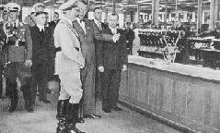
A visit to the Bavarian Motor Works.

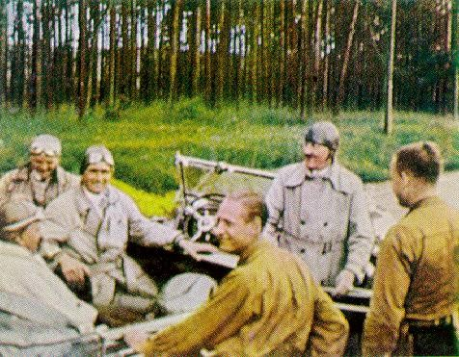
A rest on a country road.

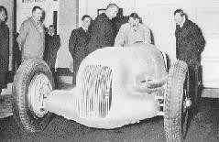
The Mercedes Benz racing car built at the instigation of The Leader.

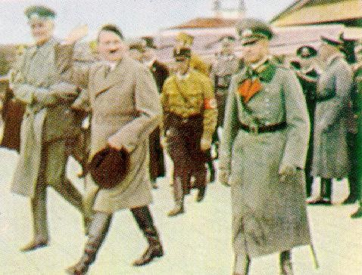
Visit to East Prussia.

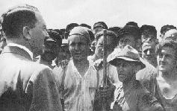
A statesman among the workers carries himself like this.

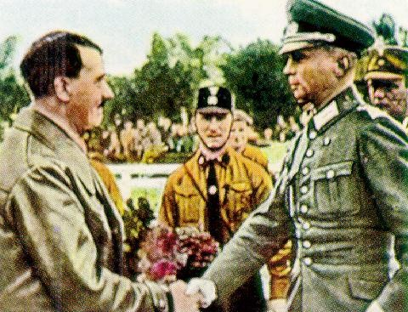
Greeting the troops.

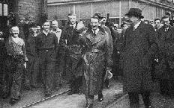
A visit to the industries of Rhineland-Westphalia.

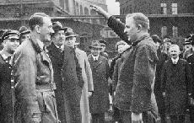
A visit to a factory. A representative of the workforce greets The Leader.

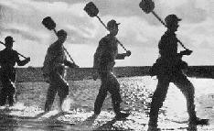
The Labour Service attends to land reclamation.

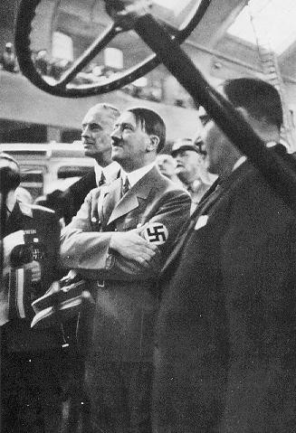
The International Automobile Exhibition in Berlin, 1935: The Protector Of The Automobile Industry.

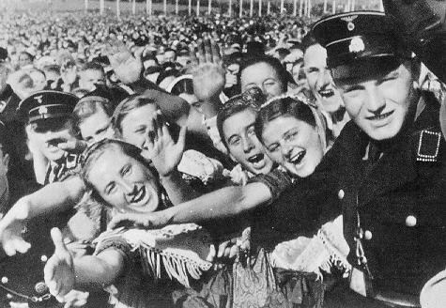
This is how the German farmers greet their Leader, Adolf Hitler. Buckeburg, 1935.

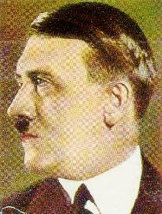
Reich Chancellor Hitler.

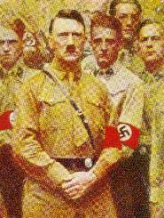
The Leader and support staff.

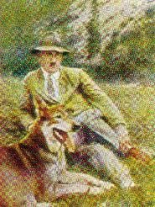
The Leader and his favourite dog.

The Leader And The Arts -- By Dr. Joseph Göbbels

Art is the most noble activity of the human soul and the human imagination. It is the concretisation of feeling. What the artist harbours in his heart, he expresses through art. Heightened feelings require heightened forms of expression. The artist is able to parade his inner spirit. He puts words to what the masses at large sometimes experience only as a vague and dulled longing; or he expresses it through his music, in stone or in marble. At all times art has elevated and shaken mankind. It has transported men out of the dreariness of their mundane existence into a better world. Indeed, whole eras of a new cultural and historical development have been transfigured and immortalised through art.
This is also why artists, as divinely gifted beings who give meaning to the innermost secrets of human life, have always stood next to great men in all other fields. The singer accompanied the king has always been the most distinguished commandment of the really great, flourishing eras of human culture and history.
This does not mean that rising historical eras need necessarily also include great artistic events. On the contrary: usually they tend to follow each other. Either a flourishing of the arts and sciences leads to great historical change, or great historical change leads to a flourishing of the arts and sciences. This may well be due to the fact that either one or the other draws the outstanding, dynamic men, so that these are either taken and used in the service of politics or in the service of art. As a result, any other potential which these men may have remains dormant and is never exploited.

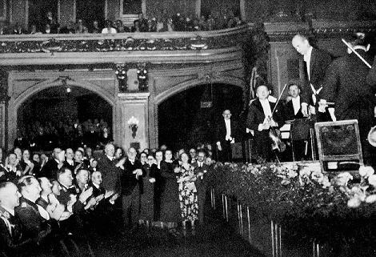
In the Berlin Philharmonic Hall. The Leader at a concert of the Philharmonic Orchestra conducted by the Director Of Music, Wilhelm Furtwangler.

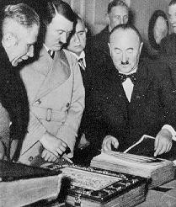
On the occasion of the transference of a valuable manuscript acquired by him, The Leader is shown the treasures of the Bavarian State Library.

However, it is not possible to generalise in this regard. There have been statesmen who were worlds removed from any artistic aspirations, who were so completely interested in and caught up in technical and scientific matters, that they scarcely had any time, inclination or desire left to concern themselves with purely intuitive values. They lacked the profound capacity for understanding the actual nature of art which is necessary to become captured by it and to serve it with devotion and passion.
There have also been many soldiers who were nothing more than soldiers, and who had no desire to be anything more. We are talking here about the outstanding organisers, instructors, educators and immortal corporals whose campaigns shook the world. Such statesmen and soldiers brought about historical developments which were not directly the result of artistic endeavours, and therefore only indirectly touched on the realm of art.
Things are different with those statesmen and soldiers whose nature and whose work is based less on reason than on feeling, and who drew more on their imagination than on the rational consideration of their strengths. These are the true great men in the domain in historical creation. They are therefore closest to the artistic nature because they are made of the same elements. To generations to follow, their miraculous and inexplicable existence makes them appear to be the heralds and shapers of a destiny which ruled over them intuitively, and which will still be visible for centuries to come.
In our own history, men like Frederick The First and Field Marshall von Moltke belong in this category of great historical figures. By nature and predisposition, they were sensitive artistic natures who stood as God's apprentices at the spinning wheel of time. Their forceful presence put a stamp on a period of evolution. It is not intended to downgrade the activities of those other statesmen and soldiers who were purely technical in their approach, and yet mastered their work to the last detail by their knowledge, diligence, energy and tenacity. Without Frederick Wilhelm I, the soldier and father of bureaucracy, as a precursor, a Frederick The Great would have been unthinkable. The former was necessary so that the latter could carry on his historical work. The former had to establish the Government which the latter shaped. The former had to found and train the army which the latter mobilised and led to its historic victory in hard and daring campaigns.
In this connection, however, we must not overlook the fact that, when both elements are not united in the one man, the original feeling for form is to be estimated more highly in its historical worth than the mere feeling for organisation, and that the feeling for form and its origins in an artistic drive and stems mostly from deep and mysterious intuition. The Frederick who wrote poetry, and searched for wise, philosophical interrelationships, but who also sat in his dirty, threadbare uniform amongst his Grenadiers at the bivouac fires at Leuthen, could hold his flute just as elegantly as he could wield his rapier bravely and determinedly.

The Prussian German Army has never been poor in such soldiers. The caricature of Prussian militarism which the world painted and held up to us could not have been further removed from the truth. Those soldiers who went through the school of the War Academy, or of the Great General Staff, were frequently not only military men but also philosophers of their craft. Nowhere has there been a clearer and more artistic stamp left on men than in these training institutions for the Army.
German politics, however, have always been poor in such rousing and fascinating personalities. It has had good craftsmen who knew their trade, but whose capabilities were also exhausted in the execution of it. Frederick The Great, in his capacity as a soldier, shares this capacity with a vast number of like minded and similarly oriented men in our history. In his capacity as a statesman, on the other hand, he stands completely on his own.
This was the great and unique feature which placed The Leader above those who have a purely aesthetic enjoyment of art. For him, art was not an escape from life, but an escape before life. He turned to art whenever things became difficult and unbearable, and he needed to draw force and strength from other areas in order to master life anew. Art is not weak, and therefore does not train people to be weak. Its strong rules make people strong and keeps them strong.
Men who, possessed with a deep feeling for art, apply in the face of the nation great theories of politics and military strategy, are also acting as true artists, and for them politics and leading an army is therefore also an art. It is one form of art amongst the many others to which they feel deeply related and linked.

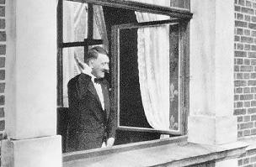
The Leader in Bayreuth.

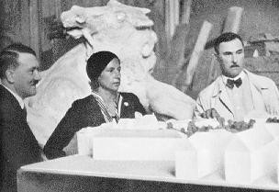
Visit to the artist's studios in München. Here with Professor Wackerle and in the centre Professor
Troost.

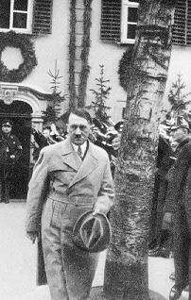
A Visit to the Schiller House in Weimar in 1934.

The Leader as a statesman belongs to these unusually rare figures in German Prussian history. His most profound characteristics arise from his artistic nature. He is by trade a master builder, and later was often to say with a smile that in his youth he once had the intention of building, yet without knowing at the time that fate would call on him to build not houses but a Government. His reconstitution of the Reich again shows in its original design the eternal laws of true architecture. His organisation of the Government is determined by a logic which appears to be self evident. It is carried out according to far sighted and well thought out planning without haste and tension, as under a master builder who knows Rome was not built in a day, and that he has been called on to work not for a restricted time, but for decades and centuries to come. This is exactly what distinguishes the new foundation of the Reich by The Leader from all previous attempts. It rests on permanence, and has an inherent architectural clarity, combining purposefulness and beauty in rare harmony.
The Leader once, long before he came to power, said in one of his speeches: If the German artists knew what I will do for them later, they would stand behind me to a man! These words were lost in the wind at the time; without having to be reminded by impatient creditors, The Leader has been true to his word long before others dared to hope.
Just how strong his inner need for art is should have been known and suspected when, at times, before he came to power, faced with extremely difficult political negotiations or wearing tactical battles, he would sit of an evening alone or with a few companions unnoticed somewhere in a box at the theatre. Here he would listen to the heroically intensified beats of a Wagnerian opera and hear in them the artistic harmony with his political nature. There are only a few people today who, to take an example, would have heard The Master Singers or Tristan as often as he has. He is a fanatical follower of art. He does not indulge in the bourgeois smugness of professing to understand a genius after having seen or heard him once. He is still filled with a deep and almost humble respect for the talent and greatness which dwell in an artistic genius.

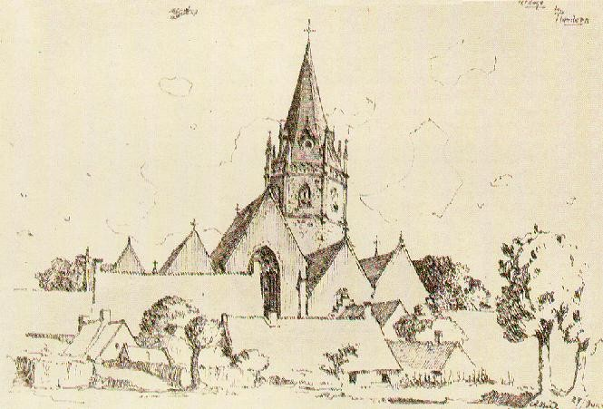
The drawings of the frontline soldier Hitler: Ardoye in Flanders (summer, 1917).

The drawings of the frontline soldier Hitler: Shelter in Fournes.

This respect sees and appreciates the man and his work as an entity. It is necessary to have seen The Leader in the company of artists to understand the depth of his affinity with them. It is necessary to have had the opportunity of observing his untiring care for art and artists in his daily dealings to understand the meaning of both for him and his historic work. His respect for true artistic worth and work is, to an extent, a converted gratitude. What he means for the work of Richard Wagner in general, and for Bayreuth in particular, as a patron and directly involved friend and adviser is known only by those who have had the good fortune of being able to help him in his work.
To the little circle which usually surrounds him, those hours in which The Leader, at a time when he had only just taken over the opposition leadership, quickly sketched on loose bits of paper grandiose plans for the architectural redesigning of Berlin and München, will remain unforgettable. Here everything was in the right place, and modern technology and thinking were combined with the latest architectural strength. Here, in prototype, there arose the face of these cities, cleansed and purified of the unsightly features which an era lacking in taste and style had imposed on them.
The monumental buildings of the Party, the new layout of the Königsplatz, the House Of German Art in München, the large scale reorganisation of the Reich capital city, already reflected in interim projects -- these are the first visible acts of completion of this seemingly incredible preplanning at that time. It seems almost incomprehensible to an outsider that, not only did the inspiration and initiative for these monumental projects come from The Leader, but that it is The Leader himself who supervises and follows the execution of the plans in great detail and with expert precision. The Leader always has time for a building plan. How often did we observe him in the studio of that architectural genius who unfortunately died all too soon, Professor Troost, and see his enthusiasm for plans and models which are now step by step becoming a reality. How often did we accompany him to new construction sites during their various developmental stages

and witness his great joy at the smallest detail which, purposefully and meaningfully, would form part of the whole in its completed form.
Even the pictures which he painted in his youth radiate this spirit. They are meticulously executed to the last brush stroke, and reveal the precision and exactitude of the master builder.
It is claimed that there are business minded imitators who are unparalleled in their mastery of the forgery and copying of such small works of art, but they are unable to deceive the true expert. A genuine picture by The Leader can be distinguished from a fake at first glance, because it has the imprint of The Leader, and contains in embryonic form all the artistic laws which appear in their full magnificence and monumental nature in his reconstruction of the State.
The man who, in his youth in Vienna, went without countless meals so that he could buy standing room tickets to the Viennese Opera to hear Wagner or Mozart, it today attached with the same artistic passion to a painting or a piece of sculpture. A stroke of luck gave him the opportunity of acquiring Bocklin's Battle Of The Centaurs. The Leader has been seen sitting for a long time, motionless, filled with emotion and humility, in the face of the greatness of true artistry as exemplified by this picturesque creation of a genius.
Who could doubt that these noble passions are the almost inevitable forms of expression of his artistic feelings, which are also evident in his historical work? Are not, for example, his speeches a record of this tridimensional and intuitive vision? Do they not, in their construction, their clarity of style, in the monumental nature of their chain of thoughts, their precision but also variety of expression, appear to be like a classical monument or like a Bach fugue? It is a poor view of a man to attempt to dissect his individual characteristics in an attempt to understand his personality as a whole. Here individual characteristics are united into a general picture, and its totality shows the contours of a man who feels and acts with the intuition of the artist, who in everything is and appears to be as he must be and must appear to be, and who, even if he wanted to, could not be or appear to be anything else.

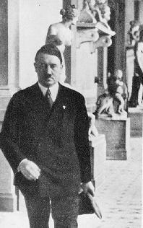
The Leader leaves an artist's studio in the Academy Of Fine Arts in München.

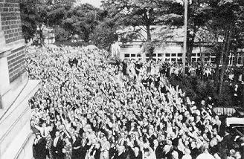
Visitors to the Festival at Bayreuth greet The Leader.

From its very beginning The Leader imbued his Movement with that burning impulse to modern activity which later gave it the strength for its great victories. He did not subordinate it to technology, but consciously placed technology at its service. For The Leader has a positive attitude to technology. He uses the means and achievements of technology to the concentration of his will and his work. Even technology has its artistic side. Even a magnificently built bridge or a modern car constructed according to precise, almost classical lines, will always satisfy the sense of beauty in man. The highways which The Leader designed and which modern engineers built according to his plans are works of art of the 20th century. We can still see The Leader on a sunny Sunday afternoon standing in front of the bold and splendid arch of the Mangfall bridge. In his face were reflected the pride and satisfaction of the man who can feel the eternal artistry even in the most modern technological testimonials to our vital time.
The Leader is the sworn enemy of amateurism; he is of the proud opinion that it is more worthwhile to read, see or hear what is good and great ten times than to waste time with ten different average or below average works. If he is shown a film which represents an artistic success, he will ask for it to be shown again a second time if the opportunity presents itself.
Mediocre films are stopped after five or ten minutes.
Is it a wonder then that all genuine artists love and worship him from the bottom of their hearts? For he is their friend and, where required, their protector. He cannot imagine a life without art. No royal patron was ever as receptive to the arts as he. Where art is great and promising he will lend an encouraging hand, and nothing will be further from his mind than to treat an artist with condescension. And he, who had to fight his way to art as a penniless building worker with severe material sacrifices, shows his generosity above all when it concerns bringing art to the Folk and the Folk to art. Ideas such as that of a National Theatre have become a reality with his support. The great German cultural organisation, Strength Through Joy, finds in him its most warm hearted friend, adviser and patron. His sense of beauty does not have that unpleasant aesthetic trait that is associated with the selfish sybarite. It is at the same time a sense of what is purposeful and universal.
Not so long ago, statesmen from various countries visited him in Berlin, and for days on end they discussed with him in the course of tough negotiations the questions of European reconstruction. They scarcely suspected that the same man who, during the morning, noon and afternoon, defended the German right to existence and, in the manner of the economic or military specialist, had at his fingertips every figure and date to prove his point, would that same evening sit with them in his home and, deeply stirred and moved, listen to the quintet from the third act of the Mastersingers or a song by Schubert, Schumann or Wolf. Perhaps they thought that this man had suddenly become someone quite different, or that he had suddenly slipped a new, unknown hat onto his head; and yet, in reality, he remained the same man, a statesman whose personal interests were almost unfathomable, a man who encompassed all the traits and possibilities of the German Soul, an artist who moved amongst artists and therefore felt an affinity with them, because he also carried deep within him the artistic spark. Perhaps this hour gave to all those who were able to participate a deeper insight into the essential character of The Leader than

countless technical discussions and conferences. Here again there has appeared that fascinating strength of a genuine personality which enabled the great Prussian king to fight and come through his decisive battles not despite the fact, but because of the fact, that he also wrote poetry, was an adherent of philosophy, constructed Sansouci, played the flute, and, if the tough business of government and the military left him time, gathered around his table the most refined and illustrious minds in Europe. Because here, from what seems to be contradictions and contrasts, is formed the final synthesis of a great human nature and work which will survive for centuries to come. Here art has been transposed into military and statesman matters; the same strength is found here, it is merely exercised in different areas. In doing so it uses the same motor energies which also stimulate and inspire art: imagination, instinct, inspiration, grace and motivation.

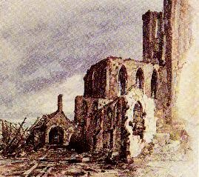
A watercolour of the frontline soldier Hitler: The Ruins Of The Monastery In Messines (December,
1914).

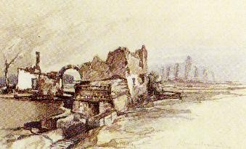
A watercolour of the frontline soldier Hitler: House With White Fence.

Perhaps only a later time will be able to measure exactly what this means for Germany, for our Folk and for its national fate. We, on the other hand, have had the good fortune of seeing and experiencing the work and effect of a true genius all around us. Here the artistic feeling of a great man has not arisen from the need for luxury or frivolity. Here it is need in the true sense of the word and therefore indispensable from existence, life and work.
Perhaps The Leader is best understood when seen in these terms. This is because for him art is that mysterious power which ignites the human heart in all those grey hours, as life's

wild dance crowds in on us to new love. His attachment to art and artists, his solicitude and indefatigable care, are only the payment and fulfilment of a debt and a duty which the poet has stated when he says: Blessed art, I thank you!

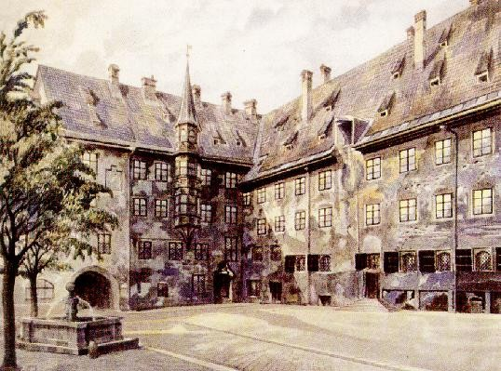
A watercolour of The Leader from the year 1914: The Courtyard Of The Old Residence In München.

The Buildings Of The Leader -- By Architect Albert Speer

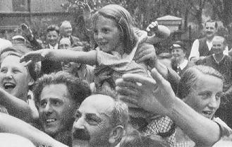
The Leader leaves the construction site of the House Of German Art.

It has often been the case in history that a Head Of Government would to a great extent support the arts and, in particular, architecture. Thus a rococo prince of the 18th century would have castles and gardens built on which to feast his eyes, and give free rein to the architects of his time.
The Leader also builds as a Head Of Government; but he will never be able to build in this same tradition, because his great buildings, which are beginning to appear today in many places, are to be an essential expression of the Movement for thousands of years to come, and therefore a part of the Movement itself. The Leader, however, created this Movement, came to power through its strength, and even today still determines to the smallest detail its final form. He can therefore not build as a Head Of State in previous centuries, nor as a benevolent client, even less as a patron, of the arts -- he must build as a National Socialist. As such he determines, just as he determines the will and expression of the Movement, the clarity and purity of the lines of the building, the severity of its appearance, the quality of its materials, and, most importantly, the new inner purpose and with it the inner content of his constructions.
Building is no mere pastime for The Leader. It is a serious concern, destined to give expression in stone to the will of the National Socialist Movement.
It will be unique in the history of the German Folk that, at the decisive turning point, its Leader began not only with the greatest philosophical and political reorganisation of our history, but at the same time also set about the task of creating buildings with the superior knowledge of the master builder. These buildings were to bear witness to the political will as

well as to the cultural greatness of our time for thousands of years to come.
After long centuries of confusion, the will of one man has established a clarity and severity in building which, in its continued development, will have as its consequence a completely new style of architecture.
Just how closely The Leader since his youth has felt attached to architecture, he wrote in 1924 in My Struggle:
As soon as my interest in social issues had been awakened, I began to study them with great thoroughness. It was a new and up to now unknown world which disclosed itself to me. That I should zealously at the same time serve my love of architecture was a matter of course. Architecture seemed to me, next to music, the queen of the arts: my preoccupation with it could under such circumstances not be regarded as work but as the greatest joy. I would read and draw into the early hours of the morning without getting tired. Thus my belief that my beautiful dream would become reality, even if it took many long years, was strengthened. I was firmly convinced that I would one day make a name for myself as a master builder.
He himself tells how important these impressions from his years in Vienna were in the first chapter of My Struggle:
At this time I formed a philosophy of life and a conception of the world which became the rigid foundation for my actions. To that which I thought out for myself at that time, I have only had to learn a few more additional things, but there was nothing I had to change. To the contrary. Today I strongly believe that in general all my creative thoughts had already manifested themselves in my youth, in so far as such thoughts exist at all.
This love of architecture which The Leader developed in his youth has never since left him. However, through war and revolution, the foundations of State and national life in Germany were so shaken that Hitler, who even as a soldier began to become more and more preoccupied with political issues, decided to become a politician: He said: Was it not ridiculous to want to build houses on such a foundation? He was totally serious in his conviction that he should become a politician, and it was a difficult decision to say farewell to architecture, the art to which he always remained faithful, with which he always continued to occupy himself, and which up to now has been his great love.

In the first turbulent years of his political struggle and during the early formation of the Movement, he also gave the final artistically clear form to all its symbolic means of expression. He designed the Swastika Flag of the Movement -- and with it the National Flag of the German Folk; he determined the National Eagle of the Party -- and with it the National Emblem of the German Reich; he was responsible for the ensigns of the SA and the SS; he developed a new structuring of his many rallies, and thereby determined the basic idea according to which all the buildings on the Reich Party Day site are erected.

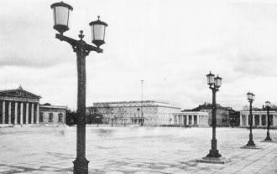
The Königsplatz in München after its redesigning by Adolf Hitler.

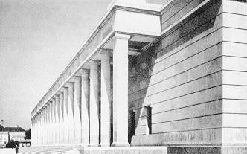
The columned hall of the House Of German Art in München.

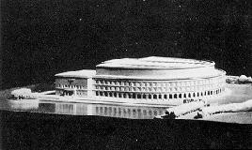

Design for the Congress Hall on the Reich Party Day site in Nürnberg.

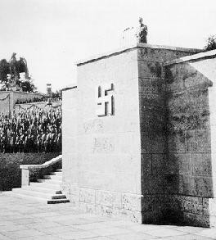
Rostrum in the Luitpold Arena of the Reich Party Day site in Nürnberg.

In the course of many thorough discussions, he designed and determined Nürnberg at the Party rallies; not only the guidelines and programmes, but, in the course of lengthy considerations, he also laid down exact arrangements for the setting up of the individual subdivisions of the Party, for the deployment of the flags, and for the decoration of the various rooms. In Nürnberg sketches and drawings by The Leader from this time are still carefully preserved.
At a time when all his energies are called on to achieve the great goal, his preoccupation with art is and remains not work but the greatest joy.
At the right time, fate led to his meeting with his architect, Paul Ludwig Troost, with whom he soon formed a friendship based on an affinity of minds. What Dietrich Eckart was to The Leader as far as the exchange of ideas of a philosophical nature was concerned, Professor Troost soon became for him as far as architecture was concerned.
The first building to arise through the unique combination of these two men, and also the first small construction of the Movement, was the Brown House in the Briennerstraße in München. It was only a renovation, but for that time, as The Leader sometimes related later, a massive undertaking.

Here one can already see everything that was to be expressed even more distinctly in the buildings which were to be constructed after he came to power: severe and austere, but never monotonous. Simple and clear, and without false decoration. Ornamentation used sparingly, but in the right place, so that it could never be considered as superfluous. Material, form and lines combine to create an impression of nobility.

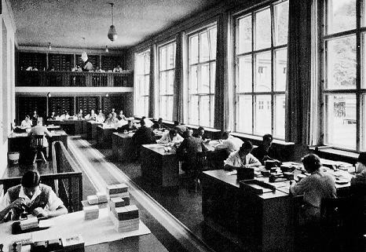
A picture of the Index Room in the Brown House, München.

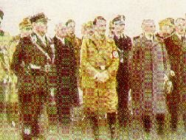
The Leader in München.

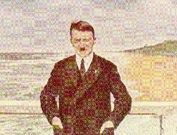
The Sacred Pier.

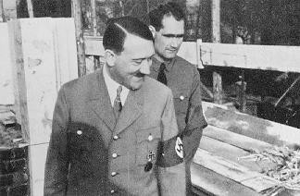
The Leader and Rudolf Heß inspect the construction of The Leader House in
München.

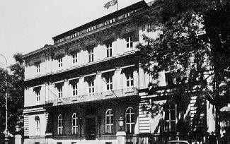
The Brown House in München.

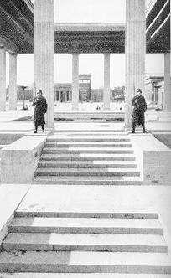
The Eternal Guard on the Königsplatz in München.

The plans for this renovation were made in the same simple studio owned by Master Builder Troost in the back room of a house in the Theresienstraße in München, where later the plans for the Königsplatz in München, for the House Of German Art, and for many of The Leader's other buildings were to be made. These plans were to form the basis of a new style of

architecture.
The Leader has never received the plans for these important buildings in his official rooms. For years he has gone to Professor Troost's studio in his free time to engross himself totally on the spot and free from his political work in the plans of future constructions. The Leader does not occupy himself solely with the major overall plans; he surveys every individual detail and every new assembly of materials, and much is improved by his stimulating suggestions.
These hours of mutual planning are, as The Leader has often confessed, hours of purest joy and great happiness. They are a form of relaxation of the most noble kind in the course of which, again and again, he finds renewed strength for other plans. Here he has the opportunity, in the few free hours which politics permit him, to dedicate himself to his love of architecture.
Many years before he came to power, Hitler had discussed with Troost plans for buildings which only now are being executed. Already in the winter of 1931/1932 he talked over with him the future formation of the Königsplatz in München, and many splendid drafts have been the result of these meetings. And even before he came to power, as a result of these many discussions, the Square already existed in its present shape in plans and models.

When the Glass Palace burned down in München in 1932, and an inconsequential design for its reconstruction was put forward by the Government of the time, The Leader had one additional concern besides his many others, and that was that this imperfect plan would be started before he came to power. If one compares the model of this earlier design with the model of the now completed House Of German Art built according to the design of Paul Ludwig Troost, then one can see more clearly than anywhere else from which other ideal world The Leader draws his buildings.
In the irreplaceable artist Paul Ludwig Troost, The Leader had found his architect. Troost seized The Leader's intentions, and always managed to give them the right architectural expression.
In his great speech at the cultural rally of the Reich Party Day in 1935, The Leader unveiled a memorial to Professor Troost with words that could not be more moving for an architect of our time. He said:
We should be happy and proud that, by some strange chance, the greatest architect Germany has ever known since Schinkel was able to erect in the new Reich and for the Movement his first and unfortunately only monumental works in stone, as memorials of the most noble and truly Germanic tectonics.
It is a pleasure for The Leader to see the plans of a new building arise; it is just as great a pleasure for him to be able to experience personally the actual progress of these buildings.
Whenever he wanders through his building sites, often accompanied by only a few employees, he is the complete expert. His numerous questions of

a technical nature, either about the foundations, the strength of the walls, or about problematic details of construction, are clearly put and usually unintentionally touch on some existing unsolved difficulty. Often it is in this area of engineering construction, when, after long consultations, all the experts are doubtful of a solution, that he comes up with a suggestion which usually proves to be logical and easily executed.

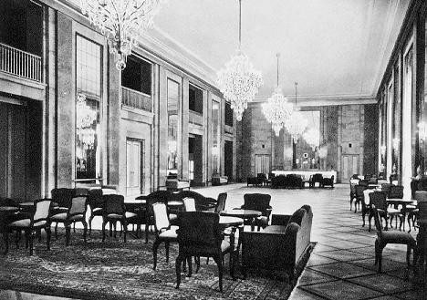
The foyer of the German Opera House in Charlottenburg

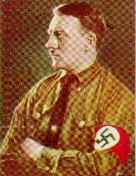
Our beloved Leader.

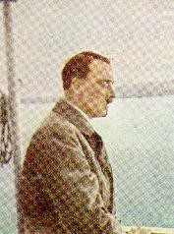
The Leader in a pensive mood.

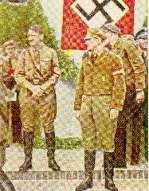
The Leader in Potsdam, 1932.

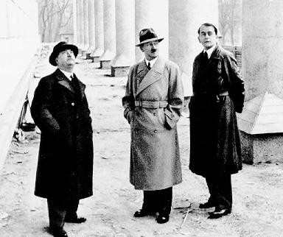
The Leader, Professor Gall, and Architect Speer inspect the building progress of
the House Of German Art.

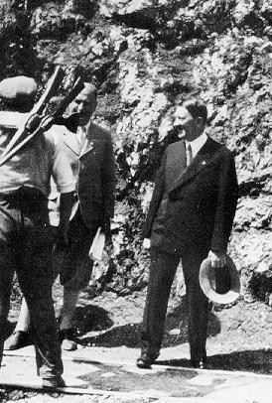
A meeting on the new Alpine Road.

Every new step in the construction and every new detail in the building receives his thorough attention and appreciation. However. All this pleasure in details never prevents him from seeing the imposing alignments which distinguish all buildings.
The buildings of The Leader are constructed according to technically proven principles from natural stone. Natural stone and Nordic clinker bricks are our most durable building materials. What may initially appear to be the most expensive proves to be the cheapest in the long run. In all technical considerations, unlimited long lastingness is always the prime and most decisive principle to follow. For the buildings of The Leader are designed to stand as a testimonial to our great time for thousands of years. Once the immortal buildings of the Movement and of our Government have arisen in all the towns in Germany, they will be buildings of which every individual will be able to be proud, and of which he will known that they belong to the public at large and therefore also to him. It is not the warehouses and administrative buildings of banks and big companies which give the towns their character, but the buildings of The Leader, created by him and designed by him.

About the appearance of our cities in the past and in the future The Leader has written:
In the 19th century our cities began to lose more and more their character of places of culture, and sink to mere housing settlements. When München numbered only 60000 inhabitants, it looked as if it were to become one of the first German centres of art; today almost every factoryladen suburb has reached this figure, if not multiplied it several times, without being able to lay the least claim to having anything of real value as its own. These suburbs and towns are mere collections of apartment blocks and tenement houses and nothing more. How any particular attachment to such a town is to be formed under such deplorable conditions is a puzzle. No one will feel particularly attached to a town which has nothing more to offer than any other town, which lacks any sign of individuality, and in which everything was done to avoid anything to do with art. But this is not all. Even the great cities are becoming relatively poorer and poorer in real works of art as the size of their population increases. What recent times have added to the cultural content of our cities is completely insufficient. All our cities live off the glory and the treasures of the past. Our cities today have no monuments which dominate the cityscape and which could in any way be described as a symbol of the era. This, however, was the case in the cities of antiquity, where almost each one had a particular monument of which it could be proud. The particular features of an antique town were not found in its private buildings, but in its public monuments, which were not destined for the moment but for eternity, because they were to reflect not the riches of a single owner, but the greatness and importance of all the citizens. Even the Middle Ages in Germany upheld the same leading principle, even though its conception of art was quite different. What in antiquity was expressed in the Acropolis or the Pantheon, could now be glanced in the forms of the Gothic cathedral. The comparison between public and private building today has indeed become lamentable. If Berlin's fate were to become that of Rome, then all our descendants would have to admire as the most imposing works of our time would be the warehouses of a certain number of Jews and the hotels of a number of companies, the buildings which express most characteristically the culture of today. Thus our cities today lack the outstanding emblem of the National Community, and one should therefore not be amazed if the National Community sees no emblem of itself in its cities.
The great buildings of The Leader on the Königsplatz, the House Of German Art in München, and the Party buildings in Nürnberg, must be understood in this sense. They are a start, but therefore nonetheless fundamental, and it is the same with the residential buildings of The Leader. We are standing at the beginning of a new development.
The fact that one always initially thinks of the great buildings when The Leader's buildings are being discussed is no doubt consistent with the meaning The Leader gives to the creations of architecture.
This, however, should not lead people to assume that The Leader's work in the domain of architecture is exhausted with these buildings.

To the contrary.
From his own speeches, we know the crucial worth he places on shaping the social conditions of all Germans in such a way that every individual can be proud of what the community as a whole has achieved. The great importance the questions of living conditions assumes in this matter has already been stressed by The Leader in My Struggle.
In his years in Vienna, he became acquainted at first hand with the poor living conditions of the working class families. He writes:
What I had suspected before, I then learned to understand quickly and thoroughly: the question of the nationalisation of a Folk is firstly the question of the creation of healthy social conditions as the basis for the education of the individual.
Official statistics on completed dwellings (new or converted buildings) in the Reich show:
1932 -- 159,121
1933 -- 202,113
1934 -- 319,439
These figures speak more loudly than words of the extent the creation of healthy housing has increased under the Government of The Leader. This increase will continue and will rise even more sharply once the great building projects which are necessary for our security have been completed. In The Leader's own words, they are urgent, and therefore cannot be postponed.
Then the monumental buildings of National Socialism will rise above the healthy houses and clean factories of our cities like the Gothic cathedrals above the gables of the houses of the town dwellers of the Middle Ages.
Here also the tasks at hand are immensely great, but The Leader gave us all the courage required when he said in his speech in the cultural rally of the Reich Party Day:
People grow in stature in the execution of such higher tasks, and we do not have the right to doubt that, when the Almighty gives us courage to demand immortal things, he will give our Nation the courage to achieve immortal things.

Adolf Hitler And His Roads -- By Inspector General Doctor Of Engineering Fritz Todt

Those who have come to know The Leader as a statesman, as an orator, as the Leader of the Movement and in his other capacities noted in the previous essays of this book, will, on reading the title of this essay, be faced with the question: Does this statesman, this politician, the Head Of State Of The German Reich in this eventful time, really have such a personal interest and the time required to become personally involved in such an abstract and technical concern as road construction? The following paragraphs have been written to portray The Leader's attachment to his roads.

THE IDEA

As long ago as his time in the Landsberg Fortress, The Leader spoke about the necessity and his intention one day to have roads built which would fully meet the technical requirements of the motor vehicle and which would connect the individual Districts of Germany with each other. In the 14 years of his political struggle, The Leader has used the motor vehicle almost exclusively in his travels, and thereby has come to know the German country roads between the north and the south, the east and the west. People have never ceased to be amazed at how well The Leader knows whole stretches of road, their features, their construction, suitable rest spots and other details. The Leader values travelling overland by motor vehicle particularly because no other means of transport enables the traveller to experience such closeness with the Folk and the landscape. Someone once tried to calculate how many kilometres The Leader had covered on German country roads in the 14 years of his political struggle. It would certainly have amounted to between 500000 and 700000 kilometres, probably more. The distance covered by The Leader on the German country roads in motor vehicles is therefore 12-15 times as long as the circumference of the Earth. The idea of constructing a connected network of roads purely for motor vehicles arose on these trips, and was completely formed by the time he took over power.

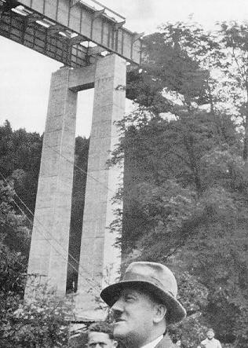
In summer, 1935, at the Mangfall Bridge.

Twelve days after his appointment as Chancellor Of The Reich, The Leader attended the opening of the automobile exhibition on the 11th of January, 1933. In his first official speech as Chancellor Of The Reich, he announced, besides other measures aimed at promoting motorisation, the commencement of a plan for the large scale construction of roads, and added:
Just as the horse and cart once paved its way, and the railway built the necessary tracks, so must motor traffic receive the highways it requires. If in the past attempts were often made to measure the standard of living of a nation in terms of the number of kilometres of railway track, in the future the number of kilometres of roads designed for motor traffic will become the indicator used.
Scarcely three months passed after that 11th February, days filled with the consolidation of the power he had assumed on the 30th January, to the 1st May, the first National Labour Day in the young National Socialist Reich.

With this spring day in nature the sun also rose higher again for the German Nation. The Leader spoke about this, and about the departure of the divisiveness which had existed previously, the elimination of unemployment, the honour of work, the beginning of communal work which, orientated to one will, is the prerequisite and basis for the strengthening of a nation. Towards the end of this first speech about the Reich which was beginning to be built, The Leader uttered these words:
We are mounting a programme which we do not want to leave for posterity to conclude, the programme of the construction of our roads, a gigantic task which requires thousands of millions. We shall clear away all the obstacles against it and begin the task on a grand scale.
With these words, the 1st May had also become a Day Of Development for the road construction programme. From the idea of The Leader the will became reality.
In the weeks which followed, The Leader received experts in road construction from Germany and from outside Germany, and was instructed by them. He then requested of the Cabinet a Law for the realisation of his plans. The obstacles he had hinted at in his speech of the 1st May were surmounted in the course of a series of meetings. On the 28th of June, Cabinet passed the Law pertaining to the setting up of the undertaking called Autobahns Of The Reich. A few days later the Inspector General For The German Road System was appointed by the Chancellor Of The Reich at a short reception lasting scarcely three minutes.

INAUGURATION OF THE INSPECTOR GENERAL

Probably the hottest summer day of the year 1933 in Berlin was the day of the 5th of July. After weeks of summer heat, the buildings of the capital city had retained so much warmth that the short nights brought no relief. As on every other day, the Chancellor Of The Reich began to receive people at ten o'clock in the morning in the Reich Chancellery. These receptions took place day after day with a short break at noon, and continued until late into the evening. Ministers, District Leaders, worker delegations, industrialists, expatriate Germans and many others alternated with each other to talk to The Leader. Many indeed promised in the anteroom to limit their discussion to no more than ten minutes, but The Leader himself would take up the subject matter, give his opinion, elaborate on the questions, and involved himself in the last discussion late in the evening in just as lively a way as he involved himself in the first.

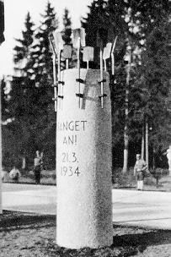
Work emblem at the beginning of the Autobahn München-Landesgrenze (Let Us Begin, 21.3.1934).

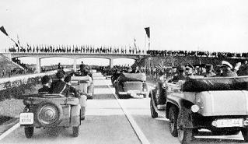
The opening of the first section of the Reich Autobahn München-Landesgrenze.

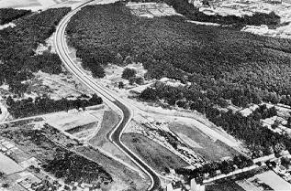
One of The Leader's highways.

The Leader had first asked to see the newly appointed Inspector General at one o'clock in the afternoon for his inauguration. However, as so often occurred, the schedule was upset in the course of the morning by many discussions which ran overtime. The appointment was changed to 7 p.m. with the explanation: The Chancellor would like to see you last so that he has time for you.

When the Inspector General presented himself after the second last visitor shortly before 9 o'clock in the evening, the Chancellor said: Come along, we're going into the garden -- I strongly feel the need for some fresh air right now. During the walk, which lasted one and a half hours, in the garden of the Reich Chancellery, The Leader introduced his Inspector General to his ideas, spoke of coming developments in the traffic system, of the inadequacy of all those measures which were designed to meet only the immediate traffic needs, of far sighted building and construction, warned the Inspector General of obstacles and difficulties, gave reasons for certain technical details, laid down exactly the minimum breadth of the roadway, the construction of which was to meet the highest demands, determined the major lines for the main network, and finally dismissed the Inspector General with the emphatic words: I believe in the necessity of this measure and in the correctness of this beginning, and you must believe in it just as firmly as I do and act decisively accordingly.

THE FIRST CUT OF THE SPADE, FRANKFURT AM MAIN, 23RD SEPTEMBER, 1933

In two and a half months of intensive work, plans and designs were drawn. For the beginning of this great undertaking, which was to stretch over the whole of Germany, only Frankfurt am Main came into question. Here a preliminary survey years ago had already looked into the possibility of a roadway purely for motor vehicles from Hamburg to Basel via Frankfurt. These preparations made for a rapid conclusion to the work on the blueprints. At the

beginning of September, the plans for the first section from Frankfurt to Darmstadt were finished. The first cut of the spade and with it the opening of the construction of this great undertaking were set down for the 21st of September. In the first meetings with the Inspector General, Hitler had already determined that he himself would open the construction of this undertaking.
For years the number of unemployed had risen in Frankfurt until there were approximately 80000 in 1932. Now, in the immediate vicinity of this city, this great construction of The Leader was to start. Thousands of workers were to be given lasting jobs which were to bring back confidence and belief into the lives of the workers and their families. At seven o'clock in the morning, the first 700 workers left the Employment Office. In the central square the District Leader and the Inspector General handed out the tools. From there the workers continued on towards the Main, their new place of work, singing and cheering.
The Leader's plane landed at 10 o'clock. His trip through Frankfurt was fraught with great difficulties: The SA men who formed the barrier cheered The Leader on and the inhabitants of Frankfurt, both old and young, again and again broke through the barrier, so that the trip from the airport to the construction site took more than an hour.
The place where the first spade was to sink into the ground was no festival ground but a construction site. In front of the embankment from which The Leader spoke stood the workers and their families. The guests of honour were a little cramped for space. But here it was the workers who were the guests of honour. The Leader spoke:
We are today standing at the beginning of an immense task. Its significance not only for German transport and communications, but for the German economy in its broadest sense, will only be fully appreciated in the decades to come. In decades to come traffic will be dependent on these new great roads which we will build through the whole of Germany. I know that this day of festivities will pass, and that times will come when rain, frost and snow will make work trying and difficult for each one of you. But it is necessary, the work must be done. No one will help us if we do not help ourselves.
The Leader concluded his speech with the words:
Go now to your work! The construction must begin today. Let the work commence! And before many more years have passed, this immense work will testify to our willpower, our diligence, our abilities and our determination. German workers, to your work!
To the cheers of the workers, The Leader seized his spade after these words, and stepped up to the construction platform. A train rolled forward pulling its large two cubic metre carriages filled high with earth. Slowly and thunderously the carriages tipped out the earth which was to build the six metre high wall at the embankment. With steady hands The Leader dug his spade into the heavy pieces of earth. Again and again he dug his spade into the mound. This was no symbolic digging, this was real earth work! A number of workers realised that The Leader would probably not stop until the two cubic metre mound had been properly levelled. They jumped forward with their

shovels to help. The Leader continued to shovel with them until the mound of earth had been spread in an orderly fashion and the first beads of perspiration fell from his forehead onto the earth. The Leader laughed and stopped shovelling with his two unknown work colleagues when nothing more was left to shovel, and then walked through the work sites where the remaining 700 workers had begun their work in the meantime.

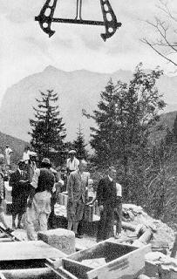
The Leader's interest in road construction: inspection of the Alpine Road.

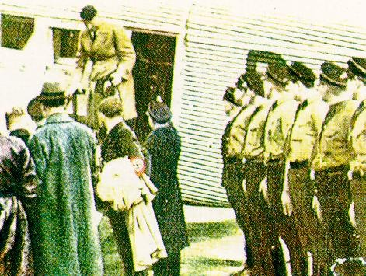
Flight around Germany.

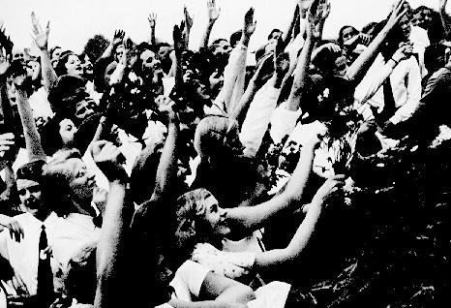
His roads lead Adolf Hitler to his Folk.

Did you see how The Leader even shovelled away the earth from the tracks at the end so that the carriages could move out again? Like a real labourer. He can really work, I scarcely managed to keep up, one of the two later related.
In the week after that first dig of the spade, a Supervisor approached the Site Manager of the Reich Autobahn. Herr Oberbaurat, we must put a fence around the spot where The Leader shovelled. Our workers remove handfuls of the earth after they have finished work and take it home in their bags. Even the women and the children take home souvenirs. Thus The Leader's work and the attitude of the workers have ennobled work, which up till then had fallen into disrepute as the dirtiest work of all. Many worker families today in Frankfurt treasure a small parcel of earth more carefully than any valuable possession.

THE LEADER'S PARTICIPATION IN THE WORK

The Leader is regularly informed of the progress of the work by the Inspector General. In the course of these briefings The Leader intervenes decisively in many details to influence the basic attitude of the coworkers to this work according to his will. In these discussions over the details, it has happened again and again that a decision made by The Leader has proved itself to be the only possible solution in the course of time. An example of this was

the decision about the lines of the section on the southern bank of the Chiemsee in Upper Bavaria. Between this lake and the rising mountains, there is a moor which is several kilometres wide. The crossing of this moor had caused severe difficulties for the railroad. The first design of the line for the Reich Autobahn avoided the moor in a wide arc to the side of the bank towards the south. The Leader did not agree to this line, which offered the road neither a view of the lake nor a view of the mountains. He requested that further and more thorough investigations should be made to determine whether a possibility could still be found to put the road closer to the lake. At his instigation further extensive drilling was carried out in the vicinity of the lake. To everyone's great surprise these further investigations revealed a rocklike ledge close to the lake. This ledge was just wide enough to enable the road to be built close to the side of the lake in accordance with The Leader's wishes.
In the construction of the great bridgeheads, The Leader has also repeatedly made the final choice. One of the first great bridges to be tackled was the Mangfall Bridge near München, with a length of approximately 300 metres and a height of approximately 60 metres above the base of the valley. From a contest which resulted in about 70 entrants, The Leader decided on the design to be used, and thereby determined the type of major bridge which afterwards was to be built at various other places. The lines and shapes of the constructions which The Leader himself determined are clear and simple, and at the same time ambitious and daring. Besides the shape, his decision is greatly influenced by the question of the soundness of the construction. Cheap construction parts, such as hollow pillars and pylons, are rejected by The Leader as they raise doubts about the unlimited durability. His constructions, like all his ideas, do not serve the moment, but the future: What we build must still be standing long after we have gone. The decision of The Leader can also from time to time be a rejection. The rejection is then pronounced and justified clearly. In one case The Leader interrupted the continuing work on an unsuccessful construction, and a telephone conversation with the Inspector General resulted in the immediate reemployment of all concerned.
For the German Alpine Road, The Leader also determined the bases of the routes himself and in repeated cases decided on different details.

MODEL CAMPS FOR WORKERS ON THE REICH AUTOBAHNS

The commencement of construction work in all parts of the Reich in the course of 1934 required workers to be housed partly in huts. These workers' camps were first constructed, as they had been built for many years before, in the building and construction trade. In summer these camps were only just satisfactory. When winter approached, it became urgent to remedy the existing situation, as these camps were inadequate for the workers of Adolf Hitler's roads. A number of reminders to this effect to the industry were only partly satisfactory. In was difficult to remedy the unsatisfactory nature of this accommodation in a quick and satisfactory way after long years of workers having tolerated it. Finally the Inspector General brought the matter to the

attention of The Leader to seek instructions. When The Leader learned that the accommodation in the huts of the workers on his roads left much to be desired, he set changes in motion in the space of a few hours with his customary uncompromising energy which we have seen in similar instances. With the assistance of the Labour Service, model camps were erected in the whole of Germany within a few weeks. The worker on the roads of Adolf Hitler is housed here in clean quarters. Meals are taken in larger rooms. Every camp has washing and shower facilities, with hot and cold water and a communal room for relaxing after work. The Leader himself drew the details for these camps in sketches. Through The Leader's intervention in the autumn of 1934, the housing of the German worker has reached a standard which no other European country can boast of even approaching.

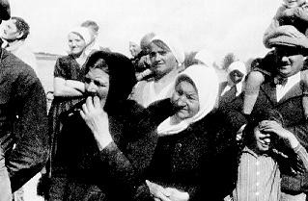
They see The Leader for the first time.

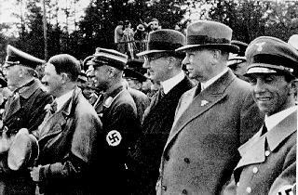
Opening of the Reich Autobahn Frankfurt-Darmstadt in 1935. From left to right:
Reich Minister Of War von Blomberg, The Leader, Inspector General Dr. Todt,

President Of The Reich Bank Dr. Schacht, Director General Of The Reich Railway Dr. Dorpmuller, Reich Minister Dr. Göbbels.

THE LEADER AT CONSTRUCTION SITES AND FINISHED ROADS

The inspection of a construction site or a stretch of road which has just been finished gives The Leader immense joy. The Leader shows an interest in all aspects of the work: the workers, the manner of construction, the housing of the workers; and he also has a keen interest in the positioning of the road with respect to the landscape. The Leader wants his roads to be bold and spacious, but at the same time in harmony with the landscape. The workers are usually very surprised when he suddenly walks out amongst them. Many have dropped their picks in surprise. Then, however, their eyes light up with the purest joy to know that The Leader has come to their work. The feeling of happiness and joy which prevails at a construction site when the faces of hundreds of grown men express their delight in a way we have only ever seen in children in front of a Christmas tree is totally unimaginable. As a rule the workers stay at their spots and, after their initial surprise, continue to work. In doing so they show their capacity for work. The Leader speaks with individuals, particularly with older workers. 60-70 year olds are no exceptions at these sites. To one 70 year old The Leader said near Darmstadt: When I am as old as you, I would like to still be able to work as you are doing now.
The first trips over completed stretches of road inspire The Leader.
The traffic counts interest him, particularly as they confirm the interest of private and commercial motor travel in the new roads. The stretch from Heidelberg to Frankfurt am Main was christened by The Leader with a picnic. He came for the first trip a few days before the section was opened to traffic on the way from Mittelbaden after the Rheinland. Having been advised by the Inspector General, The Leader determined that a rest stop should be made at a suitable picnic spot. In the magnificent autumnal beech forest, The Leader's cavalcade left the Autobahn, and Kannenberg, the Provisions Master, produced a splendid repast in the woods. After such a trip over a section of road which has just been completed, one later hears from those who had been present just how enthusiastically The Leader speaks about his roads.
Thus the roads of Adolf Hitler come into being in close connection with their creator. The immense importance of these completed roads for the future development of transport and communications has been repeatedly emphasised by The Leader himself: In a few years, these roads will be one of the most powerful means of promoting an increase in motor traffic, and with it, in productivity, the extent of which is still inconceivable today, but also an annual attraction for many hundreds of thousands of foreigners, because, after the completion of the Autobahns, Germany will be able to lay claim to having by far the most modern network of highways in the world (15th February, 1935, at the opening of the Automobile Exhibition).

Far beyond the borders of Germany, countries are observing the road construction of our Leader. Almost weekly, official and private groups of foreign guests come to visit the construction sites or the completed stretches of the Reich Autobahns. The enthusiasm and admiration with which they observe The Leader's gigantic work are expressed in their letters and their newspapers. From the many foreign press agencies one has written:
Just as the pyramids tell of the history of the Pharaohs, and the Roman roads testify to the power of the Roman Emperors, so the magnificent highways will serve to remind the German Nation of the most outstanding figure in its history, a National Comrade, once without name and position, who from nothing and without external help created a new Reich merely through his own strength and imposed his will on the fate of the whole Nation.

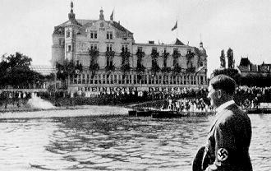
The Leader travels on the Rhein to attend the transfer of the Saar in 1934, on
the Ehrenbreitstein.

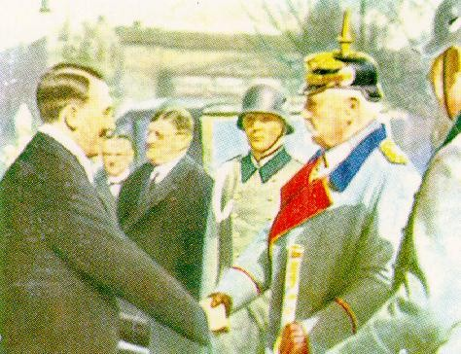
The Federal President and the Federal Chancellor.

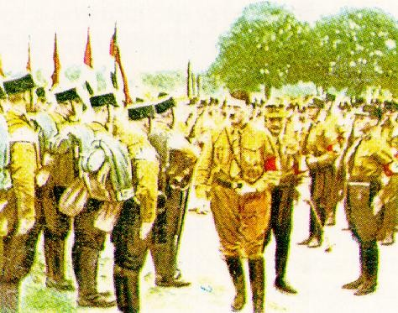
Viewing the SS troops.

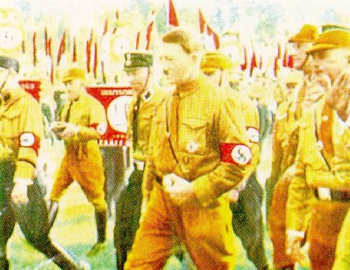
Braunschweig March, 1931.

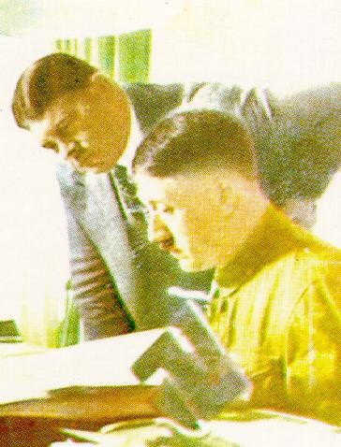
The Leader and Troop Leader Röhm.

Our Hitler: A Radio Broadcast -- The German Folk On The Leader's Birthday -- By Dr. Joseph Göbbels
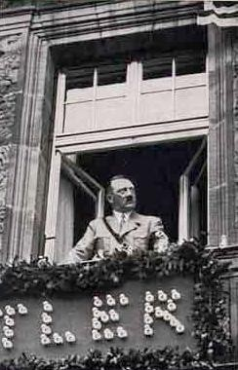
In the city of the Party rallies. At the window of the hotel Deutscher Hof in Nürnberg.

However often The Leader must show himself to thousands, at times hundreds of thousands, of people at mass gatherings, at receptions or at state functions as the representative of the Party and the German Nation, and converse with them, just as often The Leader consciously avoids all demonstrations and honours which are aimed only at him and him alone. It is this attitude which has led to his spending his birthdays in some little village or in a little town in Germany which previously had been generally unknown. Just how strongly The Leader impresses his closest colleagues by his very humane and very personable nature can be felt in the radio speeches which Reich Minister Göbbels has given to the German Nation on all radio stations on the occasion of The Leader's birthdays. The text of the third speech on the 20th of April, 1935, particularly merits being recorded within the covers of this work.
Ladies and gentlemen, my National Comrades! Two years ago

already, on the 20th April, 1933, after Adolf Hitler had been in power for a mere three months, I gave an address to the German Nation on the radio on the occasion of The Leader's birthday. Just as then, it is not my intention today to read out to you a glowing editorial. I leave that to better stylists. Nor shall I endeavour to honour the historical work of Adolf Hitler. On the contrary: Today, on the occasion of The Leader's birthday, it is time, I think, to present to the whole nation Hitler, the man, with all the charm of his personality, the mysterious magic and the immense strength he radiates. There is probably no longer anyone on the face of this earth who does not know him as a statesman and as a superior national leader. Only a few, however, have had the privilege of being in his presence daily, seeing him at close hand and, I may add, consequently getting to understand and love him all the more. These few alone have understood the miracle of how and for what reason it is possible that a man, who a mere three years ago still had half the nation against him, today has been elevated above all doubt and above all criticism by the entire nation.
If Germany now has found an unshakeable unity, then it is in the conviction that Adolf Hitler is the man of destiny who has been called upon to raise the nation up again out of its most terrible internal divisiveness and the humiliation imposed on it from without to the freedom its Folk have longed for.
The fact that one man through his work, which has at times necessitated hard and unpopular decisions, has captured the hearts of the whole nation, is one of the deepest and most so wonderful secrets of our time. This cannot be explained merely by the force of his achievements, because it is the very Folk who have sacrificed the most, and those who must still make sacrifices in the cause of national reconstruction, who were most moved by his broadcast, and who are the most sincere and ardent in their love for him as The Leader and as a man. This is the result of the immense charm of his personality and the magic of his pure and unspoilt humanity.
This humanity, as it is revealed most vividly to those closest to him, is to be the subject of this speech.
Like every genuine humanity, so this one is simple and clear in its being and in its action. This is revealed just as much in the smallest as in the greatest things. The simple clarity which is foremost in his political dealings, is also the ruling principle of his whole life. It is totally inconceivable to imagine him posing. His Folk would not recognise him again in a pose. His daily menu is the simplest and most modest that one can imagine. Its presentation does not change whether he is dining with a few close friends or with important State visitors. When recently at a reception for the Districts Leaders of the Winter Assistance Scheme, an elderly Party member asked him to sign a menu as a souvenir after lunch, he hesitated for a moment, and then laughed and said: It really doesn't matter. Here the menus never change, and anyone may have a look at them.
Adolf Hitler is one of the few State leaders who, with the exception of a single distinguished war medal which he won as an ordinary soldier for his immense personal bravery, never wears medals and decorations. This shows his restraint, but also his pride. There is no one on Earth who could be more

distinguished than he himself. Every sign of obtrusiveness he finds unpleasant; but wherever he has to represent his Government and his Nation, he does so with a composed and impressive dignity. And behind everything he is and does are the words which the great soldier Schlieffen wrote about his work: More essence than appearance! In him, diligence and an untiring tenacity which reach out far beyond normal human strength, combine in the pursuit of set goals. A few days ago when I landed again in Berlin at one o'clock in the morning, he was still sitting fresh and engrossed in his work alone in his apartment. He had me report for close to two hours about the construction of the Reich Autobahns, a topic which seemed totally removed from the weighty problems of foreign policy with which he had been dealing the whole day from early in the morning until late at night. Before the last Party Day in Nürnberg, I was his guest for a week on the Obersalzberg. Every night until six or seven in the morning, there was light to be seen at his window: The Leader was dictating the great speeches which he gave a few days later at the rally of the Reich Party Day. No law is accepted in Cabinet which he has not thoroughly studied to the last detail. He is the most thorough and well informed military expert; every piece of artillery and every machine gun he has a specialist's knowledge of. Only those who are familiar with the finest details can inform him in such matters.
His work pattern is clear and precise. Nothing is more distasteful to him than nervous haste and hysteria. He knows better than anyone else that there are a hundred and one problems which need to be solved. Of these, however, he chooses two or three pressing ones which he has identified as the general problems, and refuses to let himself be distracted by the gravity of the remaining ones as he attends to them. He knows that by solving the few very great problems, problems of lesser importance often tend to solve themselves as a result.
In attacking the problems themselves, he shows on the one hand the firmness which is required to carry through the principles, and the flexibility which seems to be necessary in implementing the methods.

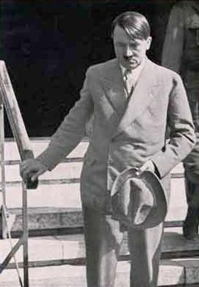
Last visit to Hindenburg before his death in July, 1934.

The Leader is nothing less than a stickler for his principles and a worshipper of dogmas; however, principles and dogmas never come off badly because he approaches them with the superior adaptability of his methods and procedures. His goals have never changed. What he is doing today is what he wanted to do in 1919. However, in accordance with the situation at hand, he has always been able to change the methods which he used in the past to achieve these goals. When he was offered the office of Vice Chancellor in 1932, he refused plainly and bluntly. He had the feeling that the time was not yet ripe, and that the ground on which he was to be placed was too narrow for him to remain standing on. When on the 30th of January, 1933, a wider door was opened to him, he strode through courageously, even if it was not total responsibility which he was given. He knew that the foundation on which he was now standing was sufficient for him to begin the struggle for absolute power from there. Those who claimed to know better at the time understood neither one nor the other; today they need to offer their apologies humbly because he was superior to them not only in tactics but also in the strategic carrying out of principles whose champions they had set themselves up to be in arrogant short sightedness.

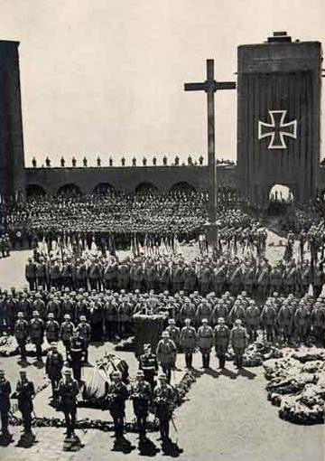
Funeral service for Field Marshal von Hindenburg in the Courtyard Of Honour of the Tannenburg Memorial: The Leader's obituary.

Last summer two photograph appeared in the press which show The Leader's solitariness in a most startling way. The first shows him saluting a march past of the Army from the window of the Chancellery the day following the 30th of June, when he was forced to wash treason and mutiny away with bloodshed. His face was almost paralysed by the incisive bitterness of the difficult hours he had just experienced. The second photograph shows him leaving the house of the Reich President after a last visit to the dying Field Marshall. His face is overshadowed by pain and sadness at the merciless death which was to rob him of his fatherly friend within the next few hours. It was

with an almost prophetic foresight that, on New Year's Eve, 1934, he had already told a few of his close friends of the great dangers ahead for 1934, and that Hindenburg would be torn from our sides in the course of the year. Now the unavoidable had happened, and in the drawn features of one individual is expressed the pain of a whole nation.
This whole nation not only admires him but loves him with all their heart because its Folk feel that he belongs to them, is flesh of their flesh and spirit of their spirit. This is expressed even in the smallest and most trivial things of everyday life. There is, for example, in the Reich Chancellery a respectful camaraderie which ties the last SS Man in the escort command irrevocably with The Leader. On trips everyone sleeps in the same hotel and under the same conditions. Is it a wonder then that it is the most modest people in his entourage who are the most devoted to him?! They have the instinctive feeling that there is no pretence, and that everything about The Leader is natural and comes from deep within his soul.
A few weeks ago, about 50 young girls, German nationals living outside the Reich who had spent a year in the Reich on courses and now had to return sad to their homelands, asked in the Chancellery if they could briefly see The Leader. He invited them all to dine with him, and listened for hours as they talked about their homes and their modest lives. As they were leaving they suddenly joined in the song When Everyone Becomes Unfaithful, and huge tears ran down their cheeks. In the midst of them stood the man who had become the embodiment of an eternal Germany for them, and who now sent them on their difficult way with warm and friendly words of consolation.

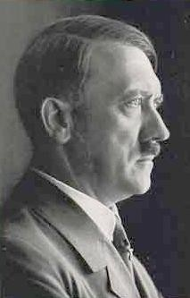
The Leader on his 47th birthday.

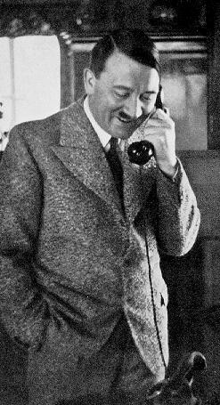
On the morning of the 15th of January, 1935: The Leader thanks District Leader Burckel on the occasion of the Saar Victory.

He came from among the Folk, and he has remained one of them. He, who spends two days in 15 hour conferences with the statesmen of the world ruler England, negotiating with polished dialogue and a masterly control of the arguments and figures over the fate of Europe, speaks in the same completely natural way to men of the Folk. By a friendly, informal Du, he restores at once the self confidence of a war comrade who approaches him with trepidation, and has probably been deliberating for days as to how he should address him and what he should say to him. The smallest children walk up to him with a friendly and trusting nature because they sense that he is their friend and their protector. In fact, the whole Folk love him because they feel safe in his hands, like a child in the arms of its mother.
This man is fanatically possessed by his cause. He has sacrificed his happiness and his private life for it. There is nothing else for him than his work

which fills him and which he serves as the most faithful worker in the Reich with deep humility.
An artist becomes a statesman, and in his historical construction his great artistry is revealed again. He requires no external honours; his most lasting and immortal honour is his work itself. We, who have had the fortune of being daily in his presence, shine only in his light, and want only to be his obedient followers in the train led by his banners. Often enough he has said in that small circle which is comprised of his oldest combatants and his closest friends: It will be terrible one day when the first amongst us dies, and his empty place will no longer be able to be filled. May a kindly fate grant that his place remains filled for as long as possible, and that for many more decades to come the Nation under his leadership will be able to continue along its path to new freedom, greatness, and power. This is the most sincere and fervent wish which the whole of the German Folk lay at his feet today in gratitude. And like us, who stand gathered closely around him, so at this hour may the last man in the furthest village join in saying:
What he was is what he is, and may he always remain what he is: Our
Hitler!
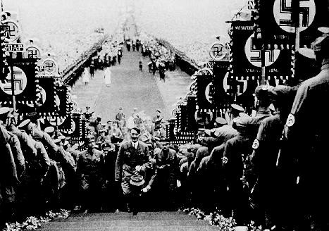
Buckeberg, 1934.

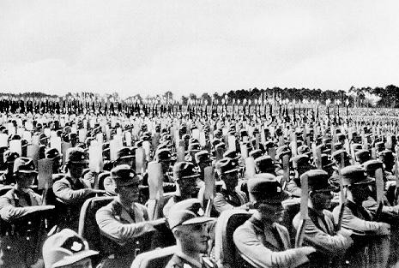
The Work Army. Reich Party Day, 1935.

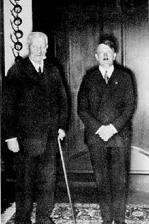
Reich President von Hindenburg and Reich Chancellor Hitler.

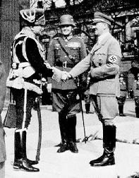
Hero Commemoration Day, 1935. In front of the Memorial in Berlin.

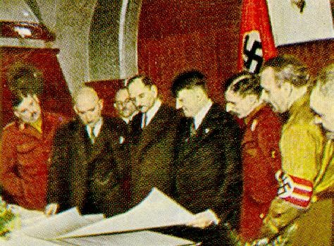
Adolf Hitler entertains prominent citizens of the Free State Of Bavaria.

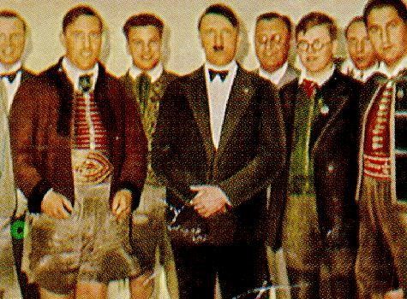
Farmers with the Chancellor.

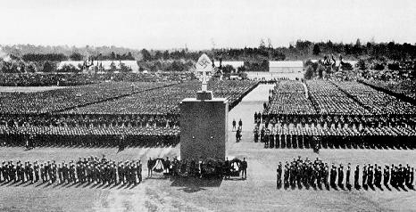
Reich Party Day, 1935: The Labour Soldiers.

The Leader And The Defence Force -- By Lieutenant Colonel Förtsch

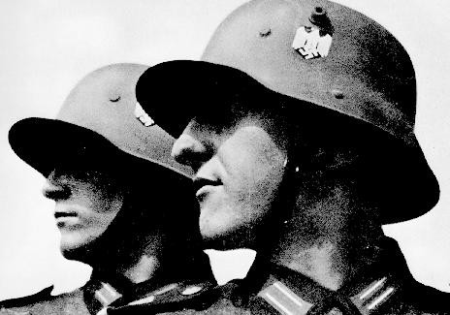
Germany's present.

Adolf Hitler was a soldier in the German Army. He was so on a voluntary basis, and with every fibre of his being in the greatest war which an Army ever had to fight, in the hail of bullets of raging world battles, in dirt and mud and clouds of gas, in the very front line which for four long years bled to death for the Homeland.
He was a keen observer. He understood what the November Revolution could not, and was incapable of, understanding if it were not to have its activity immediately revealed as outrageous treason: that a Folk cannot work if they are unable to protect the workplace of even their smallest son from enemy attack, that it cannot cultivate the earth if the sword does not guarantee the plough. He also saw what the Old Army was lacking, and how it had been sinned against in the liberal era of 1914 by the Reich Parliament.
Thus two basic facts revealed themselves to him: the restoration of German military freedom, and, at the same time, the creation of a new German Defence Force, strong enough to defend the German borders from any attack, and secondly, basing the formation of the Defence Force on old idea of universal conscription and on the principle that military service is a service of honour to the Nation. It is therefore not accorded to anyone unworthy or

inimical to the Folk, nor should there be any preferential treatment or special considerations granted to any individuals.
With inner sympathy and great satisfaction, The Leader saw that the Reich Defence succeeded, amidst the pacifism and defeatism, the treason and the dilapidation of the November Republic, in keeping the German Defence Force in form and even shaping from it a strong and useful weapon within the framework of the existing possibilities.

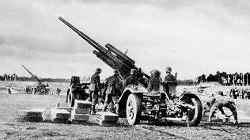
Day Of The Defence Force, 1934, in Nürnberg: antiaircraft gunners in position.

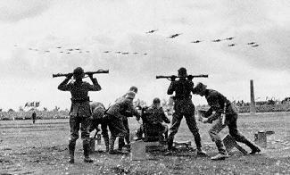
Rangefinders of the antiaircraft battery on the Day Of The Defence Force at the
Reich Party Day, 1935.

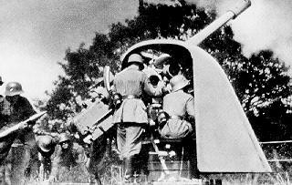
Coastal protection: marine artillery defending the coast.

Already in the early stages there began as a result a liaison between the Reich Defence and The Leader of the National Socialist German Workers' Party. Particularly the younger Officers soon realised that here was a man who was the only one capable of rebuilding the German Army once again.
A few days after the 30th of January, 1933, The Leader, who had just been made Chancellor, assembled in the Ministry Of The Reich Defence all the higher ranking Commanders. In detail he revealed to them the essential features of National Socialist politics. He assigned to them their tasks, and put them clearly into the picture concerning what he demanded of the Defence Force, and what its duties would be in a National Socialist Germany. The public at large heard nothing of this discussion. It was only two years later that the new German Defence Force emerged to see the light of day.
When Adolf Hitler wrote his work My Struggle, he remembered the Old Army in which he had served for four years as an ordinary soldier, and then later as a Lance Corporal, and he remembered it with words which show today and always the great pride in the German Defence Force: The Army was the most powerful school in the German Nation, and it was not in vain that the hatred of all its enemies was directed expressly against this umbrella of national survival and freedom. No more splendid memorial can be dedicated to this single institution than the realisation of the truth that it was slandered, hated, fought, but also feared, by anyone and anything inferior. What the German Folk owe the Army may be briefly summarised in a single word: everything. The Army taught absolute responsibility at a time when this quality had already become rare; furthermore, it taught personal courage in an era when cowardice threatened to become a rampant illness, and the willingness to make sacrifices for the common good was already considered almost stupidity. The only people thought to be clever seemed to be those who knew best how to protect themselves alone and to promote their own best interests. It was the school which still taught the individual German not to look for the well being of the Nation in the hypocritical phrases of its international alliances, but in the strength and unity of its own national traditions. The Army taught decisiveness,

whereas in the rest of the community indecisiveness and doubts began to determine the dealings between the people. In an era when know it alls were setting the tone everywhere there was a lot to be said for upholding the principle that a command was always better than none at all. In this one single principle there was still a robust, unspoilt healthiness which had long since become lost in the rest of our life if the Army and its training had not ensured the continuing renewal of this elemental force. The Army taught idealism and devotion to the Fatherland and to its greatness. It taught that there was a united Folk and not separate social classes, and here perhaps its one flaw showed, namely, the institution of a yearly voluntary service. The highest achievement which can be attributed to the Army of the Old Reich, however, must be that at a time of general outvoting of heads, it placed the heads above the majority. The Army upheld the belief in personality against the Jewish democratic notion of a blind worship of figures. Thus it also taught what the present required most urgently: men. In the swamp of a general softness and lack of masculinity, there shot out from among the ranks of the Army every year 350000 vigorous young men who, in their two year training, had lost the softness of youth, and whose bodies had become as hard as steel. The young man, however, who during this time had practiced obedience, could now learn to command. The soldier who had done his military service could be recognised by his very step. This was the highest school of the German Nation, and it was not in vain that upon it was concentrated the grim hatred of those who, out of jealousy and greed, desired and wished for the impotence of the Reich and the defencelessness of its citizens. What many Germans were too blind to see or refused to see due do ill will was recognised by the rest of the world: The German Army was the most powerful weapon in the service of freedom in the German Nation and the nourishment of its children.

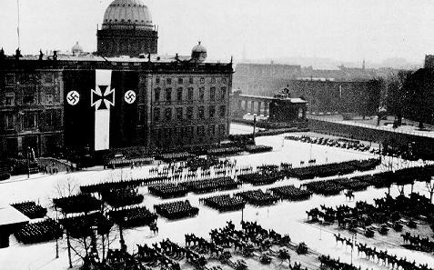

Announcement of the freedom of the Defence Force, 1935.

In one respect, however, The Leader's opinion of the Old Army could not apply to the new Defence Force as it had to exist after the Treaty Of Versailles. This was because it was not formed according to the will of the Folk. Its form was forced upon it from without. Barely two in a thousand in the population were allowed to undertake military service. Therefore the Defence Force no longer exercised the extensive, educative effect it once had.
Thus it was a matter of course for The Leader to ensure that this professional Army was once again replaced by a true Folk's Army. Every soldier knew this as well, and therefore it cannot be surprising that the decision of von Hindenburg, the Reich President at the time, to entrust The Leader with the office of Chancellor, was greeted with enthusiasm particularly by the Defence Force, because if any power in Germany at all could free the Army and Navy from the oppressive shackles of Versailles, then it was the power of this Chancellor behind whom marched the strongest political Movement of the Folk.
However, even in the ranks of the Reich Defence, it was clearly realised that this act of liberation could not be child's play, and that the greatest difficulties would be encountered. But there was at the same time an unshakeable belief that The Leader and only The Leader would be in the position of bringing about this act.
When his decision of the 14th of October, 1933, to turn his back on the League Of Nations became known, every soldier's heart leapt for joy because everyone understood that now the restoration of German military freedom had been achieved.
It is no coincidence that, since that memorable Potsdam Day, the German Army marched next to the SA and the formations of the Party on all German holidays. This new Army, which is a true Folk's Army, and which knows no differences of background, wealth or social position, just as the Party has never taken these into account, belongs to the Folk. It belongs in the midst of the Folk, and thus does not consider it a command but a matter of course that it should be amongst the Folk on these holidays, whether it be the 1st of May or the Harvest Festival, whether it be festive or mournful occasion, or whether it be the great Nürnberg Folk Day. Everywhere the Defence Force stands shoulder to shoulder with the National Comrades.
Thus even in his great Reich Parliament speech of the 30th of January, on the anniversary of the National Socialist Revolution, The Leader could say about the relationship of the Defence Force to the Party the following words:

It is a unique historical occurrence that, between the powers of the revolution and the leaders of a most highly disciplined Defence Force, there should be such a warm and close association as there is between the National Socialist Party and me as its Leader on the one hand, and the Officers and Soldiers of the German Reich Army and Navy on the other hand. The Defence

Force and its leadership has stood in complete loyalty and allegiance to the new Government. The fact that the Defence Force has no special existence, but is a National Socialist Defence Force, goes without saying in a National Socialist Government, but even in external matters this is expressed with pride and joy by the fact that every man who serves in it, from the Commander In Chief to the last recruit, wears the National Emblem of the National Socialist Movement on his uniform.

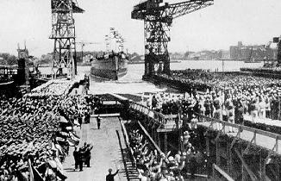
The launching of the armoured ship Admiral Graf Spee.

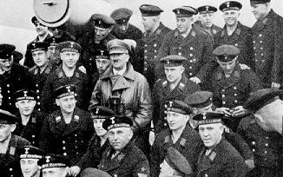
The Leader amidst his Blue Boys.

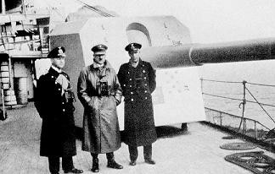
A visit to the Fleet.

The Leader has repeatedly emphasised this, and has described the Party and the Defence Force as the two pillars on which the construction of the National Socialist Third Reich is founded. With great clarity he explained that the Party was the political will bearer of the Nation, and the Defence Force the weapon bearer. Consciously and entirely of its own free will, the Defence Force developed totally in the National Socialist sense in the new Government, and allied itself to the Government for better or for worse. It is a straight line from the introduction of the comradely greeting with the Divisions of the National Socialist German Workers' Party, through the participation on all the festivities of the Party and the Government, to the introduction of the National Emblem of the Movement into the Defence Force, its participation in the Party Days, to the raising of the Naval Ensign decorated with the Swastika. And the Duties Of The German Soldier have been written in the National Socialist spirit just as the Oath Of Allegiance also expresses this:

I swear to God this holy oath, of absolute obedience to The Leader of the German Reich and the German Folk, the Commander In Chief of the Defence Force. I also swear as a courageous soldier that I will be prepared at any time to risk my life for this oath.

The Reich Minister Of War, from the first day he assumed office, had left no doubts that the National Socialist world view would also have to be the irrevocable basis for the life of the German Defence Force. During his addresses to the troops and on all other occasions, he alluded to this again and again and stated that the vow of loyalty to The Leader and his work was honourable and sacrosanct. The Defence Force grew in the Government of the German rebirth. The Reich War Minister himself once put this into words in an essay in the Folkish Observer: It came as what it was, as the innerly organised, disciplined means of power in the hands of its leadership. It serves this Government, which it supports from deep conviction, and it stands to this leadership

which gave back to it the first and foremost right not only to be the bearer of its weapons but also to be the bearer of an unlimited trust on the part of the Folk and the Government. Today a military view of things penetrates the whole of the German Folk. The strength in which the Defence Force is carried streams as an elemental force from the source of a strong belief in Germany and its right to survival. Today the soldier stands consciously in the middle of the political life of a united Folk. Military service has once again become a service of honour to the German Folk. The Defence Force has stood up to the difficult test of discipline in Germany's darkest time, under incredible strain at times, and has won out. The action groups of the trenches of the World War which Hitler made as the foundation of the new National Community became the starting point of the great tradition which the Defence Force inherited from the Old Army. It stands in close association with the whole of the Folk, proudly wearing the National Emblem of Germany's rebirth on its steel helmets and uniforms, in military discipline and loyalty behind the leadership of the Government, The Leader of the Reich, Adolf Hitler, who once came from our ranks, and will always remain one of us.
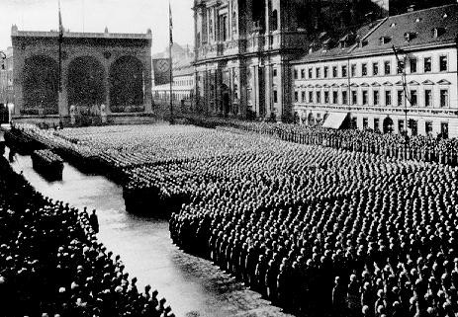
The first swearing in of recruits of the Folk's Army at the Feldherrnhalle in München on the 7th of November, 1935.

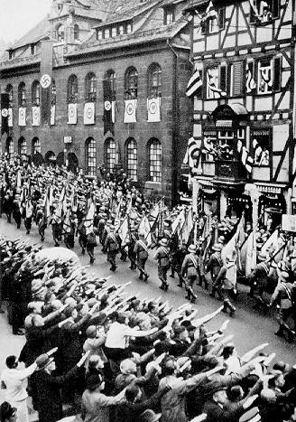
The Reich Party Day at Nürnberg, 1935: The Navy during the march past on the Day Of The Defence Force.
Here one can read the very secret which binds The Leader with the new Army. It is the same secret which binds The Leader and the worker, The Leader and the farmer, The Leader and the political fighter, because each one can say with conviction: He is one of us. The Leader comes from the farm, he was a worker like millions and millions of his National Comrades, and, as an ordinary soldier, he lay in the trenches during a four year war for the continued existence of Germany, again just as millions and millions of Germans did. He was a soldier, a courageous soldier, who risked his life as a dispatch rider in the midst of the hell that was the barrages, and when today the old soldiers from the World War sit together with The Leader, then they talk about this time as they all risked their lives for the Fatherland, and this now unites them in an immense friendship. They all know to whom they have sworn their personal oath, namely, to the comrade from the Great War, and in him to the legacy of all the fallen.
This is what makes the Defence Force a National Socialist body even from within: The Leader is its leader. He will always remain the soldier who is prepared to ward off the

enemy with his own life, and who therefore also has the right to demand this of others. He is aware of the needs and worries a soldier has, he knows what he wants and what must be kept from him, and he knows this not from reports and hearsay, but from his own great experience. Thus it is obvious that for the Defence Force today there is no greater pride than to be associated with this man, and when the troops parade before him their eyes light up, their step becomes more determined, and every muscle tenses to its greatest strength. The Commanders, however, know that the new Defence Force owes its existence principally and solely to this man who in tough political negotiations and with rigorous attention to detail created the possibility of reestablishing German military sovereignty and restoring the old right of the free German man to military service.

However, The Leader always impresses on the young soldier that this civil right to serve the Folk entails enormous responsibility, and as much as the Defence Force will find in him every support for what it requires, so he asks expressly that every soldier be aware that it is the sacrifices of the whole Nation which allow him to carry out this civil right and bounden duty. Thus after the magnificent military spectacle on the Reich Party Day in 1935 in Nürnberg The Leader spoke these fine words to his soldiers: Whenever you have to make personal sacrifices in matters of obedience, fulfilment of duties, subordination, hardness, endurance and efficiency, do not forget, my soldiers, that the whole of the German Folk also make great sacrifices for you. We make these sacrifices in the conviction that no war is needed to reward us for them. You need conquer no glorious title for the German Army -- this it already possesses -- you need only to keep it. Germany has not lost its military honour, and least of all in the last war. It is up to you to ensure that the trust of the Nation will always be yours as it once was the Army's whose helmet from its glorious past you now wear. Then the German Folk will love you, will believe in its Army, and make every sacrifice gladly and joyfully in the conviction that in doing so the peace of the Nation will be maintained and the upbringing of the Folk guaranteed. This is the plea of the Nation, its expectation of and request to you. And I know you will fulfil this request, the expectation and this plea, because you are the new soldiers of the new German Reich.
Thus The Leader and the Defence Force, the Defence Force and the Folk are one, just as the Folk and The Leader are one, bound not only by oaths and promises, but through the common striving and the common will towards a free and united, strong National Socialist Reich.

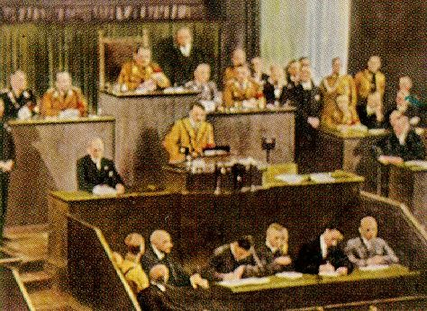
Adolf Hitler's freedom speech to the world.
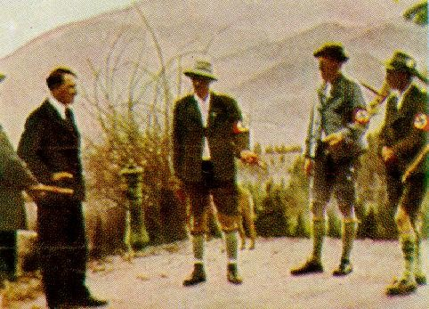

Berchtesgaden hunters.
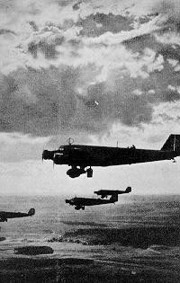
Bombers over Nürnberg.
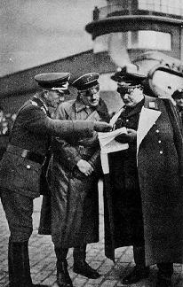
First inspection of the Richthofen Squadron.

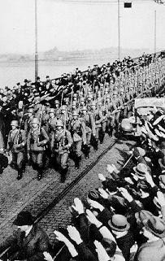
The entry of German troops over the Rhein Bridge at Mainz on the 7th of March, 1936.
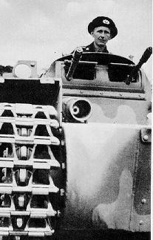
The new tank weapon.

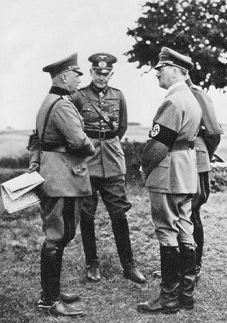
The Leader with the Reich Minister Of War and the Commander In Chief Of The Army in 1935 at the manoeuvres on the military training area near Münster.
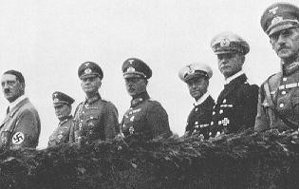
On the Day Of The Defence Force, 1935: The Leader with his Commanders In Chief: from left to right: Air Chief Marshall Göring of the Airforce; Field Marshall von Blomberg

of the Defence Force; General Freiherr von Fritsch of the Army; Admiral R ä der of the Navy.
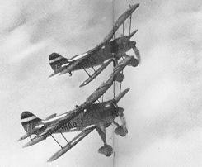
Our Luftwaffe.
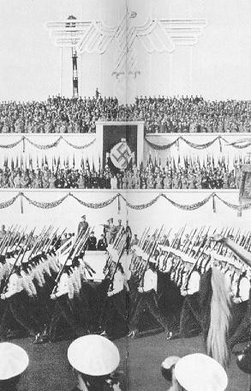

The Nürnberg Reich Party Day, 1935. The flags of the old glorious Army on the Day Of The Defence Force.
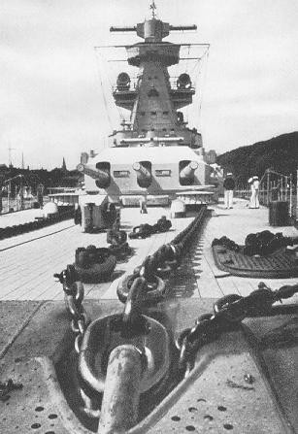
The Lützow tower and battle mast of the Admiral Scheer seen from the forecastle.

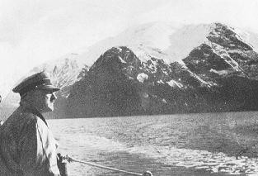
On board a warship, The Leader visited the Norwegian Fjords.
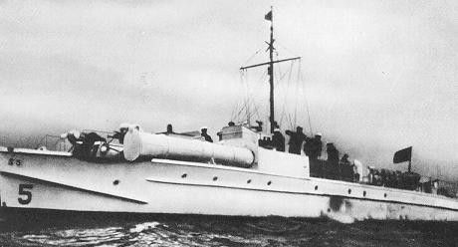
The greyhounds of the Baltic: A German Schnellboot.

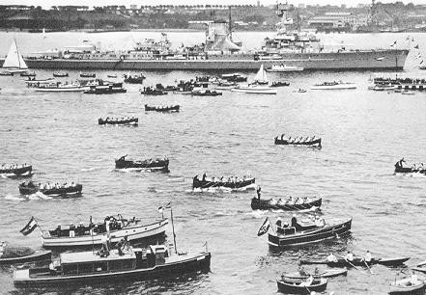
A visit to the Fleet in Kiel, 1934.
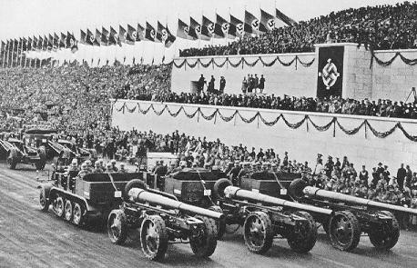
The Day Of The Defence Force in Nürnberg, 1935: motorised heavy artillery.

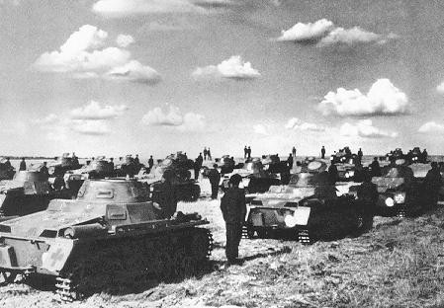
Once again we have tanks because of Adolf Hitler's action.
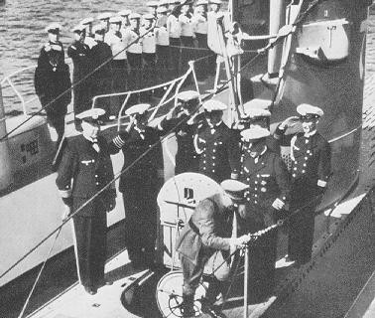
In August, 1935, in Kiel, The Leader inspects the first German submarines.

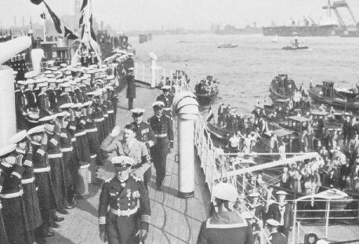
The Leader visits the Schleswig-Holstein in the port of Hamburg.

The Leader And German Youth -- By Baldur von Schirach, Lead Of The Hitler Youth

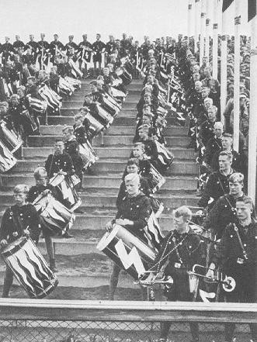
Party Rally Of Freedom: the youngest drummers in the Nation.

The Leader is paid homage by our youth in all parts of the Reich, and to the concept of Adolf Hitler today belongs the picture of an inspired and devoted youth which cheers him on and serves him. We have become accustomed to it as to something totally natural. Whether on his journeys he drives through an uninterrupted Guard Of Honour formed by this youth, or whether he is surrounded by it during the great festive occasions of the Movement, its marches and rallies, young people are always there where The Leader is, always and everywhere declaring their support for him. This picture to which we Germans have become so accustomed always appears to the foreigner as something marvellous; the mythical concurrence of The Leader of

the Nation with the young generation belongs to those inexplicable things which the foreigner calls the German miracle. There is, in fact, hardly a better expression for this occurrence of complete unity, not only of all classes, ranks, and religions, but also of all the generations of our Folk. And this seems a miracle to us Germans ourselves: the fact that The Leader succeeded in committing all age groups of our Folk to a common ideal, which each person tries to follow in his own way, that is, with the strength over which he prevails. The younger ones and the very young follow it with that passion and power of enthusiasm which has always characterised a forwards striving German youth; the older people and the aged with the calm clarity of purpose, constancy and mature strength which characterises their years. Thus Adolf Hitler raised an entire Folk to serve an idea. The ten year olds are the upholders of his work and heralds of his will with convictions which are just as strong as those of the thirty to forty year olds. Indeed, it is particularly these youngsters who feel especially drawn to the figure of The Leader because they sense with the unmistakable certainty of their instinct that The Leader has dedicated his thoughts and concerns to them above all. They know that he serves the future, which they themselves represent.
Germany has suffered greatly, particularly in its more recent past, from the conflict between the younger and the older generations. This conflict was felt in almost every family, particularly in the decade after the Great War. It is pointless to try to examine who should bear the blame here. Only this much will be said in this respect, and that is, that the blame for the obvious lack of respect and discipline which the youth at the time displayed did not rest solely on the youth itself. These young people lacked completely any models in the older generation. The so called statesmen of the time could arouse no enthusiasm in relation to their personality and their work, and were rejected or despised; thus all that remained to them were the unsatisfactory and false models provided by the film stars and sports heroes. Should one reproach the young people of that time because they could not fulfil the expectations of their elders? Does not every educator know that young people require great and above all heroic models in order to be able to take the direction which is necessary for the Folk? Men, whose heroic participation in the World War should have been able to place the young people under an obligation, were derided and abused by the press and even by influential figures in the Government, and the heroic ideal could be mocked publicly as an ideal of stupidity and go unpunished. In such circumstances it seems obvious that young people lost all sense of standards and manners. Because many members of the older generation behaved in a contemptible way, the young people concluded that all older people were contemptible. Because cowardice was praised, they believed in the cowardice of all men, and completely lost their sense of right and wrong, reasonable limits and laws: The great sex trials against young people at that time, as well as the general crime rate of young people in the post War years, are still alive in our memories. They show us with horrifying clarity what can happen even to young people in Germany when they have no leadership.

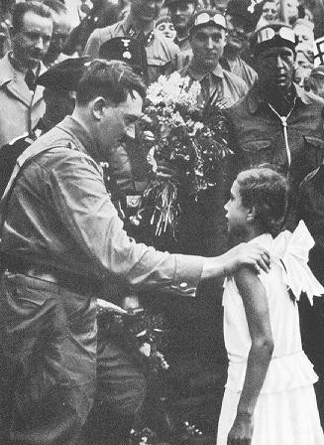
She says her little poem. The Leader on one of his election campaigns in 1932.

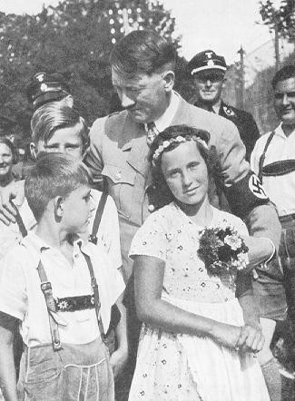
Again and again The Leader is seen in pictures surrounded by children. To the right is Baldur von Schirach.

Adolf Hitler has tried from the first day of his work to lead young people back again to himself. The fact that this attempt has succeeded to an extent that even the greatest optimists had never expected is due exclusively to his inexhaustible willpower and persistence. It is all too easy for the superficial observer of the years of struggle of the National Socialist Movement to overlook the painstaking attention to detail which, next to the great slogans and battles of the Movement, was required for its foundation and construction. Nor was the National Socialist Youth Movement merely handed to The Leader; it did not arise, as many people seem to think, merely as a result of appeals in the press and speeches, but, as in all branches of the Movement, here also The Leader strove unceasingly for years and years to formulate the guidelines of its construction until he announced the fundamental sentence according to which his youth leaders had to work. When Hitler had implanted the saying: Youth must be led by youth, a new era in the history of the education of mankind had begun. Only a genius can simultaneously with one saying close off the past and

open the future. With his slogan about youth education, Adolf Hitler won all the young people of his Nation to his cause. It is immaterial that at first this basic principle of The Leader was barely understood; indeed that there were people who tried to mock it and make it sound contemptible as they did all programmatic utterances The Leader made. It is just as irrelevant that the Youth Movement, whose structure was determined by this rule, comprised only a few thousands. The only important and essential thing is that Adolf Hitler, from the spirit of the young people and with a capacity for understanding them such as no statesman or educator before him had possessed, set up and announced a programme which -- we felt already at that time -- was to build from the tiny community at the time the greatest Youth Movement in the world.
Apart from Adolf Hitler, all statesmen of the past and the present have seen the leadership of the youth exclusively from the older generation, in so far as they considered the leadership as a general task which belonged to their generation. This had been handed down to them as a matter of course, to which they gave no further thought. The older people relieved the younger people of responsibility and leadership within their own sphere of life. Large scale governmental youth organisations in other countries are conceived and run in this way; Adolf Hitler, contrary to all the methods of educating the youth up to now, has placed on the shoulders of the youth itself the responsibility for its actions. It was he who proclaimed responsibility as an educative force.
It belongs to the most moving testimonials to the inner worth of German youth that it did not disappoint The Leader's trust, but, on the contrary, endeavoured to justify a trust which it only ever regarded as an honour and a duty. Thus it proceeded according to The Leader's guidelines and, working painstakingly and advancing step by step, has developed into a powerful community which has no comparison anywhere in the world. All this was accomplished without the compulsion of a law, without instruction by a Minister, exclusively through the inner strength of the idea which propelled it. One should try to imagine the significance of the fact that, even before the takeover of power by National Socialism, The Leader knew that the overwhelming majority of German youth was behind him! The Reich Youth Day in Potsdam took place three months before The Leader's appointment as Chancellor, and is still the greatest youth march which the world has ever seen. The communist and social democrat youth organisations were already finished before the 30th January, 1933, and this was not because of brutal force, but due to the mental conquest of its members by the National Socialist world view. This distinguishes the Hitler Youth most strongly from the youth organisations of other countries: it was not allocated its tasks as an afterthought, but fought along in the decisive battle for power, made its sacrifices in this battle, and in the spring of 1936 depended on a voluntary allegiance which in the age groups of the ten to fourteen year olds alone comprised far over 90 percent of all young people.

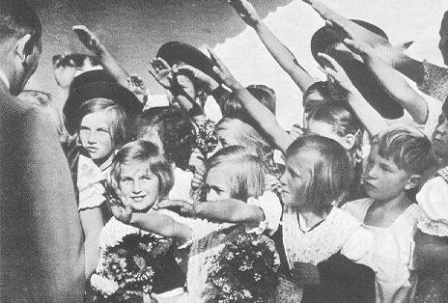
Children's hands.

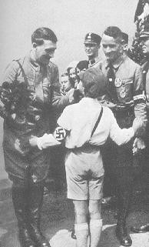
Young Germany greets The Leader in the election campaign.

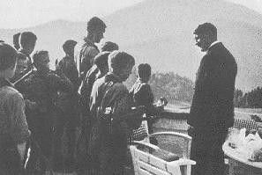
Hitler Youth as guests on the Obersalzberg.

Adolf Hitler even today follows up the work of his Youth Movement in all its facets. Year after year he receives in the Chancellery the boys and girls who have won the Reich Training Competition to offer his personal congratulations, and checks the buildings for youth groups by asking to be shown the models of youth hostels and their designs, and giving assistance in word and deed from his vast building experience. Often he makes contact with the young people themselves when, in Berchtesgaden or in Berlin, he invites home a group from the Young Folk or the League Of German Girls whom he has met on the way. He entertains the surprised guests with coffee and cake, listens to the songs they sing and the tales they tell of their travels. The Leader's birthday is perhaps the strongest expression of this close relationship between him and his youth. On this occasion there are on the long tables of the Chancellery thousands of little presents which boys and girls all over the Reich thought up to please their Fuhrer: handicrafts and original postcards, pieces of embroidery and travel books, all these things announce more eloquently than any words how much the thoughts of the young generation revolve around this man who has given our youth an existence in freedom, and it is before these simple little gifts that The Leader pauses longer than before the more valuable, sophisticated ones. The presents of the Pups seem to delight him the most on his birthday. In reality, they have been made of the most valuable material: the love of the youth, of which Adolf Hitler is the recipient in a measure no one before him has been.

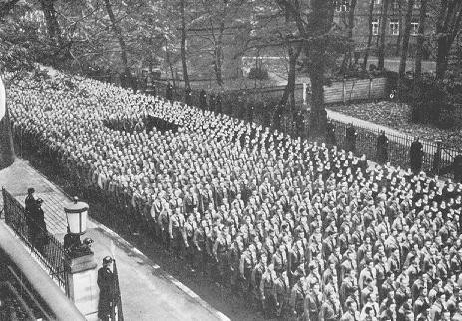
The 9th November in München. Hitler Youth in front of the Brown House before their festive acceptance into the Party.

The Hitler Youth is the only institution to bear The Leader's name. This connection between the youth of our Folk and the leader of the Reich is the symbol for the deep and close relationship between Adolf Hitler and the youngest sector of our Nation. Today every boy and every girl once again has the educative model to whom they feel committed and whom they try to emulate, and the individuals as well as the community, have thus given themselves over to a common ideal. Reassured, the German Folk can glance into their future. The mistakes of the past have been overcome. The time of the generation problems is over. If once the youth groups of the political parties opposed each other in bitter feuds, today all young people stand united, and there where once the past saw the wealthy and the poor locked in bitter class struggle, the present sees the trusting alliance of young people whose socialist feeling of being alive is stronger than any feeling of selfishness. What some time ago seemed to be still impossible and even utopian to contemplate, has today become an overwhelming reality. Certainly these young people also had to make sacrifices in order to be able to fashion this reality. Many youth alliances of the past which honestly tried to reach a greater goal had to be abandoned to achieve the great community of all young people. And the Hitler Youth itself had to bury many a dead comrade in order to be able to attain that final and complete unity without which no community on this Earth can exist.
But the young fallen of this youth died in the belief in The Leader and his future
Reich and the millions of young survivors are tied together in the same belief. They all feel themselves to be the upholders of the duty with which The Leader

has entrusted them, and they feel at one with him in their service to the greatness of the Reich. The work of Adolf Hitler can never perish because all young people in Germany have declared themselves prepared to serve this work dutifully and loyally for their lifetime, and then to hand it over to those who will come after them.
With such determination they greet the coming millenium.

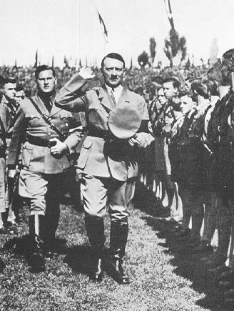
Party Rally Of Power, 1934. In the stadium with the youth.

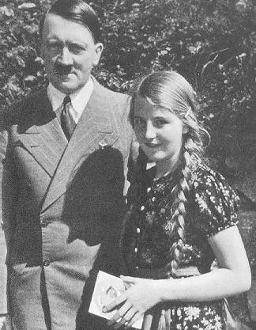
After The Leader gave her his autograph, she has the additional good fortune of being photographed with him.

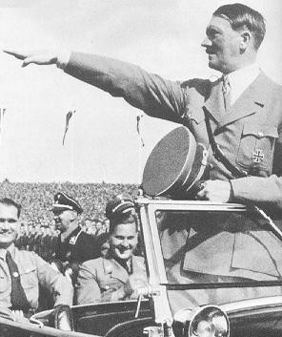
The Leader with the youth on the Reich Party Day in 1935.

This webpage intends to diffuse the nationalsocialist ideology, by means of compilations of books, texts, images and other documents, many of them censured by the tyrannic governments.

Our aim is to carry on fighting the System, to prove that we won’t submit, as we’re an anti-System voice anywhere in the world.

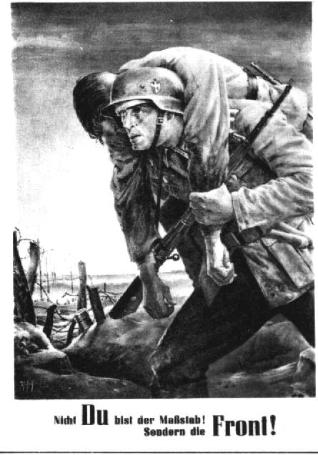
We know that nationalsocialism was, is and will be the best governing form ever experienced in political, economical, social and cultural aspects. We think the diffusion of our doctrine, the groups, and the political parties fighting against the Democratic System, to the People, is necessary.

National Socialism is the only ideology opposed to communism, capitalism, Zionism, and the democracies. For this reason it was attacked and destroyed by the allied forces, but the “Thousand-Year Reich” will be present, and we’re the people in charge of continuing the fight, in memory of all the comrades who died for our Ideal.

Today we’re the target of the democratic governments; many comrades are in prison, our publications are censured, therefore we must fight stronger than ever.

We want the possibility of diffusing our ideology without censorship, and this is the main objective of this website. We don’t mind being censured or locked in jail: we will never surrender!

¡SIEG HEIL!

PLEASE CLICK THE IMAGE BELOW TO PROMOTE OUR SITE THANKS
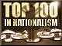

** UPDATED JUNE 1 2003

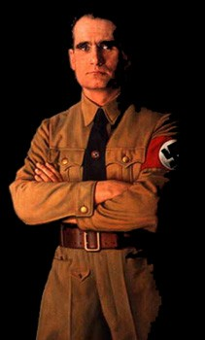
the_censorship@hotmail.com

NATIONALSOCIALIST BOOKS NATIONALSOCIALIST TEXTS

IMAGES, FLAGS, PHOTOS MUSIC OF THE THIRD REICH

REVISIONISM WAR ARTICLES

ART Personable FUHRER -His Table Talk DIVERS TEXTS LINKS

PROFESSIONAL ACTIVISM – Leaderless Resistance **

HOW TO OPERATE IN THE NET AS AN NS CELL **

** new updated JUNE 1 2003
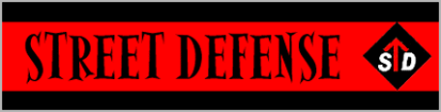

OB J E CTIVES O F THE C ENSURE O F THE D EMO C RA CY

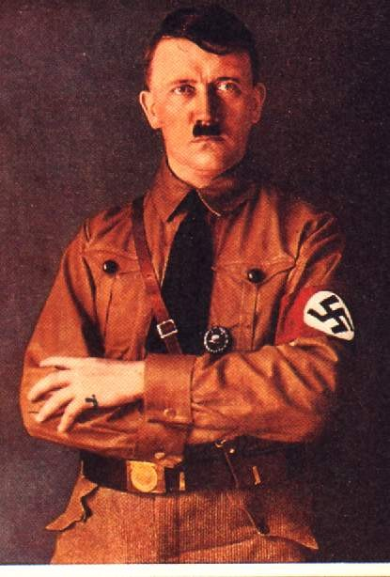
IF YOU WANT COLLABORATE IN OUR PROJECT, OR CONTACT WITH US :

the_censorship@hotmail.com

PLEASE SEND US TEXTS, BOOKS, PICTURES AND OTHER DOCUMENTS IN ENGLISH WHICH THEY ARE RELATIONED WITH THE NATIONAL SOCIALISM.

THANKS.

